Setting up Payment Terms and Billing Terms

Payment Terms:
- To setup Payment Terms you must navigate to AccountingCustomers and click on ‘Terms Setup’ over to the right to bring up the Payment Terms Setup Window. Any Payment Terms created on this screen will be selectable on both Job Orders and Assignments.
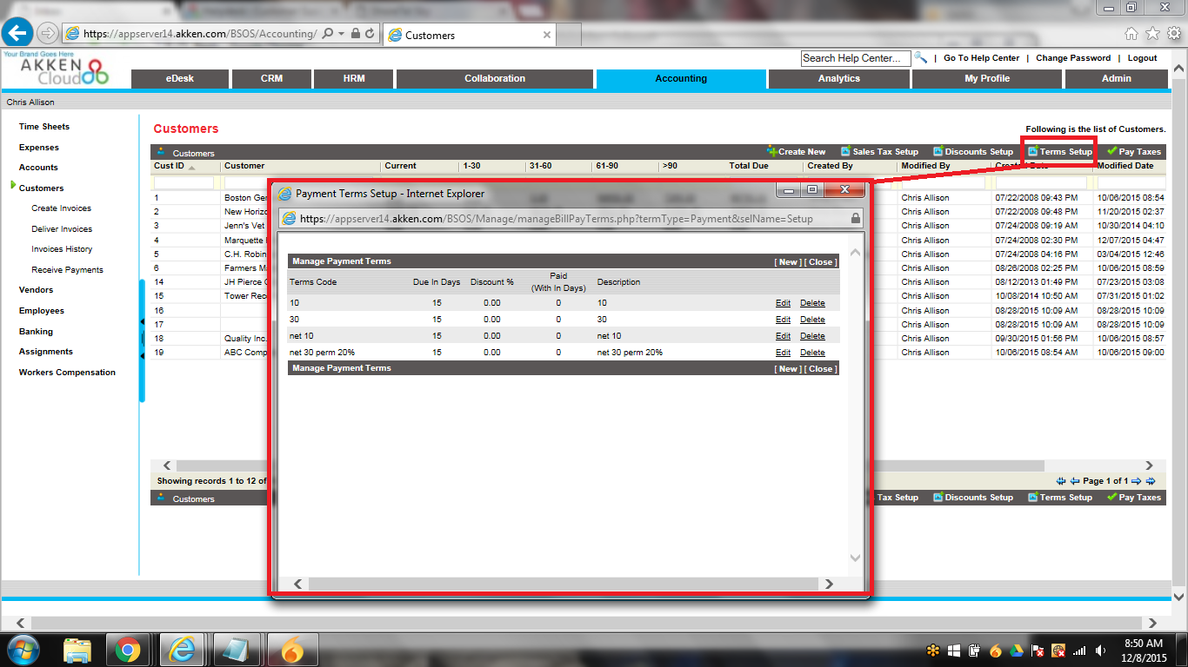

Billing Terms:
- To setup Billing Terms you must navigate to AccountingVendors and click on ‘Terms Setup’ over to the right to bring up the Billing Terms Setup Window. Any Billing Terms created on this screen will be selectable on both Job Orders and Assignments.
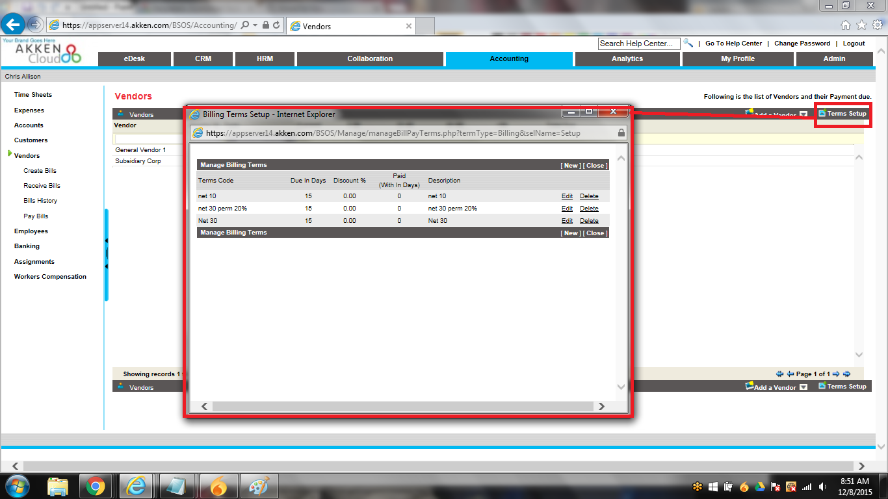

Job Orders:
You can select both the Payment Terms and Billing Terms within a Job Order or Assignment in the ‘Billing Information’ section:
