FOR BACK OFFICE USERS ONLY:

Administration Department:
In order for Administrators/Back Office/ Unlimited Users to view records within employee management of employees of your company you must be give permissions within the Administration Department in HRM to view the list. Mark Sample is the only user with permissions to view the Administration Department and all the employee records that are associated with the Administration Department. In this example below there are currently 23 employees associated with the Administration Department.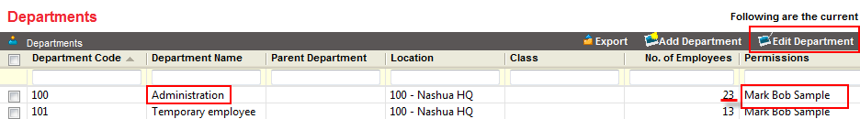
If there is going to be more than one administrator that will require access to the Administration Department, you can add permissions to other users through Edit Department. Check the box next to the department you wish to Edit, then Edit Department.
**In order to add multiple users you must hold down the control key (CTRL) and select the users you wish to add, then click on Save. These users now have permission to view the records in those folders**
