Employee Self Service Account
This guide reviews the basic features for an AkkenCloud Employee Self Service Account. Actual usage may vary depending on the chosen features for your account.
Login information:
You can log into your Customer Self Service account two different ways.
Navigate to your recruiters website and use the credentials provided to you to login
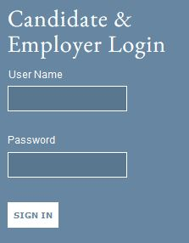
or
Go to https://login1.akken.com/ and use the login information provided to you. The format is commonly:
Company ID: Company ID of agency you are working with
Username: username
Password: password
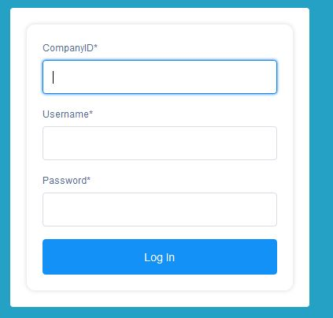

After you have logged in you will see your eDesk. We will focus on the 'My Profile' tab for Time Sheets and Expenses.
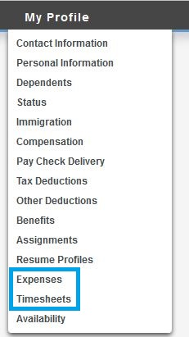
Timesheets:
Create new time sheet: Time Sheets – New Timesheet 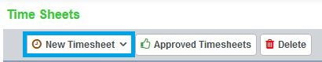
In order to have your time sheets approved, you must submit a weekly time sheet through your self service account.
Regular time sheet - select the correct date range – Type in the number of hours worked in Hours text box – Submit.
In the date range box on the top, make sure this is displaying the correct pay period. If not you can change the dates in the top right hand corner and then click on 'View'. You can now enter in the total amount of hours per week or you can type in individual hours per each day depending upon how hours need to be tracked. If you have Over Time or Double Time hours to track enter those hours in the respective columns. If you are currently working on more than one assignment you can select the assignment from the drop down list. Once you have correctly filled in the information on the time sheet, hit Save to save the information you just entered (this is used if you will enter in your hours on a daily basis) or Submit to submit for approval.
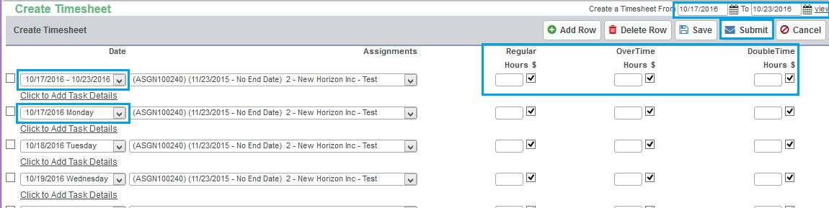

Time In/Time Out time sheet - select the correct date range – Type in the number of hours worked in Hours text box – Submit.
In the date range box on the top, make sure this is displaying the correct pay period. If not you can change the dates in the top right hand corner and then click on 'View'. You can enter in your start time and end time for each day. Any overtime or double time hours will automatically be calculated for you. If you are currently working on more than one assignment you can select the assignment from the drop down list. Once you have correctly filled in the information on the time sheet, hit Save to save the information you just entered (this is used if you will enter in your hours on a daily basis) or Submit to submit for approval.
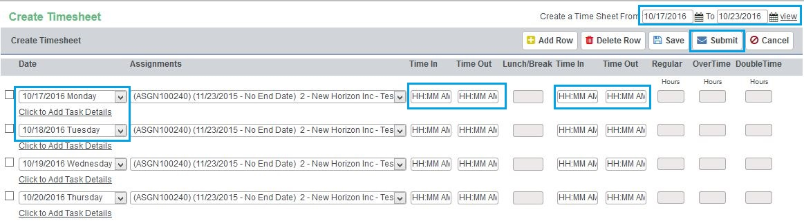
Once a time sheet has been submitted the time sheet will be listed in the main time sheet home screen. Here you can also view prior time sheets you have saved for future submission and time sheets that have been rejected by accounting.
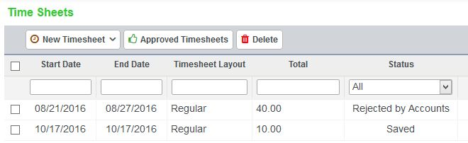

Expenses:
Create new Expense: Expenses – New – Select date expense was incurred – Select assignment – Select Expense type from dropdown list – Type in quantity, unit cost – Select Billable (if applicable) – Upload receipts or documentation - Submit
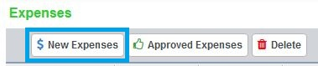

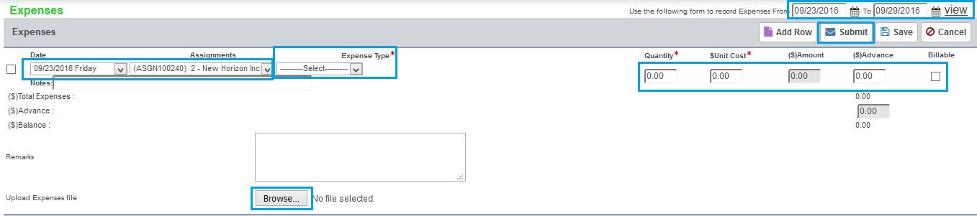

Once the expense has been submitted the expense will be listed in the main expense home screen.
