New AkkenCloud Features - November 7th, 2016

Timesheet Layout
We’ve introduced the ability to select a new Timesheet Layout Preference for Units of Measure (UOM).
To set up this Timesheet Layout Preference go to Accounting > Employees > Pay Employees > Payroll Setup.
Select UOM Time Layout and click ‘Save’.
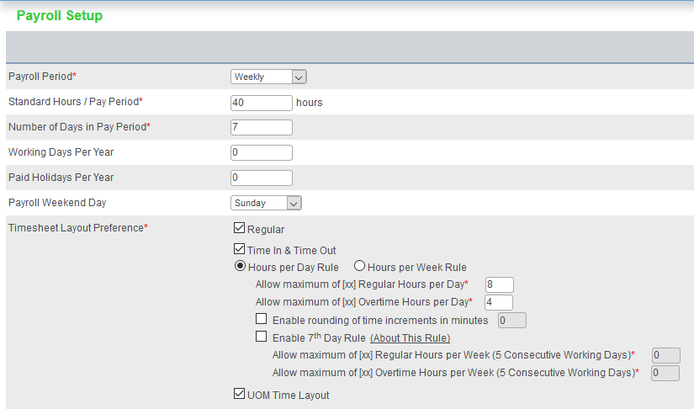
Once the selection has been saved, users can create a UOM Timesheet from Accounting > Time Sheets > New Timesheet.
In order to create a UOM Timesheet, you must select an employee with Units of Measure (*Per Day, *Per Mile, *Per Unit) selected as Pay/Bill Rates in the Billing Information on their Assignment. Example:
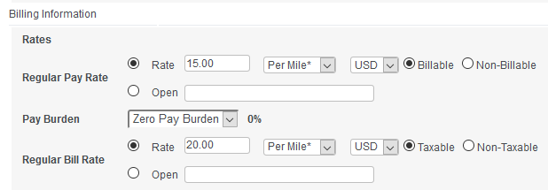
When creating the UOM Timesheet, select the name of the employee with UOM on their Assignment, fill out the Timesheet and ‘Submit’.
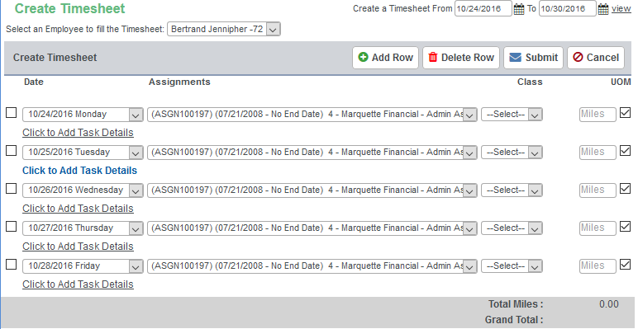
TAXI Tool Enhancement
We’ve introduced an enhanced version of the TAXI (Time and Expense) tool. In this version users have the ability to import Regular, OverTime and DoubleTime hours in one template, along with the ability to import Expenses using Assignment ID, Employee ID, Employee Names, etc.
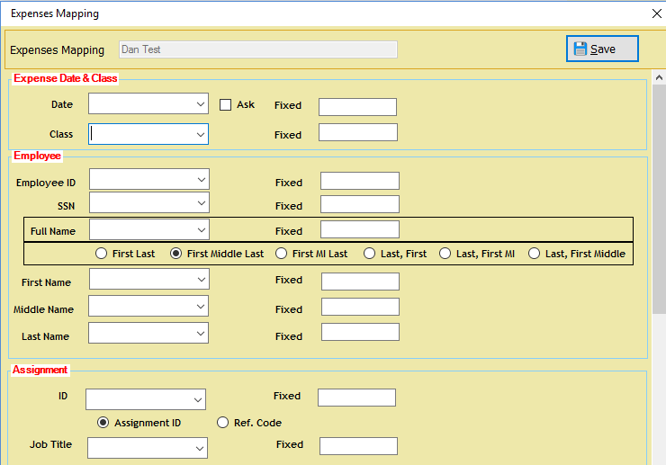
Edit List Restriction
We’ve given Admins the ability to restrict additional fields from being edited on Contacts, Companies, Candidates, and Job Orders.
To restrict users from having the ability to Edit Lists go to Admin > User Management and select the first icon (Preferences) for the user.
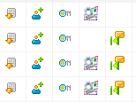
Within the Preferences, deselect Data Management and click ‘Update’. The user will no longer have the ability to Edit Lists.
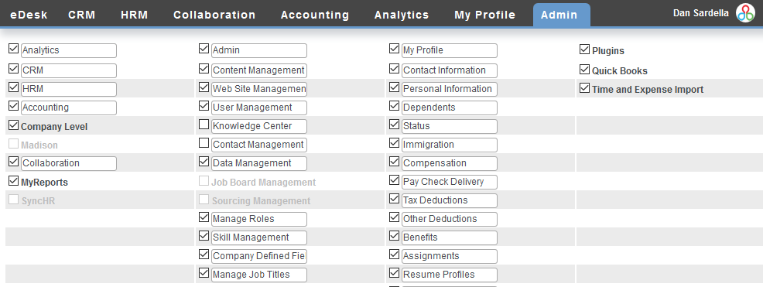
The fields that this affects are CRM > Contacts (Contact Type, Category, and Source Type), CRM > Companies (Status), CRM > Candidates (Status), and CRM > Job Orders (Status, Stage, Source Type, and Submission Status – from the Manage Submissions screen).

EOB Tags
Are you aware of all the fields that can be auto-populated using our Employee Onboarding (EOB)? First you’ll need to have Paperless Onboarding with AkkenCloud. Provided you’ve subscribed to this add-on, when you send digital paperwork to your new hires using EOB many fields can be auto-populated to the Employee record.
Some of these fields include Tax Deductions information such as Filing Status for Withholding, Total Federal Tax Allowances, Filing Status (state) for Withholding, Withholding state of the employee, Total State Tax Allowances + more!
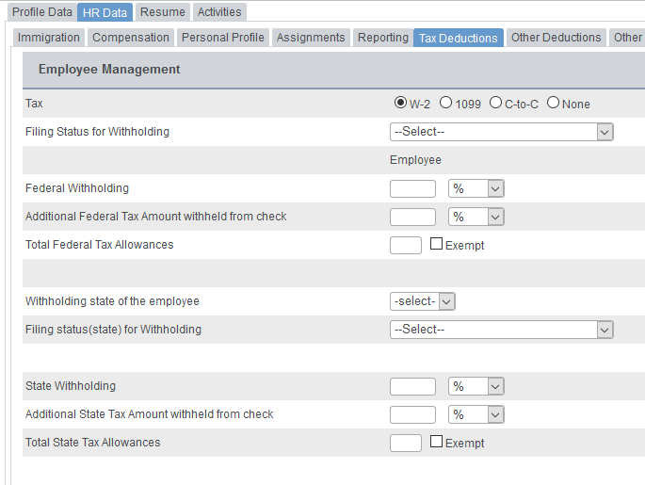
In addition, there are fields in the Pay Check Delivery tab that can be auto-populated such as Name, Account Type, Bank Name, Bank Routing Number and Bank Account Number.
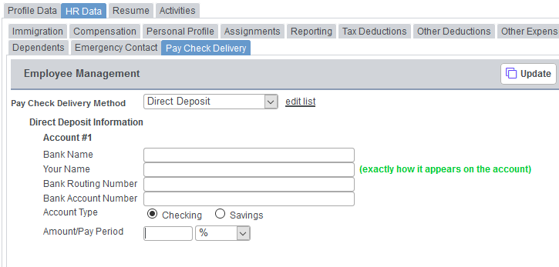

More recently, fields in the Personal Profile can now be auto-populated such as Date of Birth and Social Security Number.
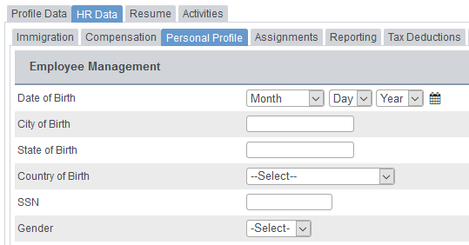
As well as fields in the Candidate Info tab such as Primary Email.
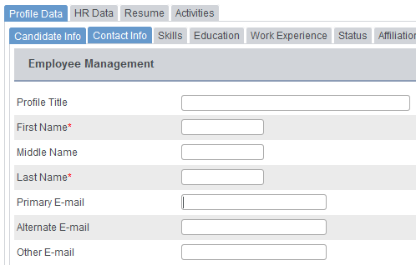
And fields in the Contact Info tab such as Address, City, State, Zip and Primary Phone.
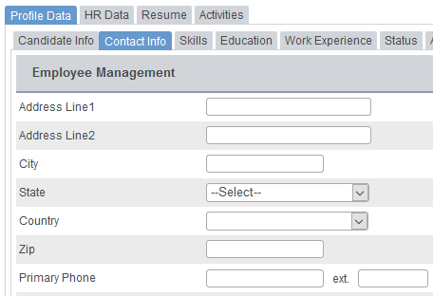
Requested Positions
We’ve introduced a new searchable and sortable column to CRM > Job Orders that can be added via the Customize Columns button. The Positions Requested column gives you the ability to compare the number of positions requested against the number of openings currently available.
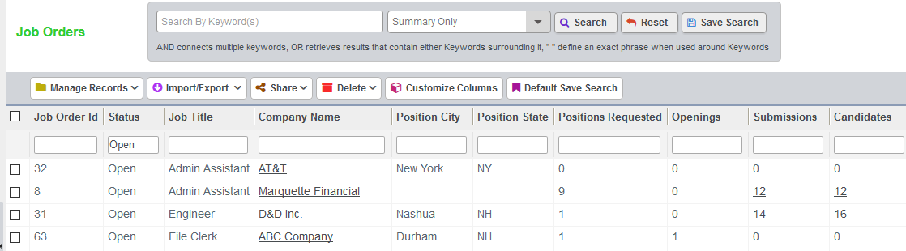
To add this column, click on the Customize Columns button, select “Positions Requested” from the Available Field(s), ‘Add’ to the Selected Field(s) and ‘Save’. Then refresh your CRM > Job Orders grid.
