How to Customize Dropdown Lists
NOTE: ALL dropdown lists should be configured and created in the system PRIOR to the company engaging in the usage of Akken. This is to ensure all users are trained within the structure of the business process from the beginning. Additionally, the management of the values within the dropdown lists should belong to a designated Akken Staffing Administrator. This user will be responsible for maintaining consistency with the values and to prevent users who are not responsible for managing the values from editing or adding values to the dropdown boxes. Any user that has access to AdminData Management will be able to edit these dropdown lists.
TIP: Create a company policy designating which individual in the company has the authority to manage the dropdown values.
Dropdowns in CRM
Contacts:
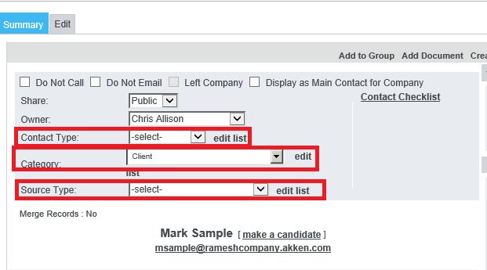
Contact Type: CRM – Contacts – Contact Type – Edit List – New Contact Type – Fill in text box – Save – Close: Use to denote a specific contact. For example: Main Contact, Technical Contact, and Key Contact. This section allows you to select what type of contact you are working with. You can edit this list to accommodate the type of contacts you work with most frequently. The list currently shown below is not editable. These are predetermined options created by Akken.
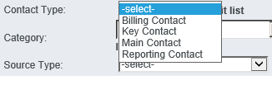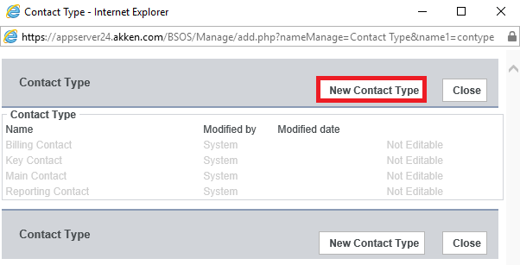
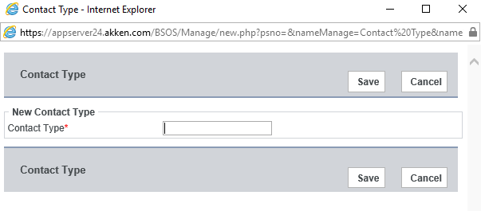
NOTE: The same process can be applied to the Category and Source Type on the summary screen.

Locations of Editable Dropdown Lists in Contacts can be found in: CRM – Contacts – Edit tab
-Salutation
- Suffix
- Category
- Source Type
- Contact Type
- Department
Companies:
Company Status: CRM – Companies – Edit tab (or Edit Settings) – Status – Edit List – New Company Status – Save: Use the company status similarly to the Contact/Category field. Both fields are found on the main Company and Contact grid screens, and can be used to sort information on that screen. Use Company Status to denote Client, Prospect, Partner, Vendor, Competitor, Do Not Use, etc.
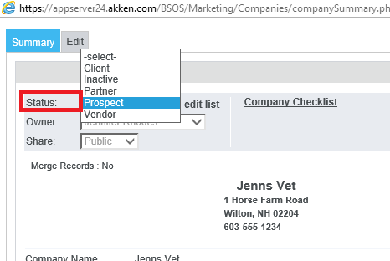
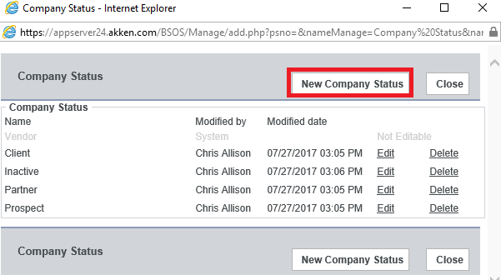
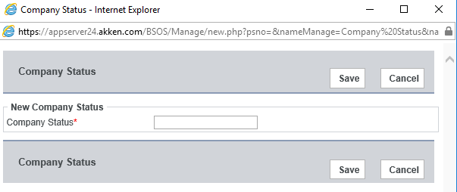
Company Opportunities: Companies – Open a Company record – Scroll to the bottom – Click ‘New’ next to the Opportunity label: You can edit the Type, Stage, Product/Services, Source, Reason, and Other sections.
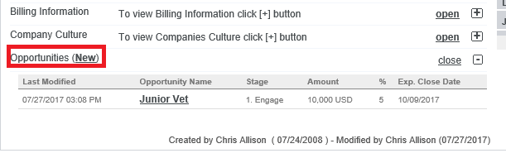
Opportunity Type: Companies – Open a Company record – Edit – Add Opportunity – Type – Edit List – New Type – Fill in text box – Save – Close: Use to denote what kind/type of business the opportunity is.
Opportunity Stage: Companies – Open a Company Record – Opportunities – New – Stage – Edit List – New Stage – Fill in text box – Save – Close: Use to denote what actions needs to be taken on the opportunity.
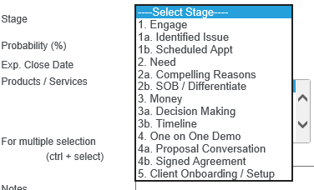
Products/Services: Companies- Open a Company record – Opportunities – New – Products/Services – Edit Lists – New Products – Fill in text box – Save – Close: Use to denote the types of products and services that the company/opportunity is interested in purchasing/utilizing.
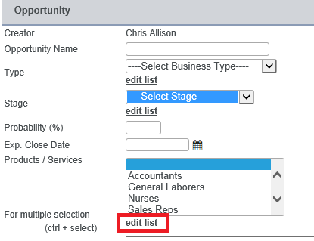
Opportunity Source: Companies- Open a Company record – Opportunities – New – Source – Edit Lists – New Source – Fill in text box – Save – Close: Use to denote where this opportunity for this company originated from.
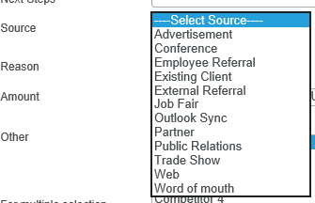

Locations of Editable Dropdown Lists in Companies can be found in: CRM – Companies – Edit tab
- Status
- Company type
- Company source
Locations of Editable Dropdown Lists in Company Opportunities can be found in: CRM – Companies – Open a Company record – Opportunities
- Type
- Stage
- Products/Services
- Reasons
-Other
Candidates:
Candidate status: CRM – Candidates – Open a Candidate record – Status – Edit list: Used to denote any type of status. This field is found on the main Candidate grid screen, and can be used to filter information on that screen. This is an extremely useful field that should be used for one of the primary ways a company needs to sort candidates.
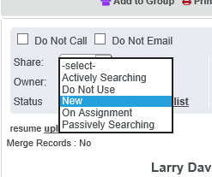
NOTE: This is a manual field, meaning it does not change with any actions performed in the system (e.g. if a candidate is placed on assignment, the Candidate Status does NOT change to "On Assignment" as you see that option above. The user would need to change the status manually. In this example, the Candidate's availability would change to the day after the end date of the assignment.

Position Category: CRM – Candidates – Candidate Info – Position Category – Edit List – New Position Category – Type in title in Text Box – Save – Close: Use this in order to denote what type of category your candidate belongs to. This will enable you to associate a position to your candidate. This information usually is copied into the Profile Title automatically if you parse a resume; however, the titles can be changed and can cause difficulty when searching for an individual. This is a searchable field in which all users can pull up individuals’ labeled as CFOs rather than using the Profile Title.
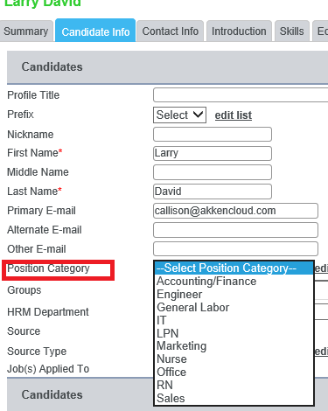
Source type: CRM – Candidates – Candidate Info – Source Type– Edit List – New Source Type– Type in title in Text Box – Save – Close: Allows you to choose where the Candidate came from. For Example: Job Board, Job Fair, Newspaper, Referral, and Website.
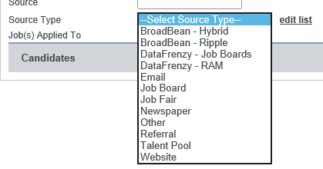

Job Orders:
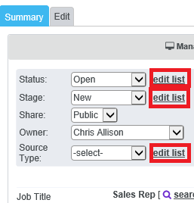
- Status: CRM – Job Orders – Status –Edit List – New Status – Type in new status – Save – Allows you to select which type of status your Job Order is currently in. For example: Open, Closed, Cancelled, and Filled.
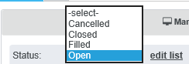
Stage: CRM – Job Orders – Stage – Edit List – New Job Order Stage – Type in new stage – Save: Use stage to denote how in the process your Job Order is at this time.
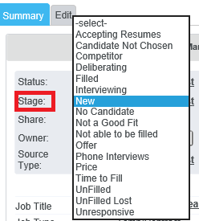
Source Type: CRM- Job Orders – Source Type – Edit List – New Job Source Type – Type in new job source type – Save
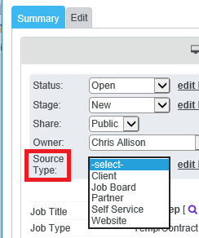
Job Order Industry: CRM- Job Orders – Edit Tab – Industry – Edit List – New Job Order Industry – Type in new job order industry – Save
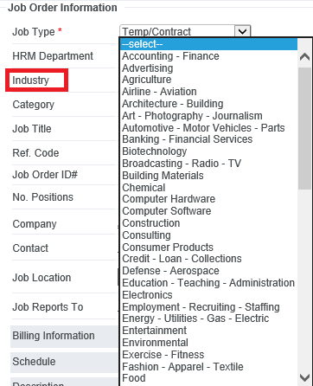
Job Order Category: CRM- Job Orders – Edit Tab – Category – Edit List – New Job Order Category – Type in new job order category – Save
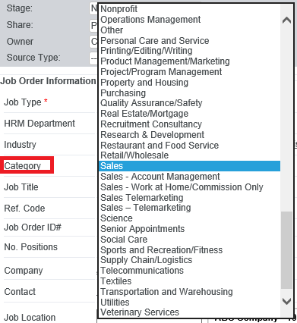
Job Order – Manage Submissions – Status – Edit List – New Status – Save – Close: Use to denote what status the submitted candidate is in.
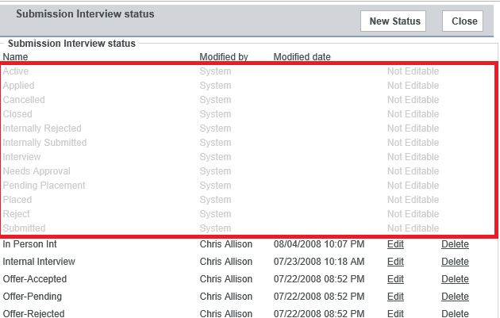
NOTE: Grayed-out statuses are system-defined and cannot be edited or deleted.

Notes: CRM – Contacts/Companies/Candidates/Job Orders– Notes – Edit List: Use to denote what type of contact you have had with this person/company/candidate, or whom you’ve might of spoke with (with regards to a job order/posting).
