How to Create a Short list
- Go to CRM – Candidates and run your search to create a subset of Candidates you wish to short list to a job order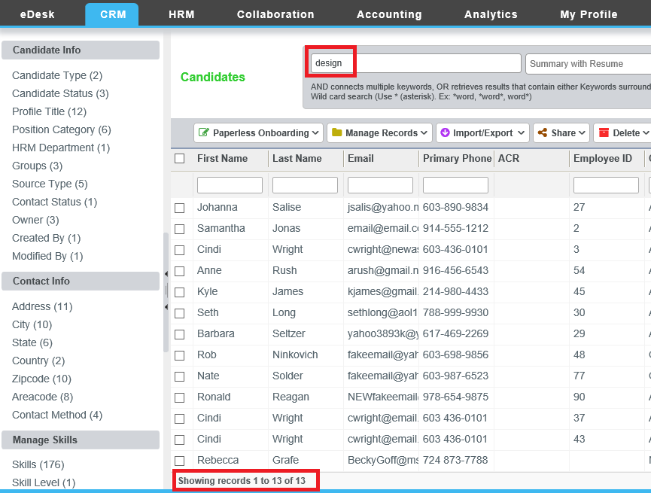
- Click on the check box next to the "First Name" on the upper left-hand corner (that will select all the candidates found in your search) and click on Manage Records-->Short Lis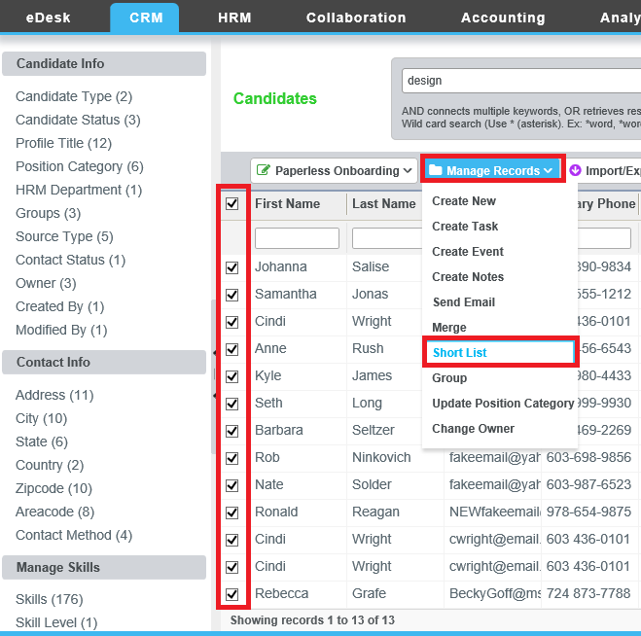
- Select the job order you wish to short list the candidates to. You will receive a message that the candidates have been short listed
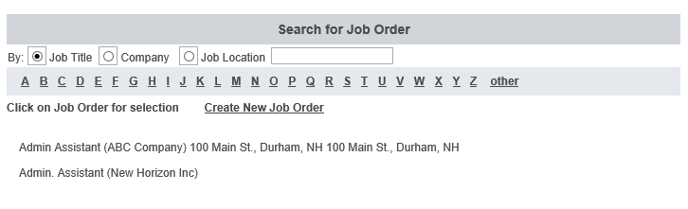
- Next: Go to your job order and double-click on the job order to open it
- Scroll down until you see Short listed Candidates on the right-hand side and click on Manage Short list
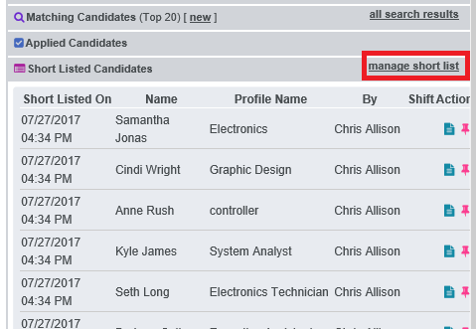
- From the short list you can Print, Add Notes, Prioritize, Send Mail etc.
