CRM Groups
Go to Contacts or Candidates in CRM. Run your search to find the candidates or contacts you wish to group together, then click on the check boxes next to the records you wish to add to a group OR click on the check box next to “Last Name” and it will select All. Click on Manage Records-->Group.
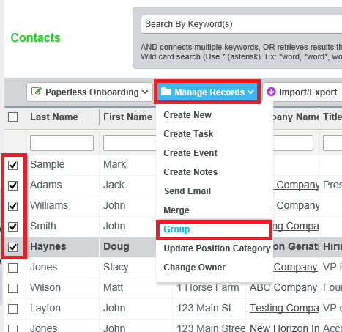
A pop-up appears and you can add to a new group if one has already been created or you can click on create a new group and create a group. You can also decide if the group will be private or public. Once you have selected your group or created a new group, click on Save.
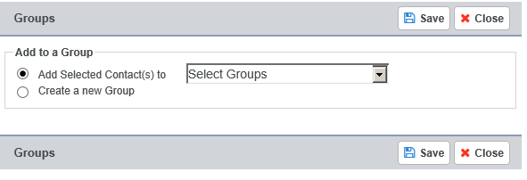
Your group has been created and you can now use it again in the future and it will show under CRM Groups. You can add new candidates or contacts to a specific group and you can use those groups for eCampaigns. Additionally, you can select multiple groups so the candidate or contact can be a part of more than one group if needed.

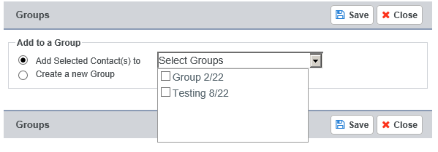
You can then manage your CRM Groups in CRM-->CRM Groups: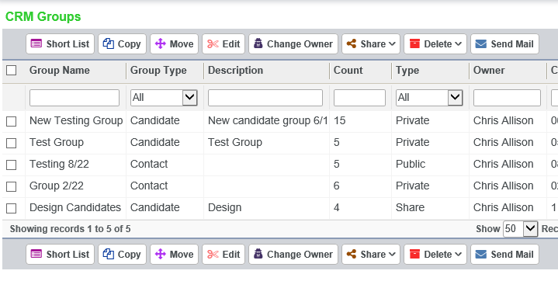
When sending eCampaigns when clicking on the “To” line you will see a list for your CRM Groups to send to.