ultigigs User Guide
Version: 1.8.9

Akken Cloud
98 Spit Brook Road| Suite 402 | Nashua, NH 03062 | USA

Table of Contents
Contents
1. Introduction 3
2. Installing ultigigs 3
3. Uninstall ultigigs 4
4. Auto Update ultigigs 4
5. UI Components 5
5.1 Single User Mode 5
5.2 Multi-Mode Login 22
5.3 Multi-user mode new registration and activation Procedure 23
5.4 Multi-mode new user login – If email id doesn’t match below screen would be displayed. 23
6. Points to Remember 24
6.1 Single user Mode (Clock In Clock Out) - 24
6.2 Time Clock Mode (Punch In Punch Out) 24

Introduction

Ultigigs is a mobile application that can be installed on mobiles, iPad etc. Its an on-demand jobs platform connecting people with flexible jobs. ultigigs creates a peer-to-peer network of people where they get compensated for referring people to jobs and jobs to people.
Some of the features include:

  - Listing of Active, Needs Approval, Closed and Cancelled Jobs
  - Job Listing with Location, Report To and Assignment information
  - Submit a timesheet from within a job listing.
  - Vacant shifts to Claim.
  - View the status of Claimed vacant shifts.
  - Get notified with push notifications on Vacant shifts Broadcasted and Approved or Rejected
  - Track details of each of your job references
  - Get paid when your references start a job.
  - Fill in your time sheets.
  - Can submit multiple assignments.
  - Timesheet rules for Saved timesheets
  - Auto apply rules to Time-In, Time-Out Timesheets
  - Per week, per day, 7th-day rules applied.
  - Added "View Clock" to easily see current Check In
  - Edit Clock for Clock In/Clock Out time sheet.
  - Can Submit Clock In/Clock Out time sheets weekly.
  - Submit your expenses.
  - Update the Availability
  - View Pay Checks
  - Contact US to view updates or company alerts.

Installing ultigigs

Before beginning make sure users log into their ESS accounts VIA a PC before attempting to access ultigigs. When accessing VIA a PC first attempt ESS user will be prompted to update PW once updating PW and accessing successfully VIA a PC follow the steps below.
Link to Play Store: https://play.google.com/store/apps/details?id=com.ultigigs.ultigigs&hl=en

Link to Apple Store: https://apps.apple.com/us/app/ultigigs/id1481832997?ls=1

Ultigigs can be downloaded from Playstore/Appstore.
Step 1: Open App
Step 2: On Sign In screen enter.

- Company Id
- Username
- Password
Click ‘Sign IN

Click the hamburger icon in the upper left-hand corner for more access

- My Jobs
- Vacant Shifts
- My References
- Time Sheets
- Expense
- My Availability
- My Pay Checks
- Contact Us
- Change Password
- Sign Out

Uninstall ultigigs

User can uninstall the application from mobile devices by clicking on uninstall button.

Auto Update ultigigs

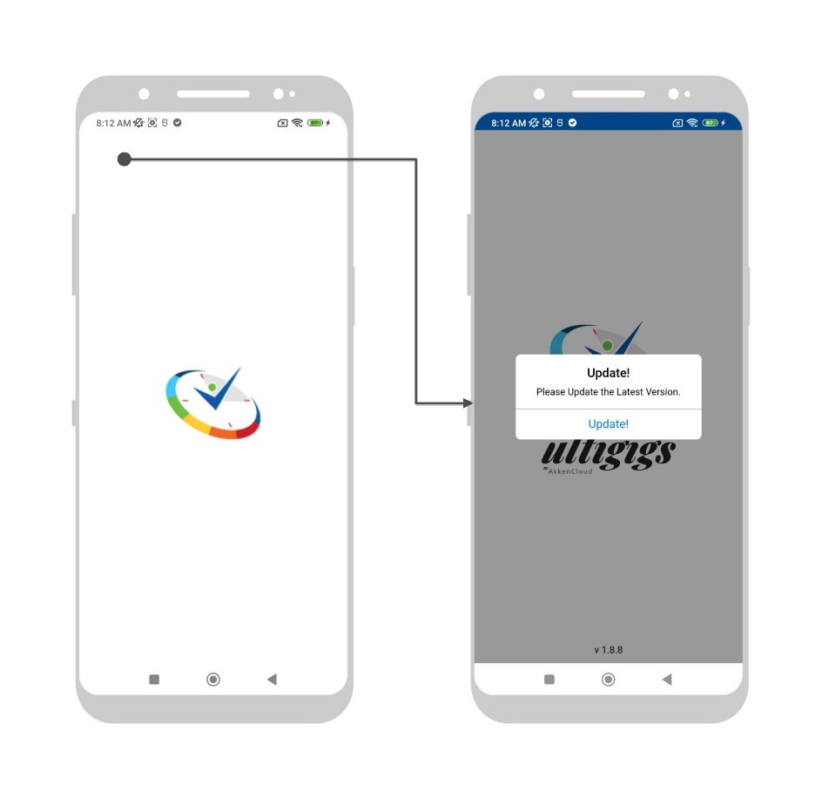
Once the new version is released to both stores, users will get notified when the application is launched. This is mandatory update i.e users will not have any option to Cancel it. Once clicked on Update button – User will be taken to the stores.

UI Components

Single User Mode Login
Users’ needs to type in company name, username and password to sign in into the application.
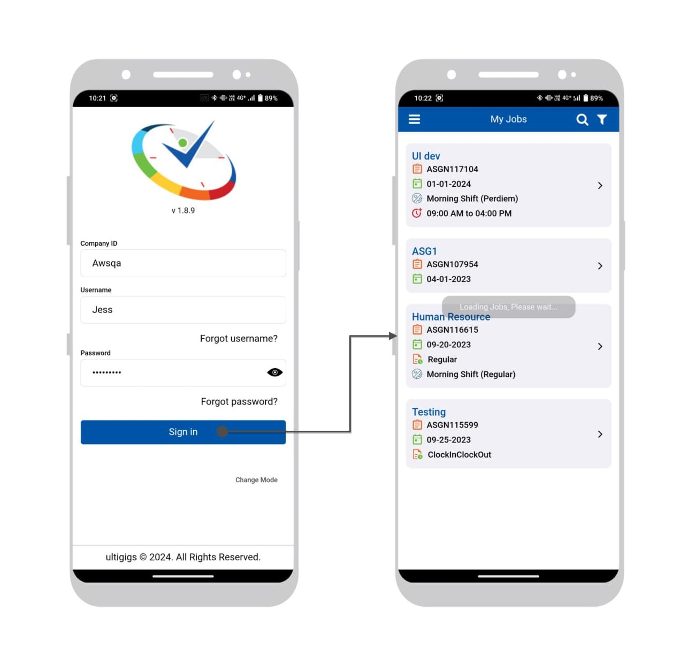

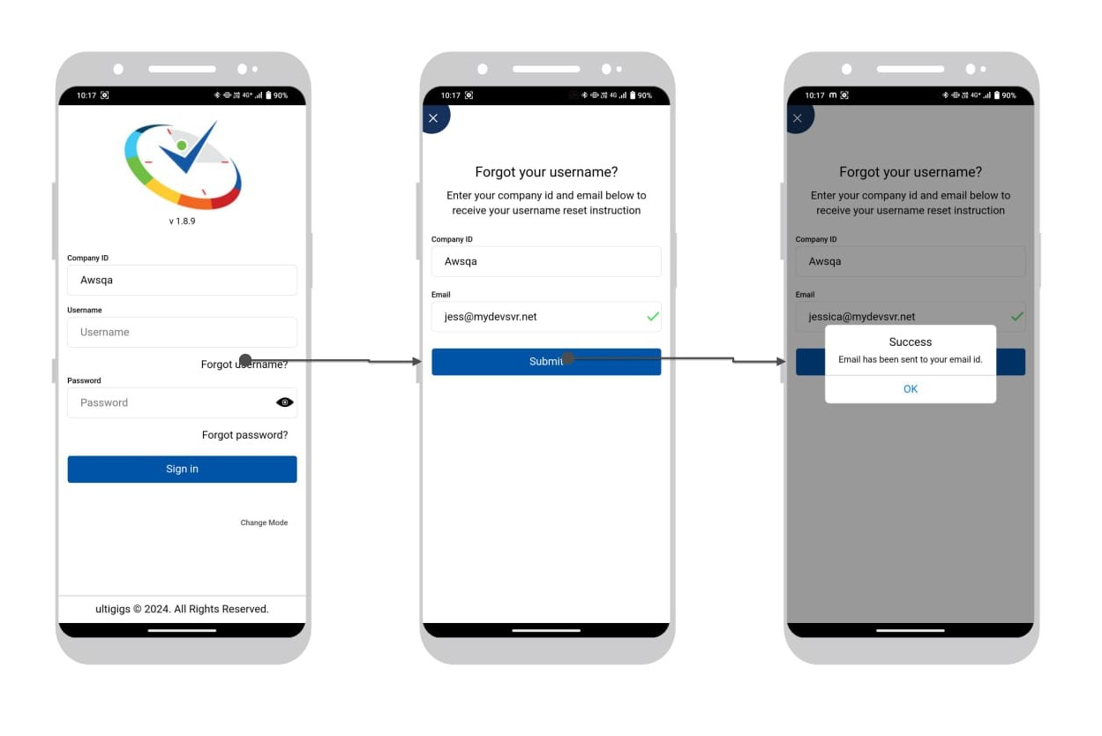
Forgot username.
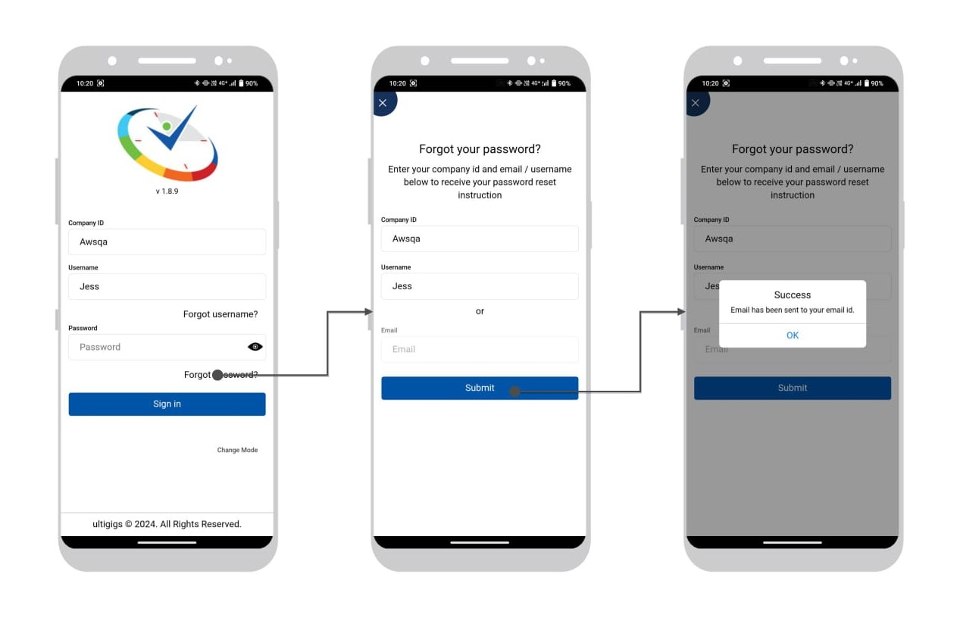
Forgot password.
My Jobs & Details

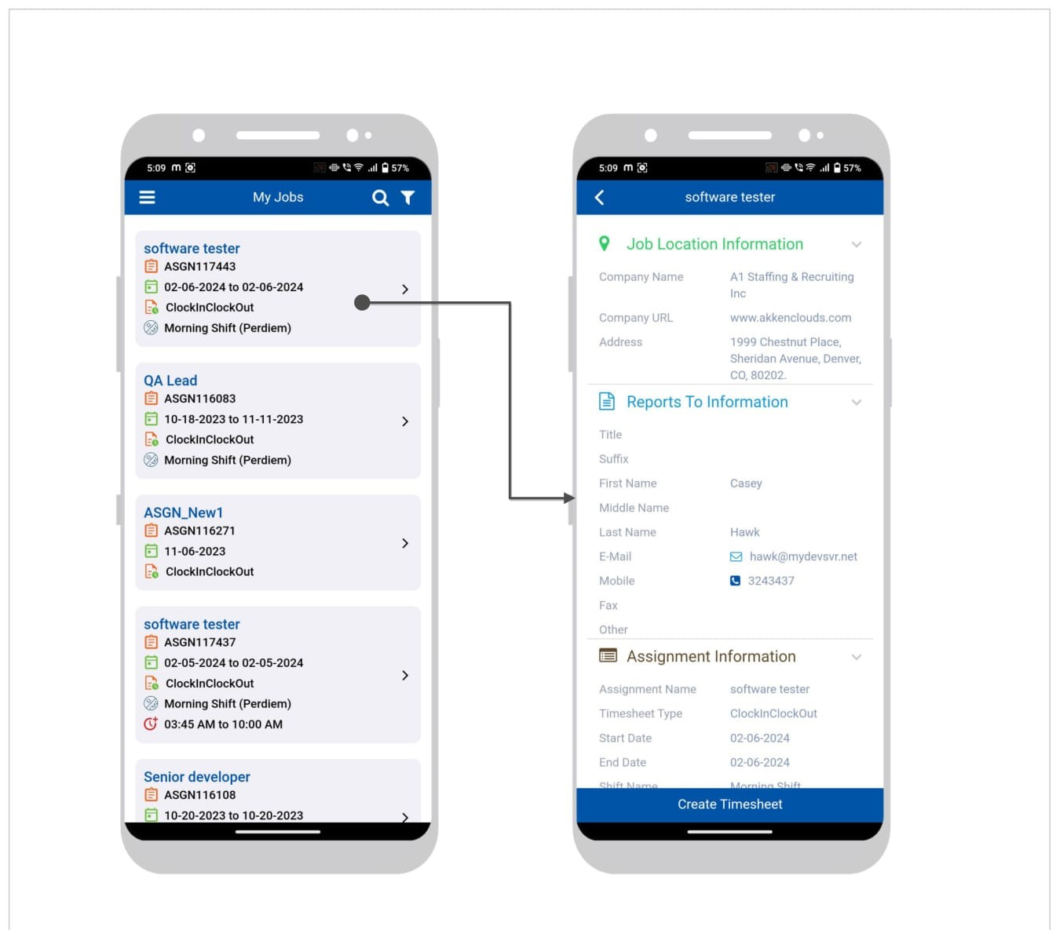

Claimed shift menu Details.
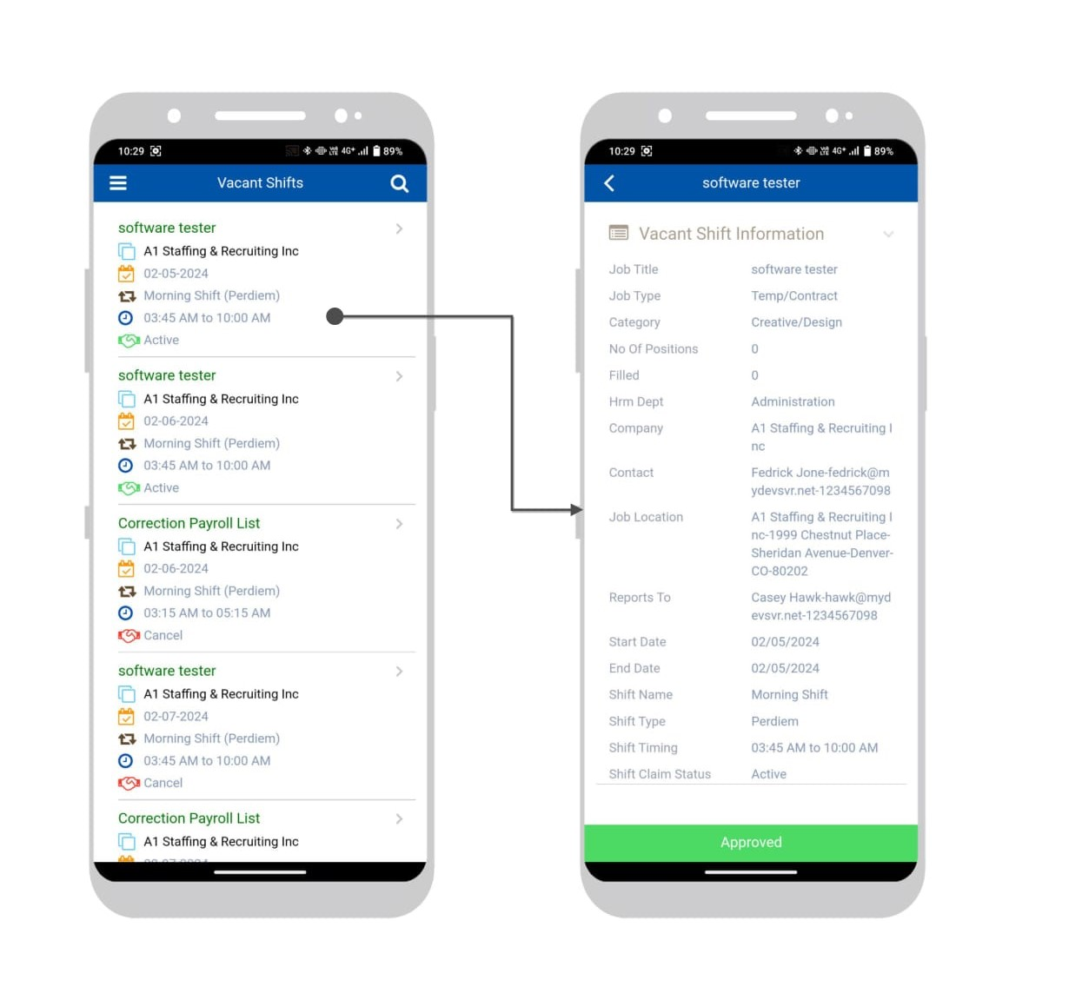

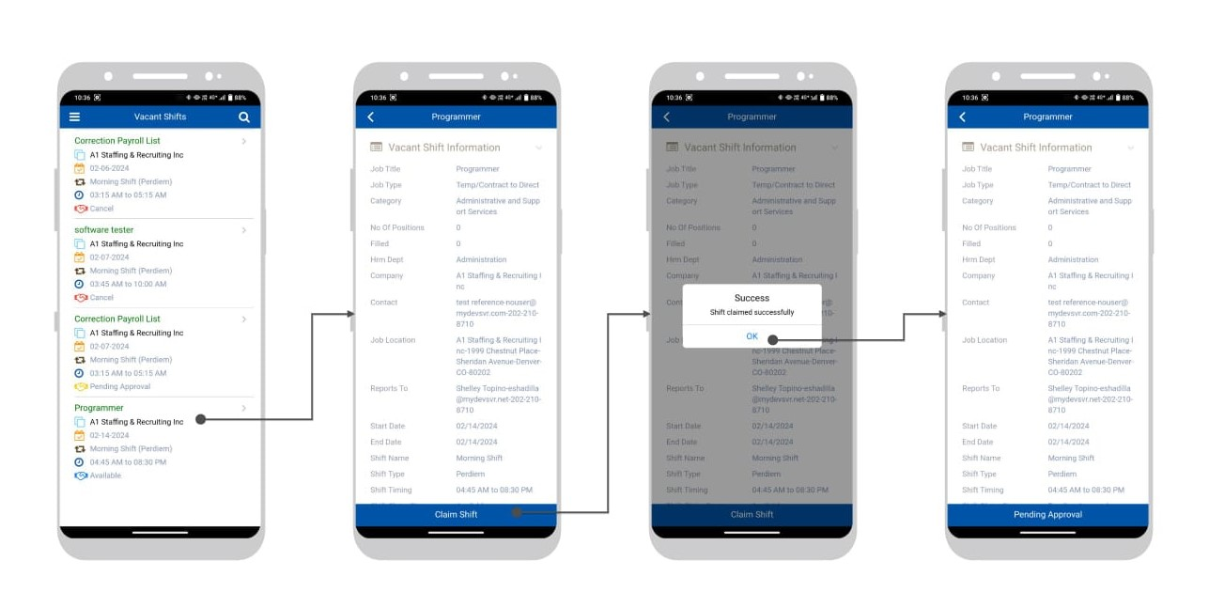
Vacant shifts to status of claimed shifts.
Rejected claimed shift.
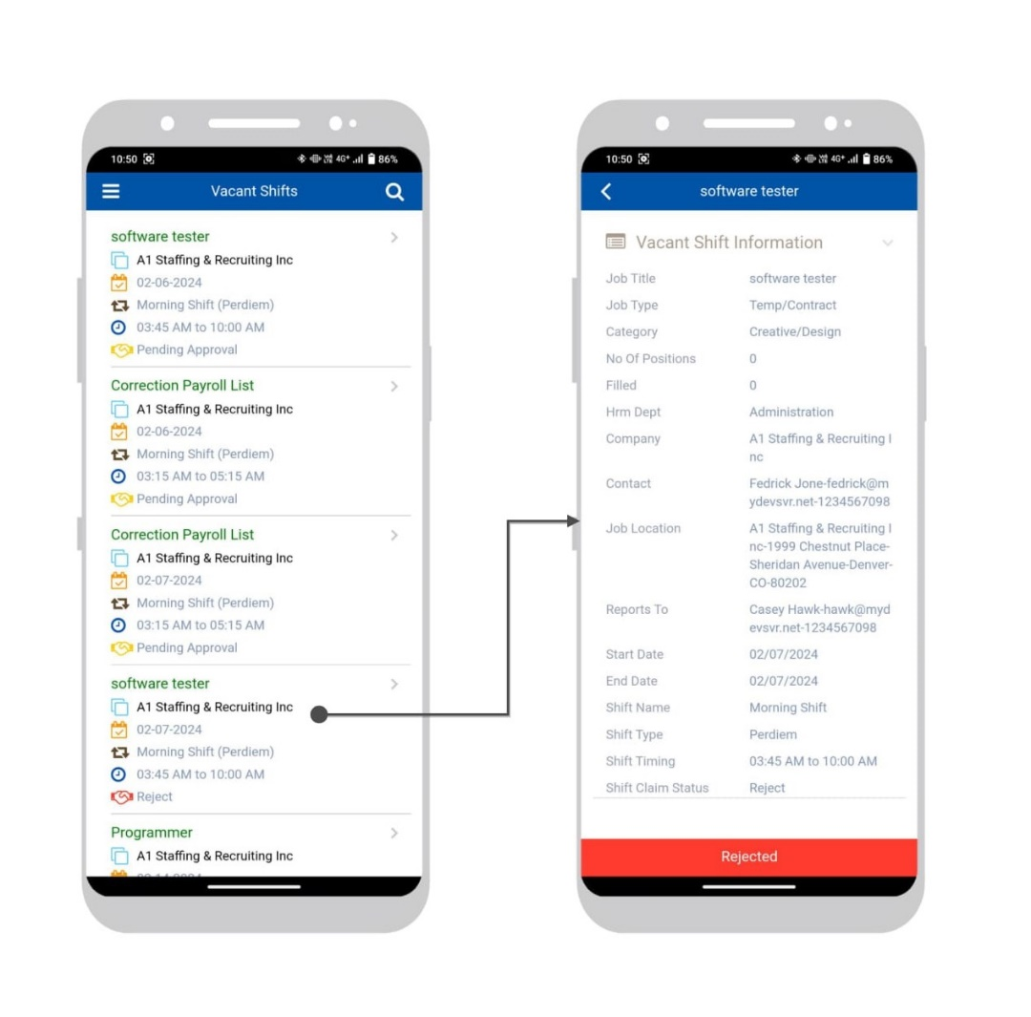

Push notification’s view and on click Navigations

Broadcasted vacant shift notification and on click navigates to List of Vacant shifts.
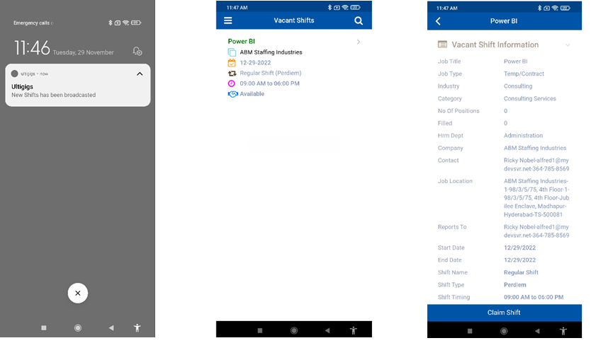

Approved Claimed shift notification and navigating to the detailed shift information page.

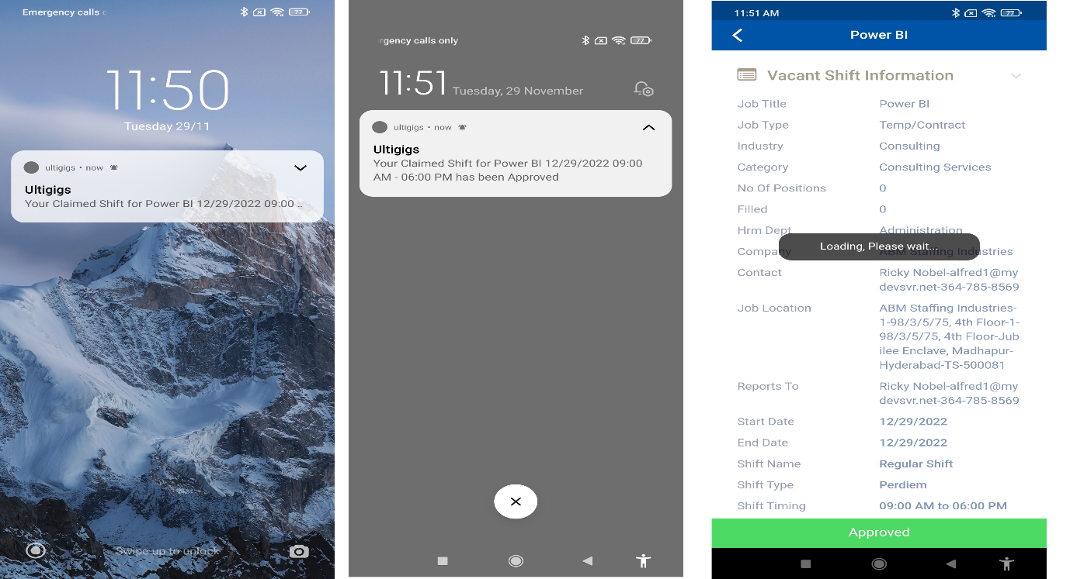
Rejected claimed notification and navigating to Rejected detailed shift information.

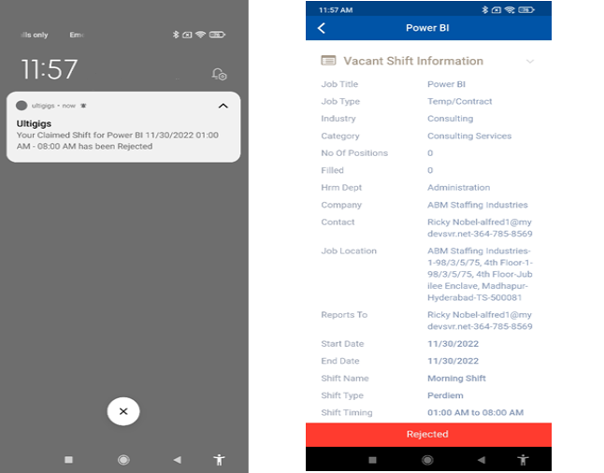

My Jobs will be displayed once vacant shift approved.
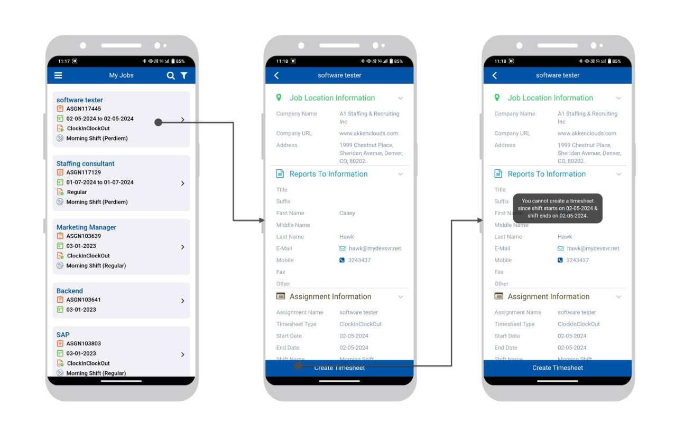

My References

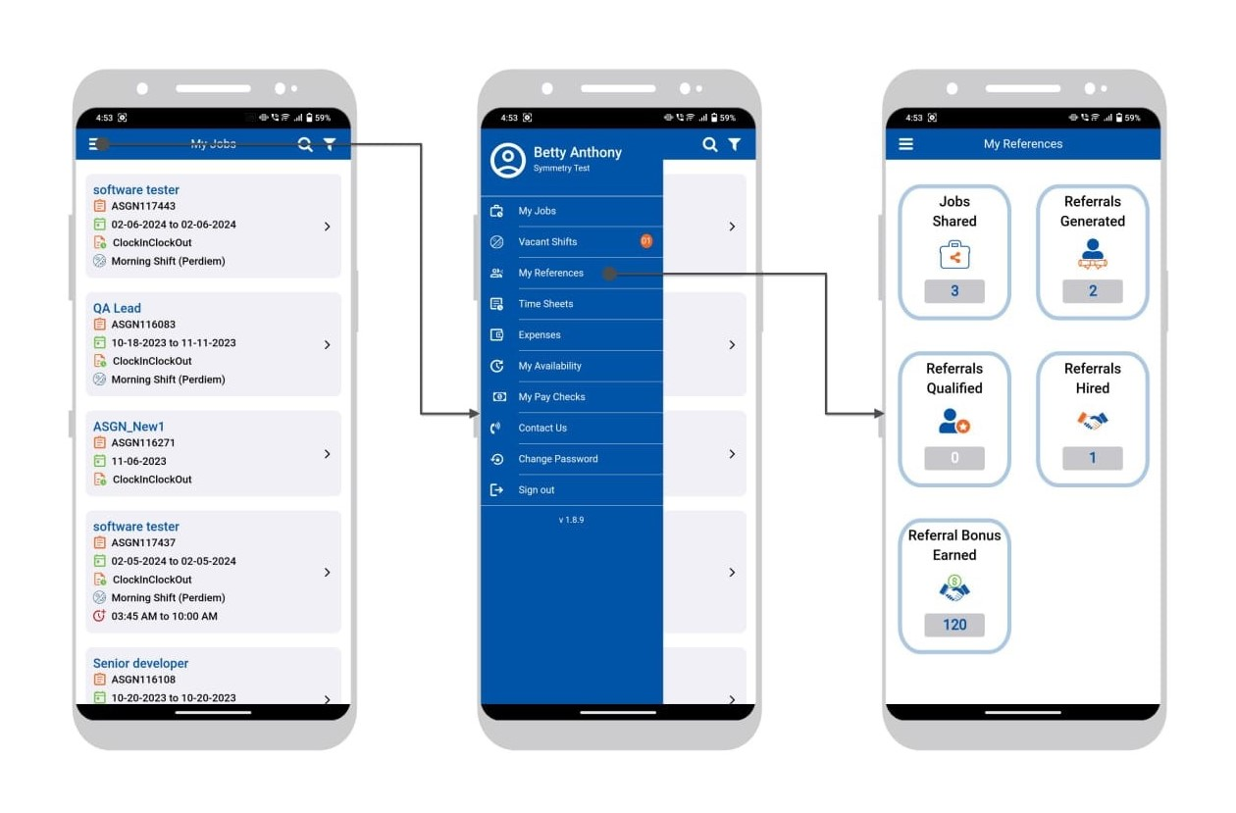
Job Shared
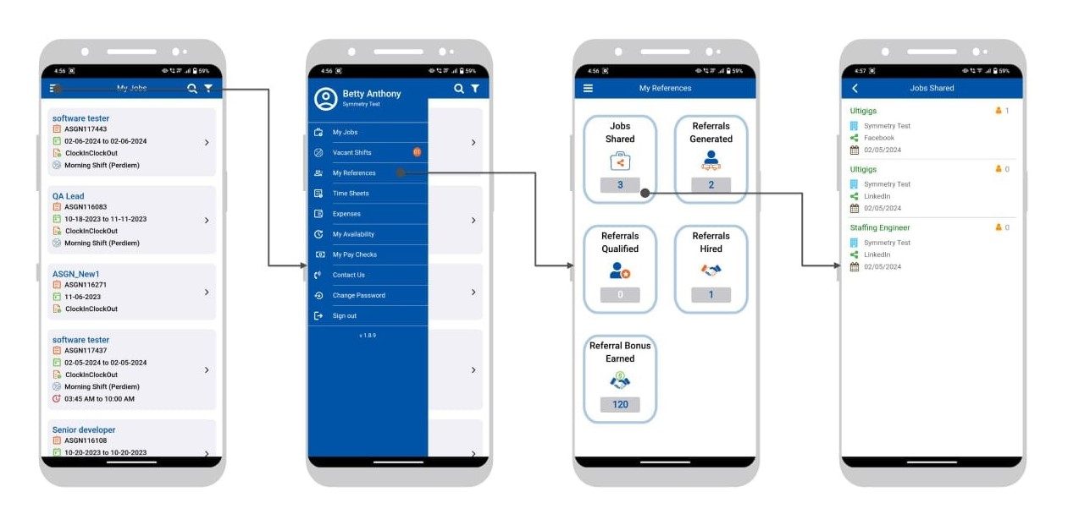

Referrals Generated
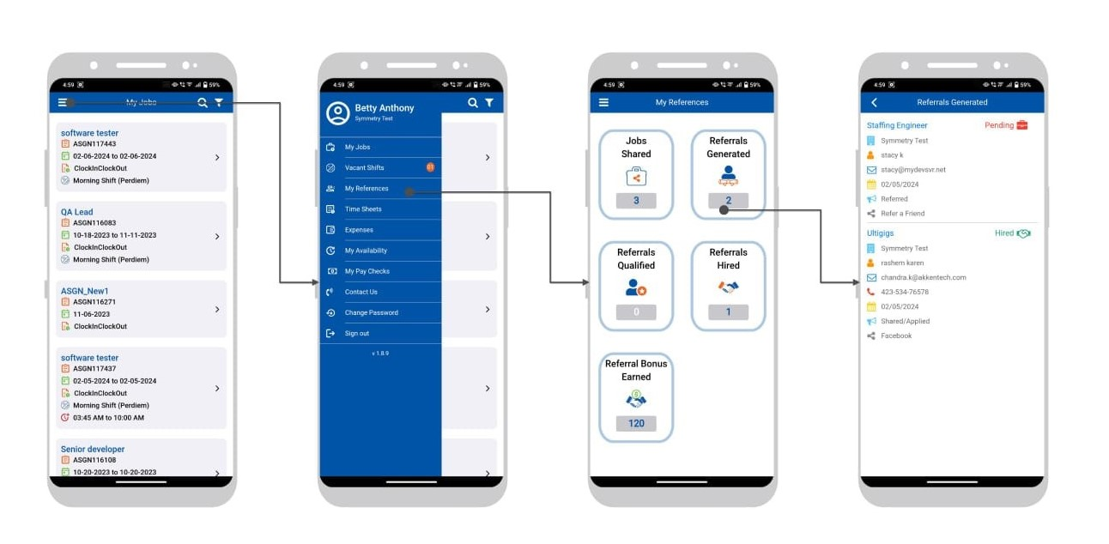
Referrals Hired

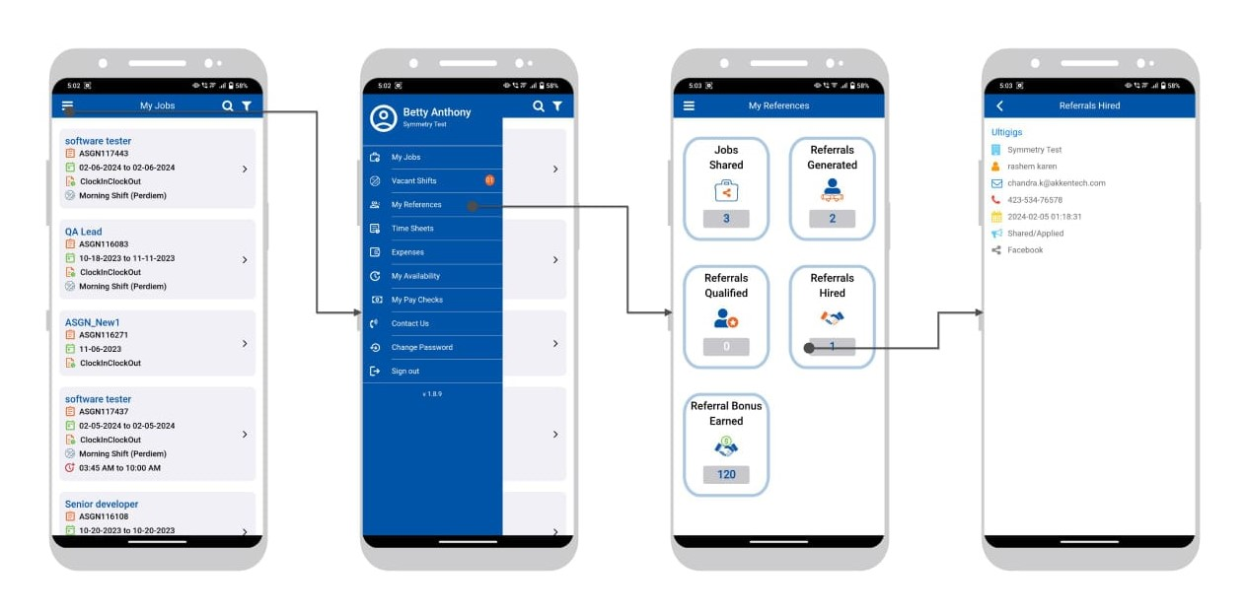

Referral Bonus Earned
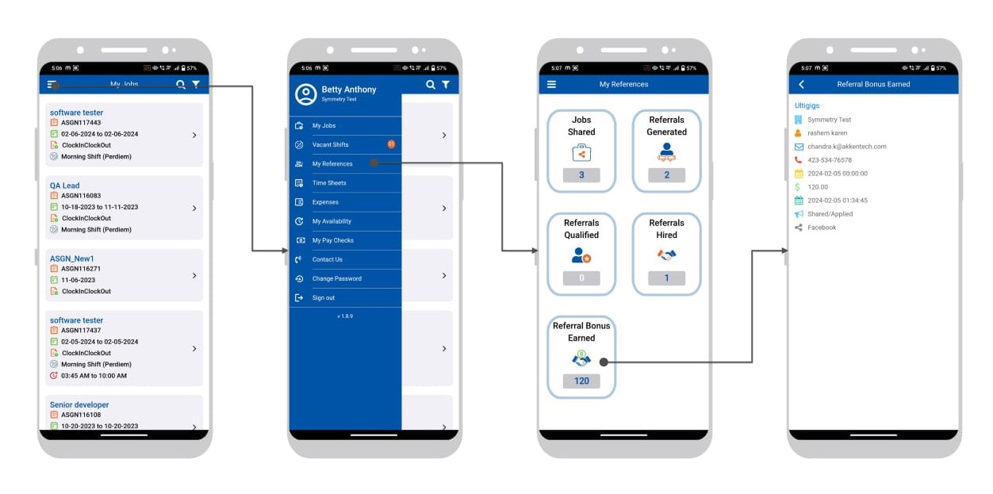

Timesheets → Create New

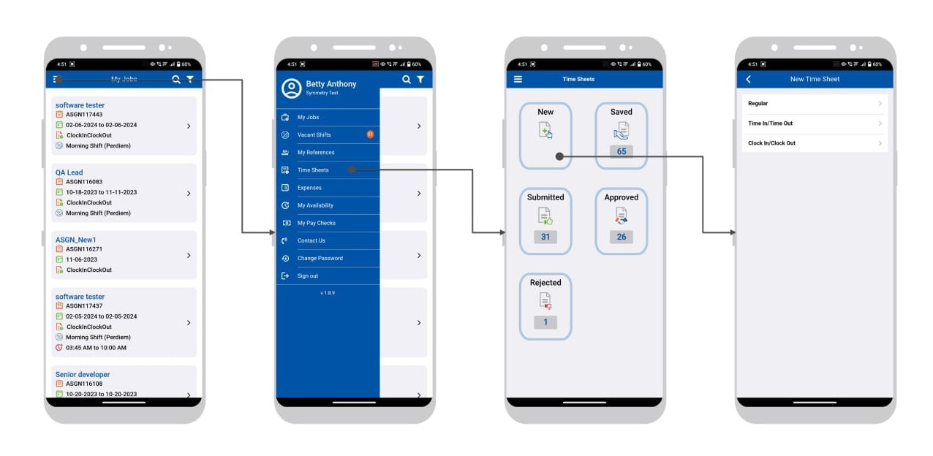

Regular Timesheets
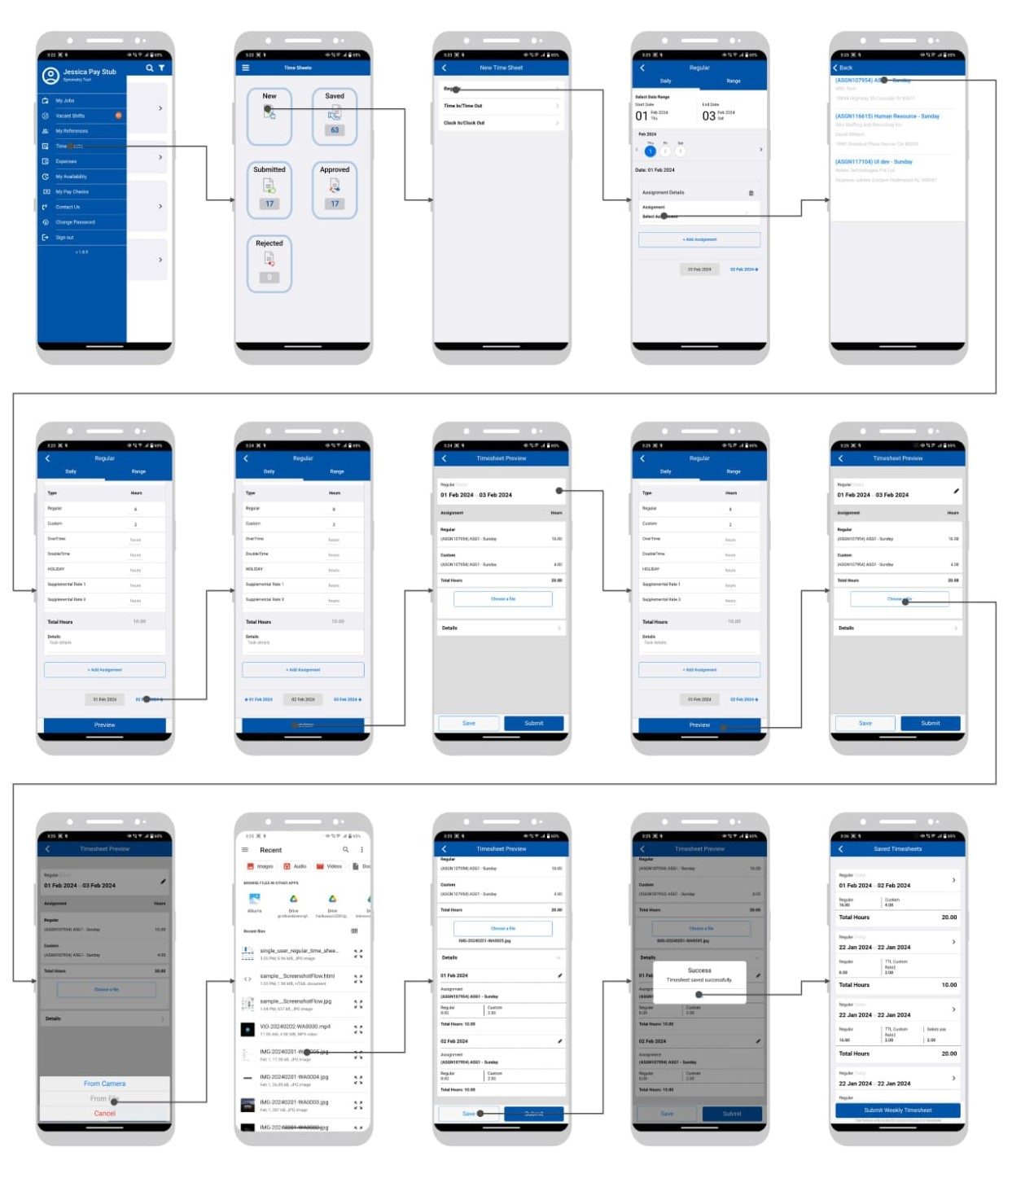
Saved Regular Timesheets Edit and Submit
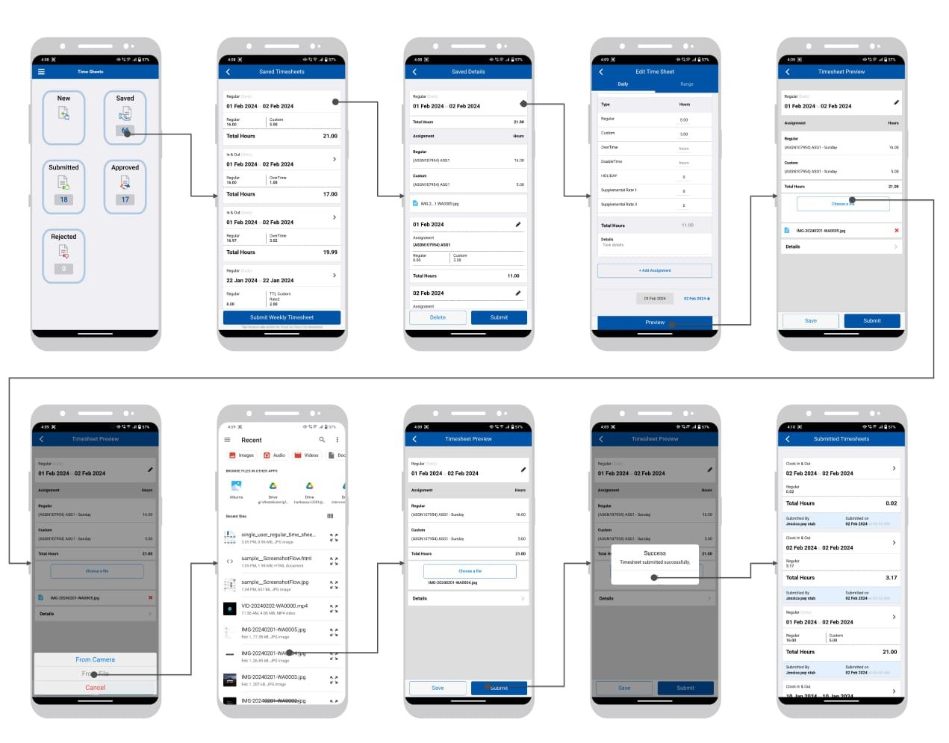

Time In / Time Out Timesheets
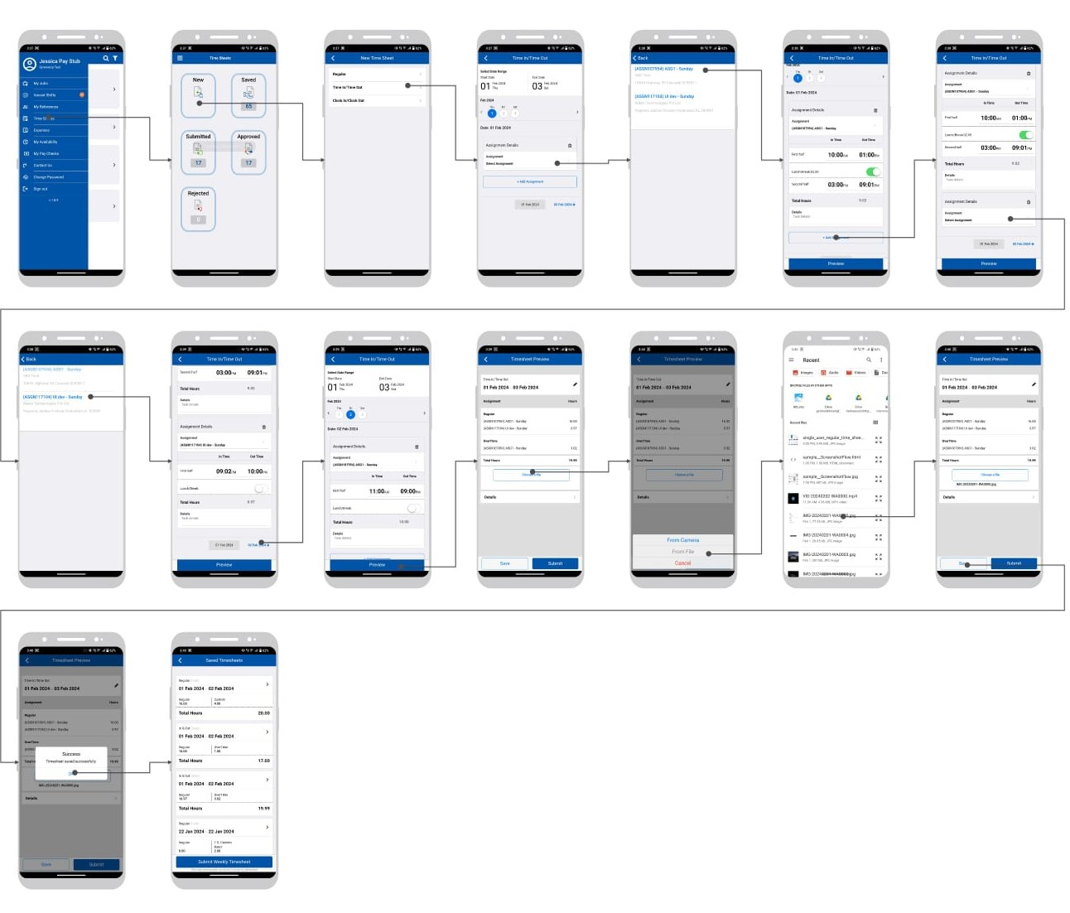

Clock In Clock Out Timesheets
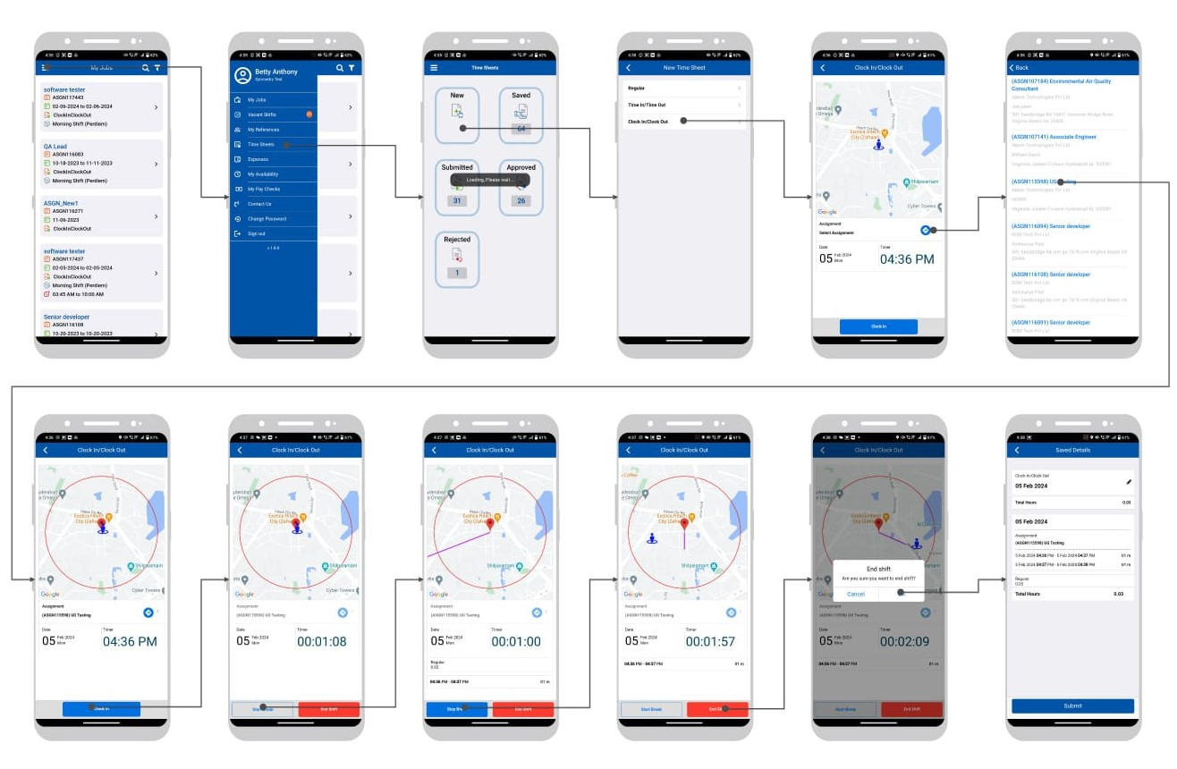

CICO alert if user not at the available in Assignment Location
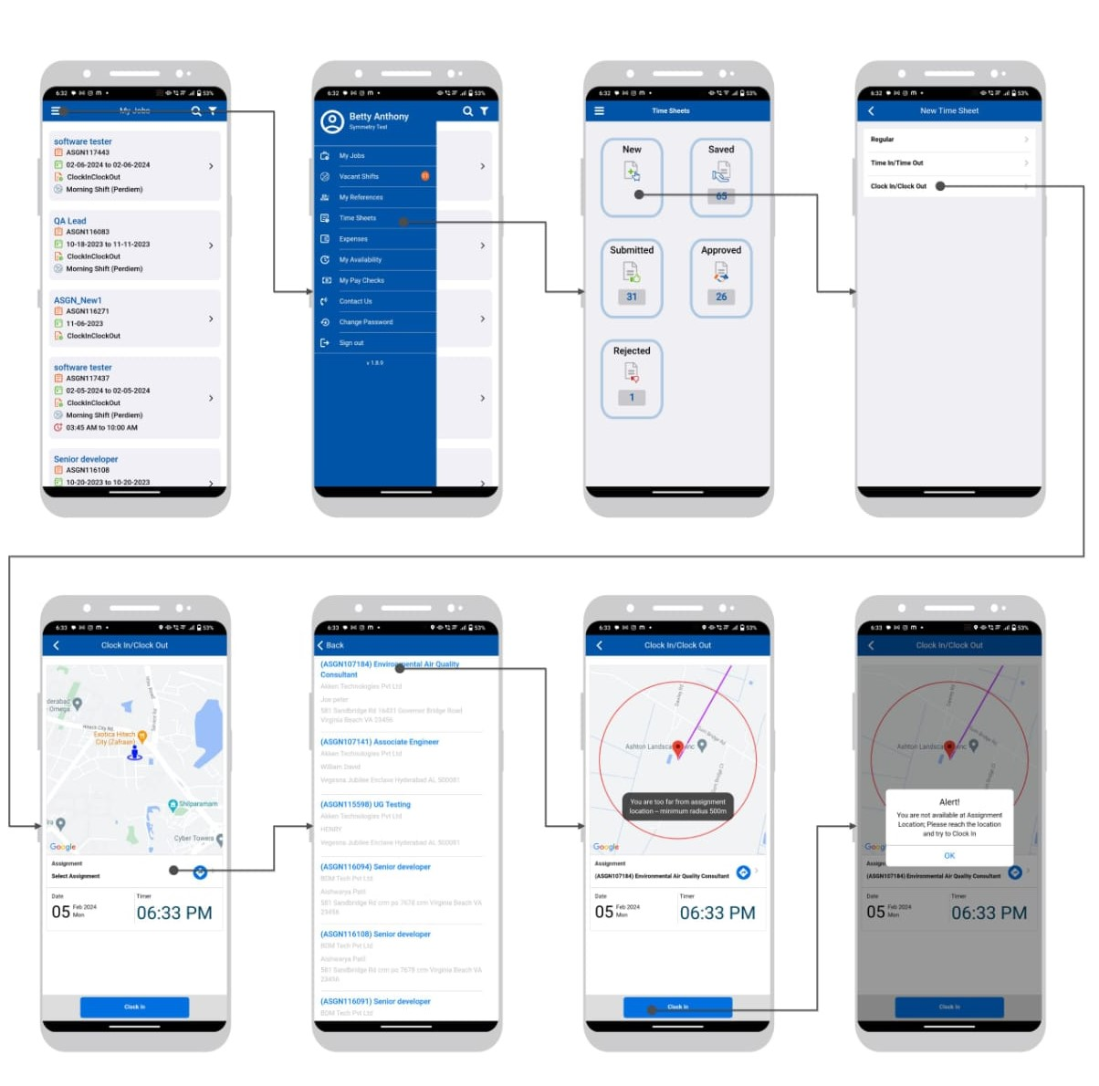

Submitted Grid List and Detailed Timesheets
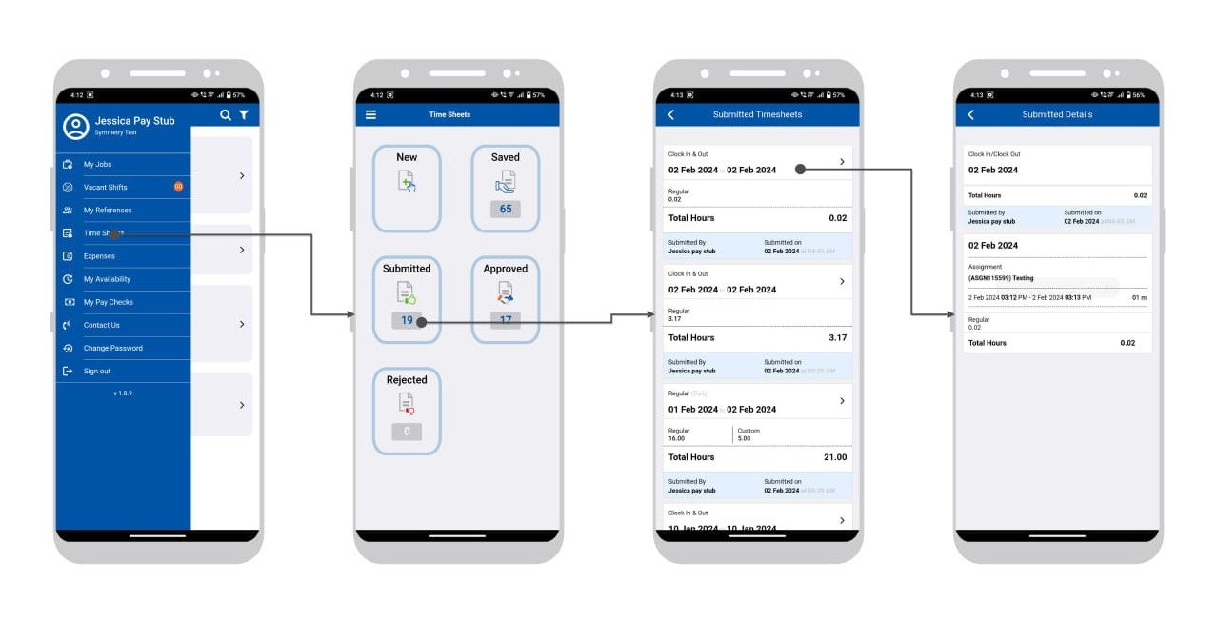

Approved Grid List and Details
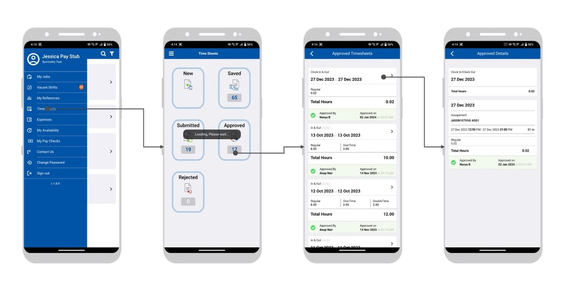

Rejected Grid and Details
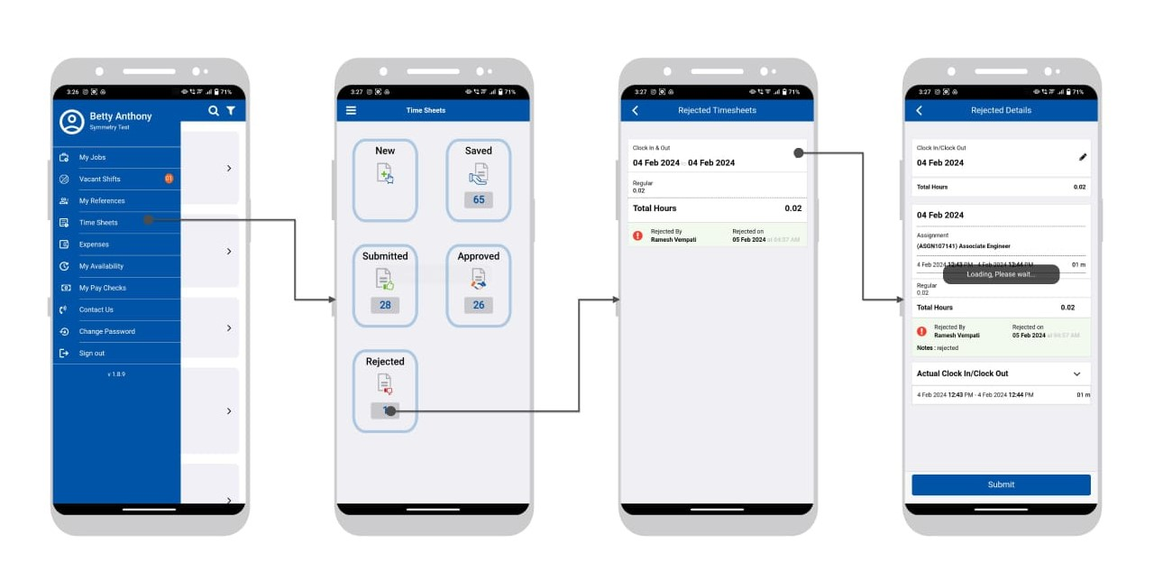

Submit Weekly CICO time sheet
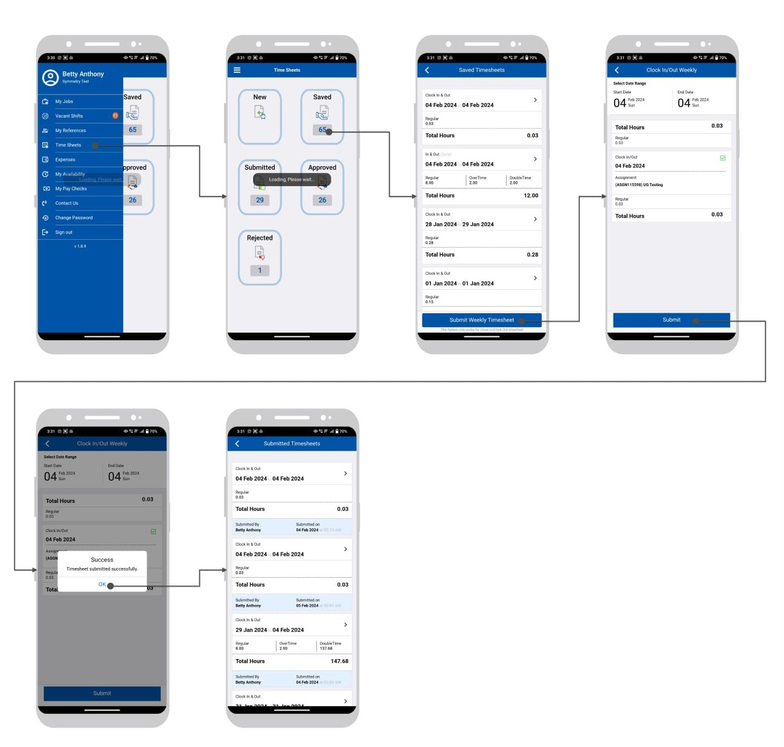

Expenses → New expenses
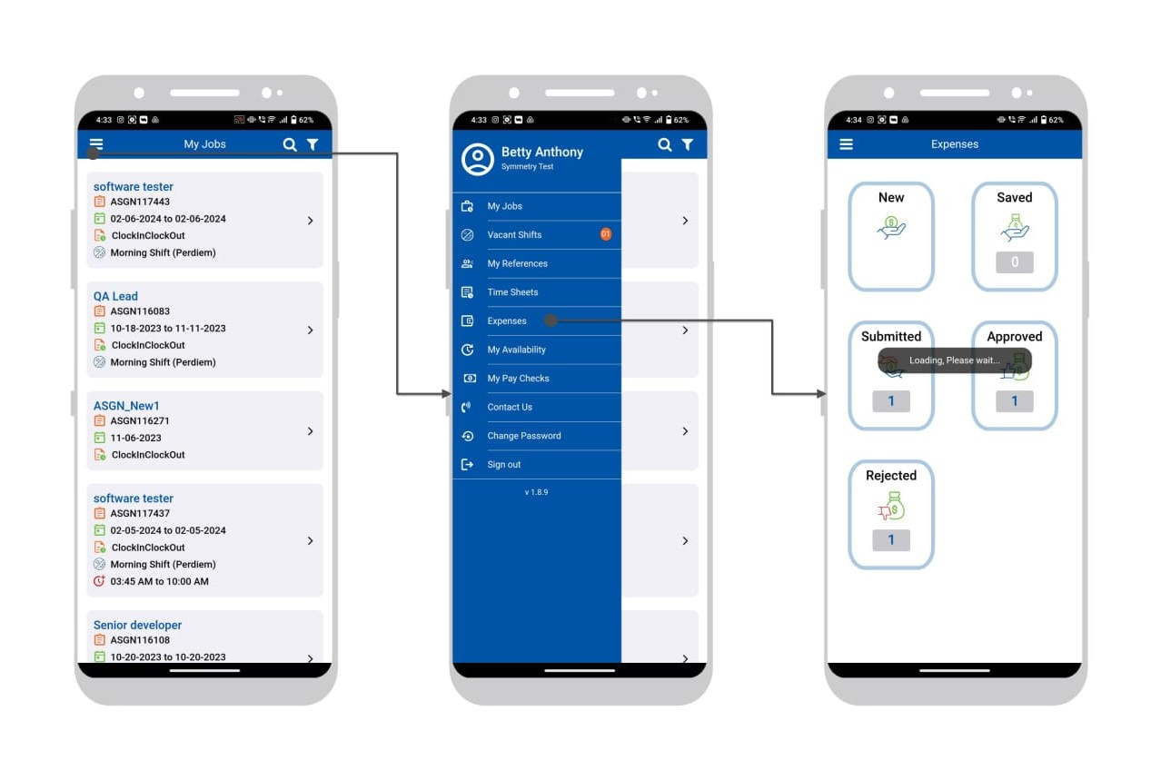

New Expenses with save.
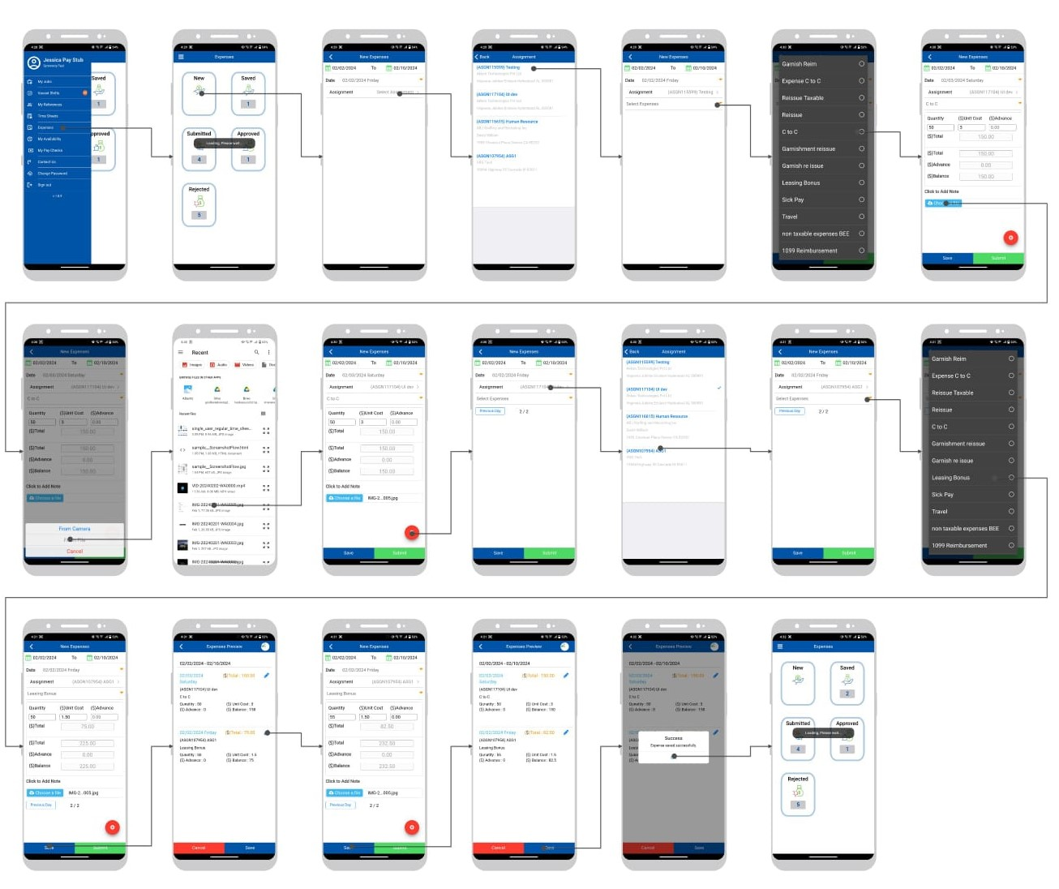

Saved Expenses with Edit and Submit
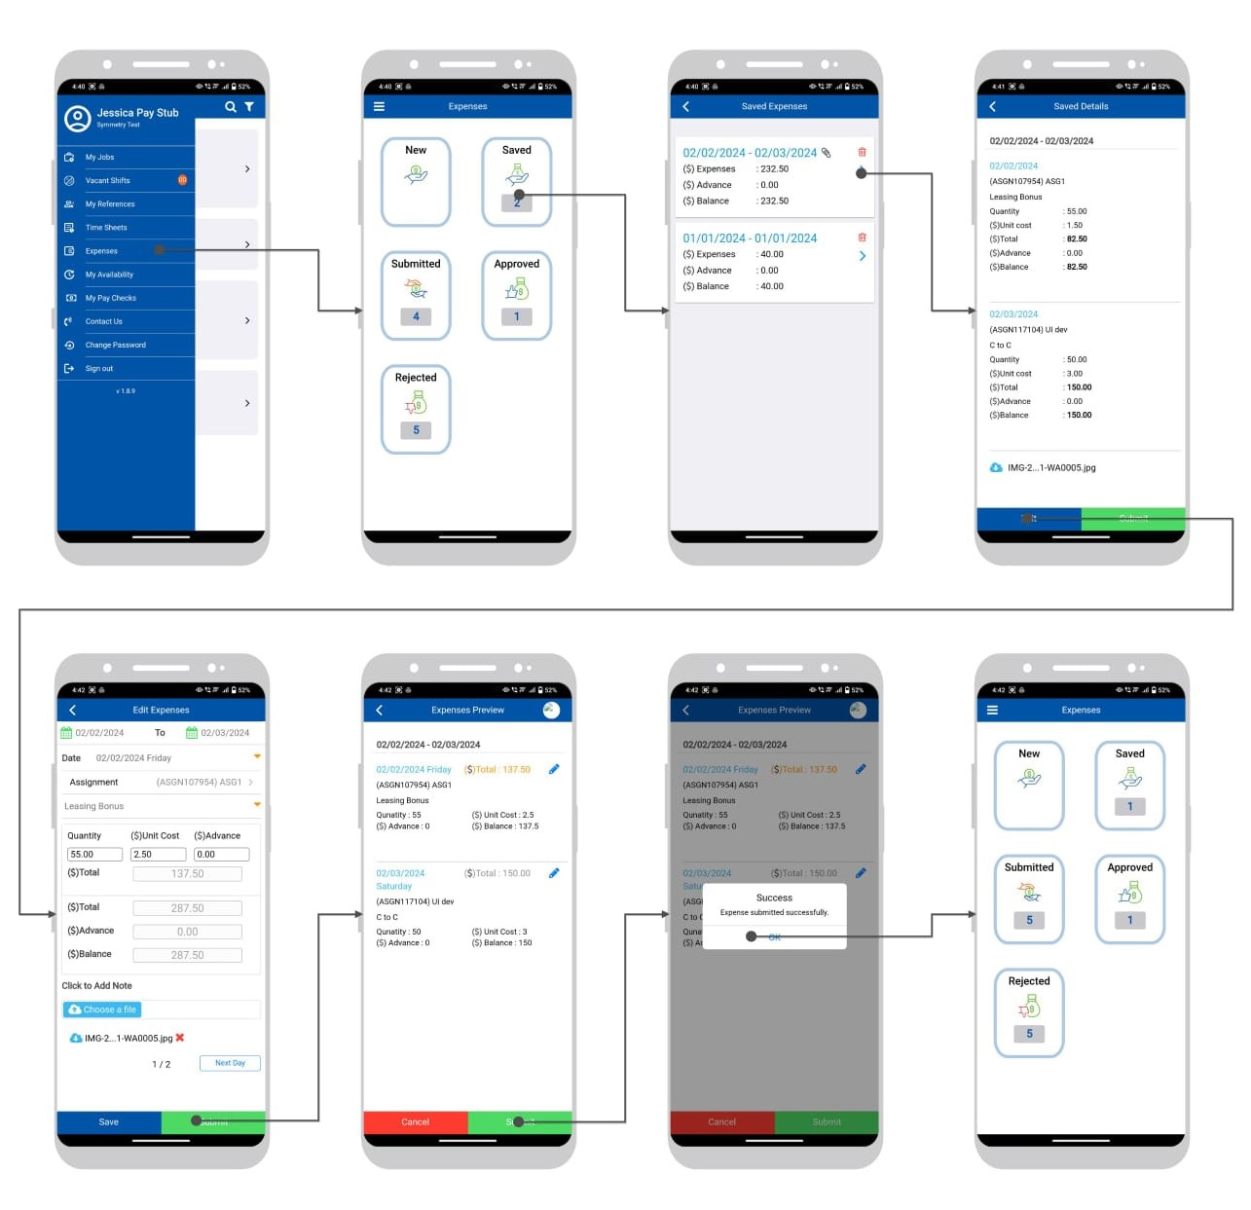

Submit expenses grid and details.

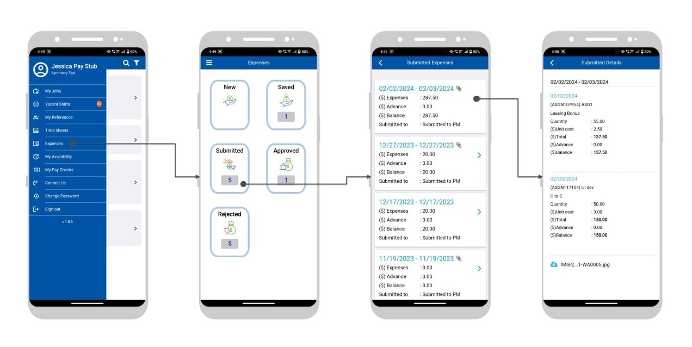

Approved Expenses and grid Details
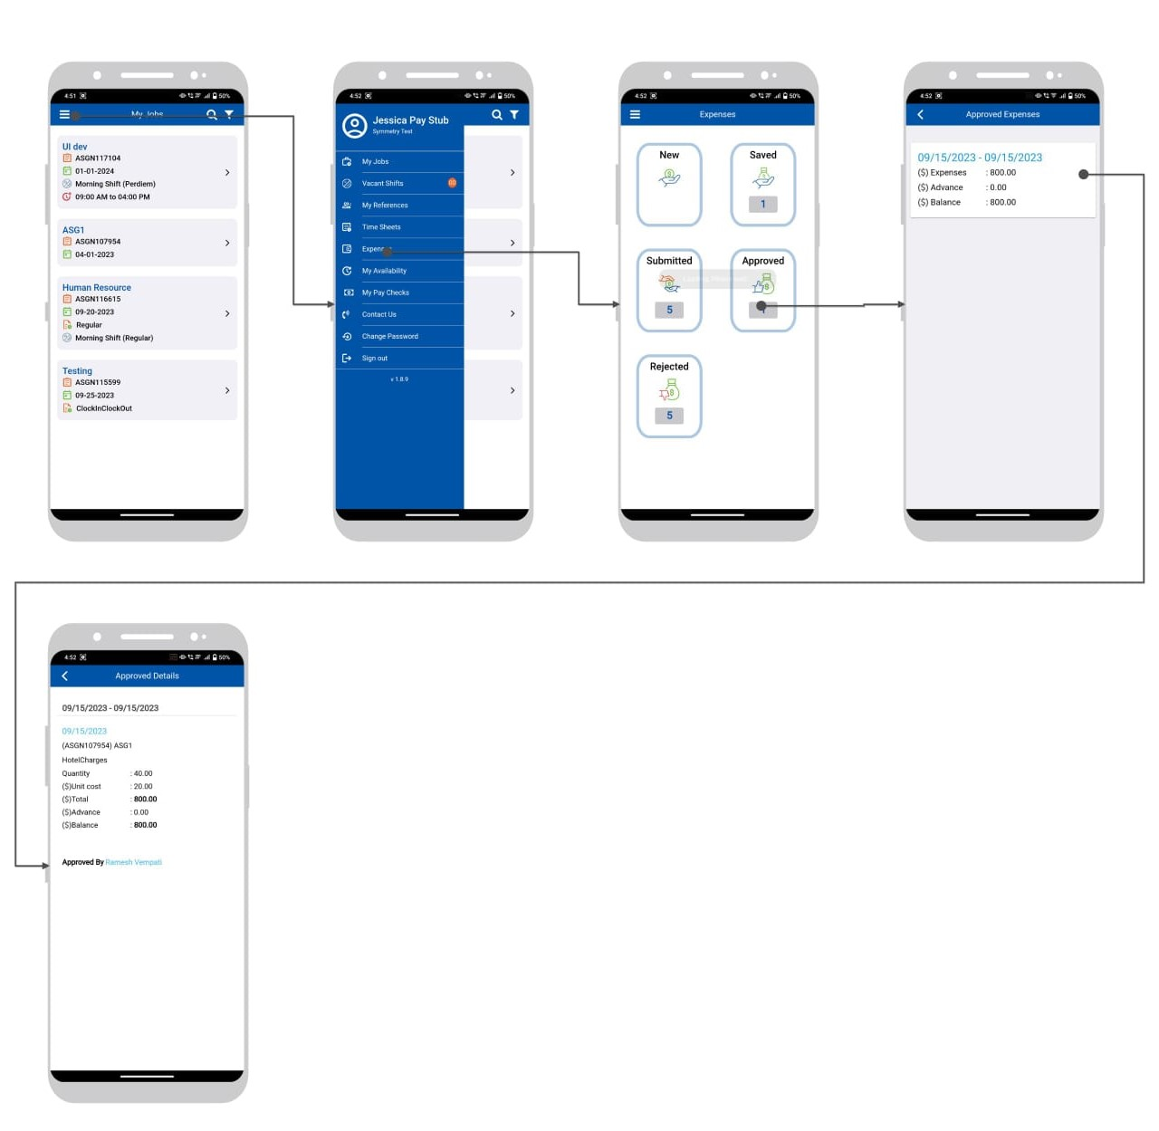

Rejected expenses and details.

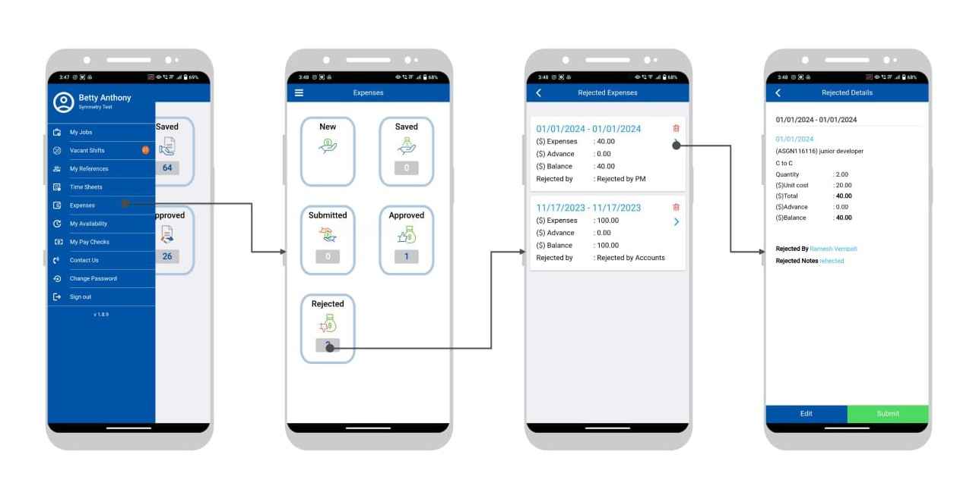

Rejected expenses with Submit.

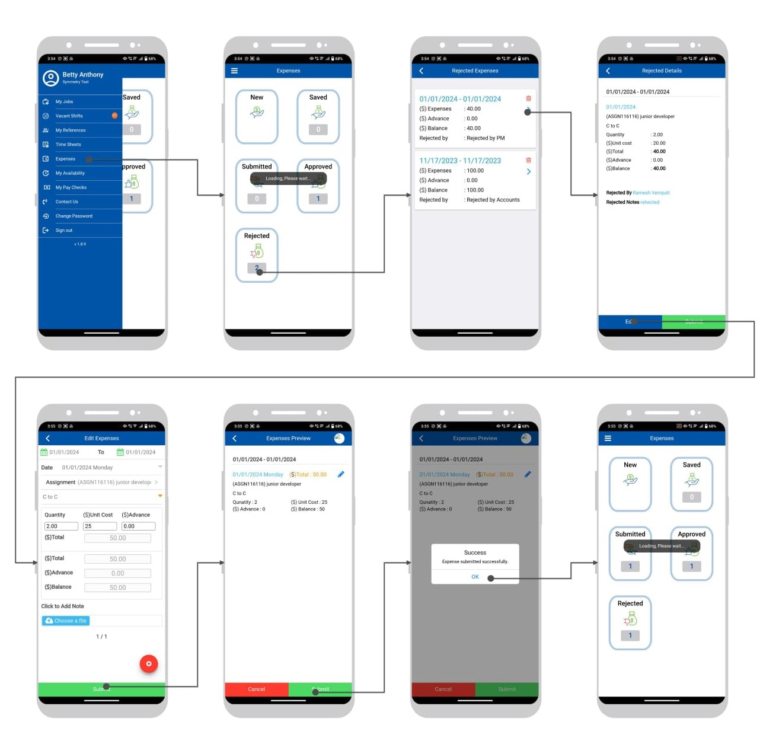

Rejected expenses with Delete.

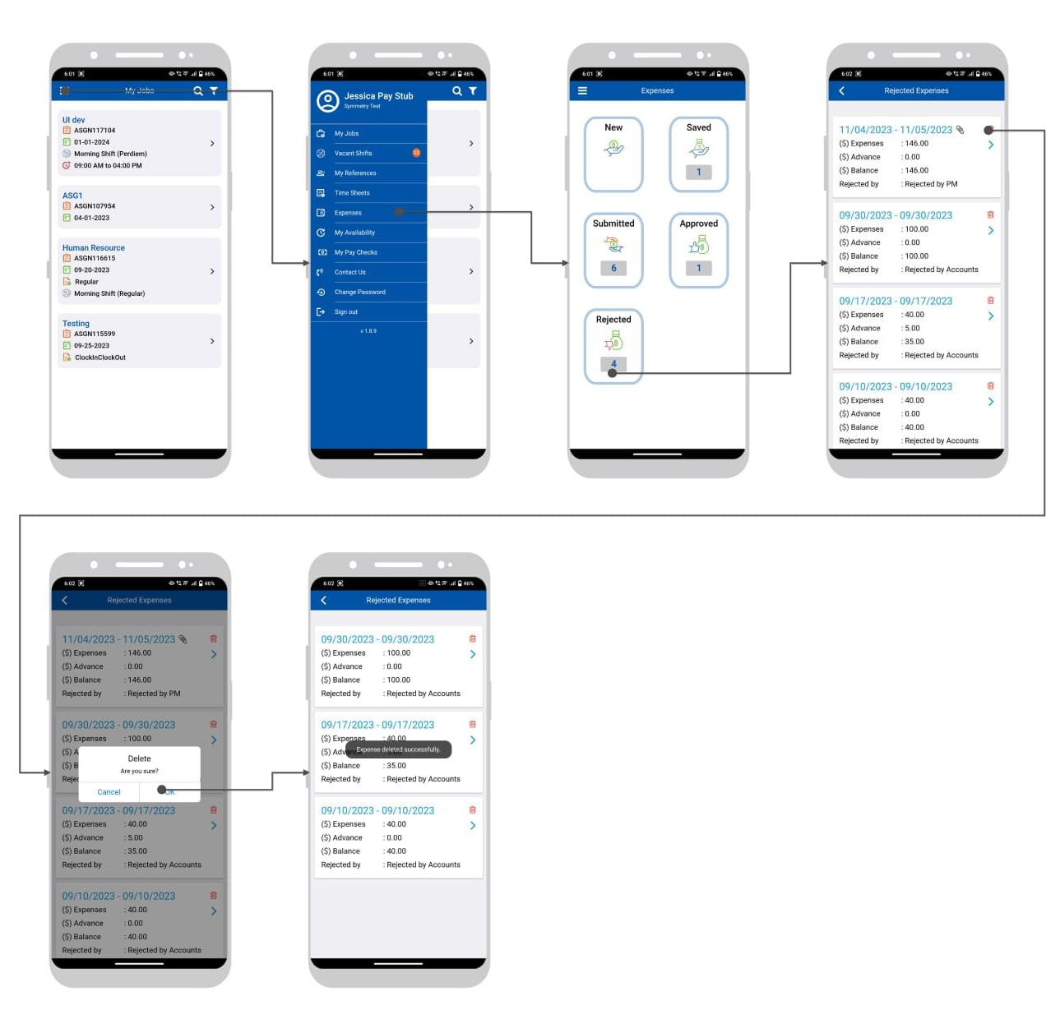

My Availability
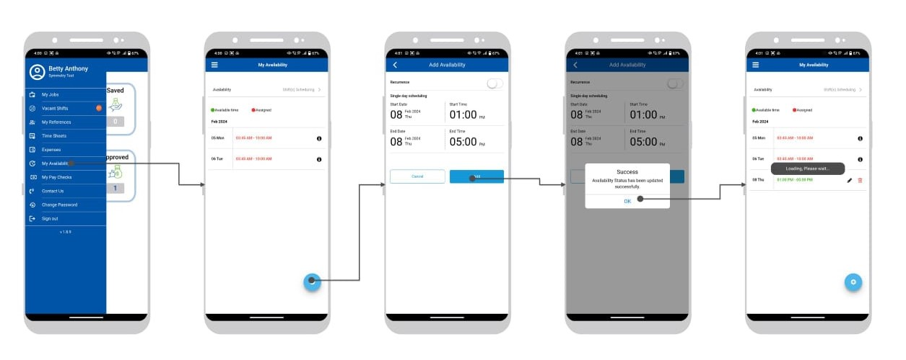

Change Password and Sign out and Sign In
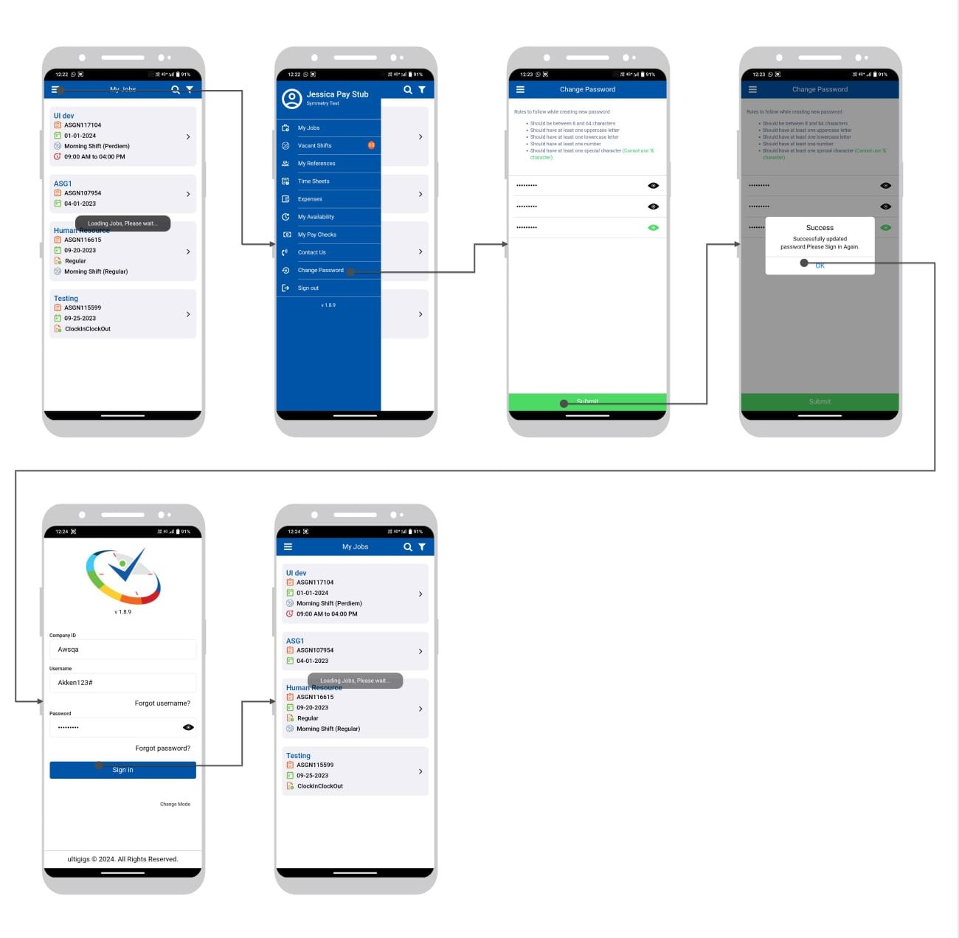

My Pay Checks
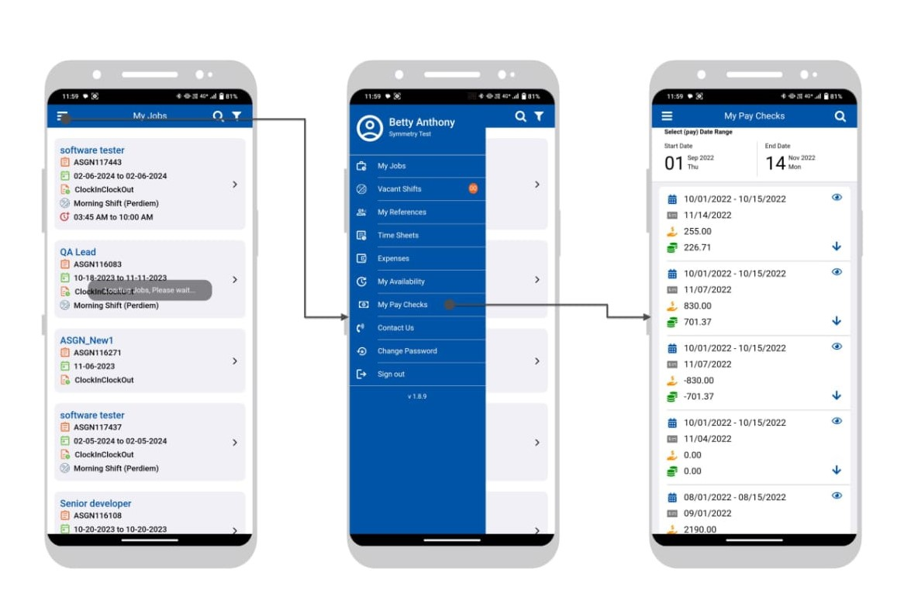

My Pay Checks File Seen
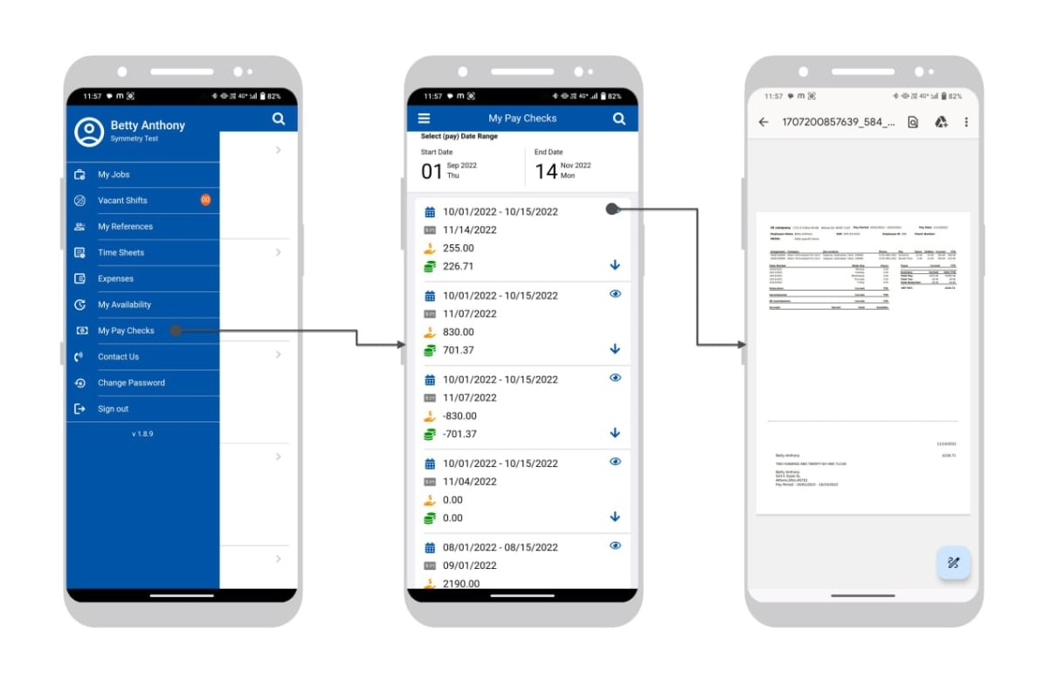

My Pay Checks File Download (Only Android you can view file in Downloads folder, iOS it will be in cache)
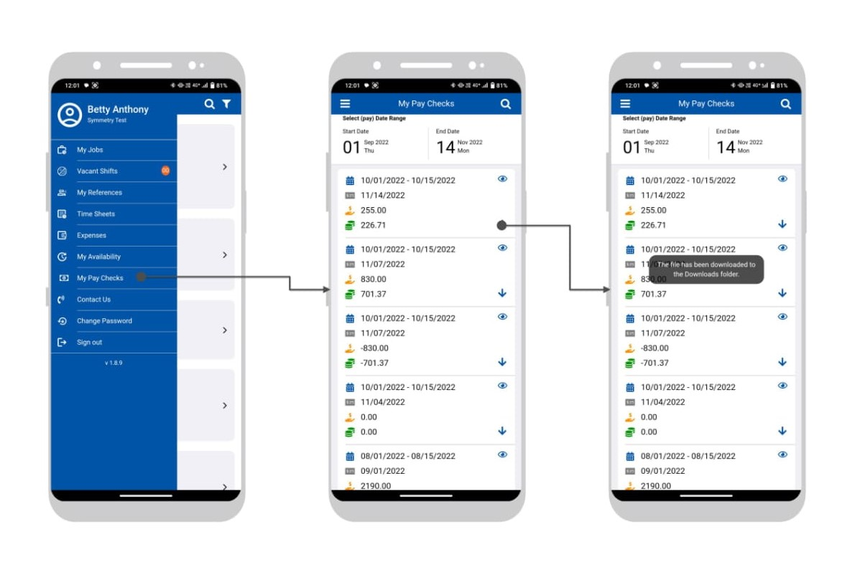

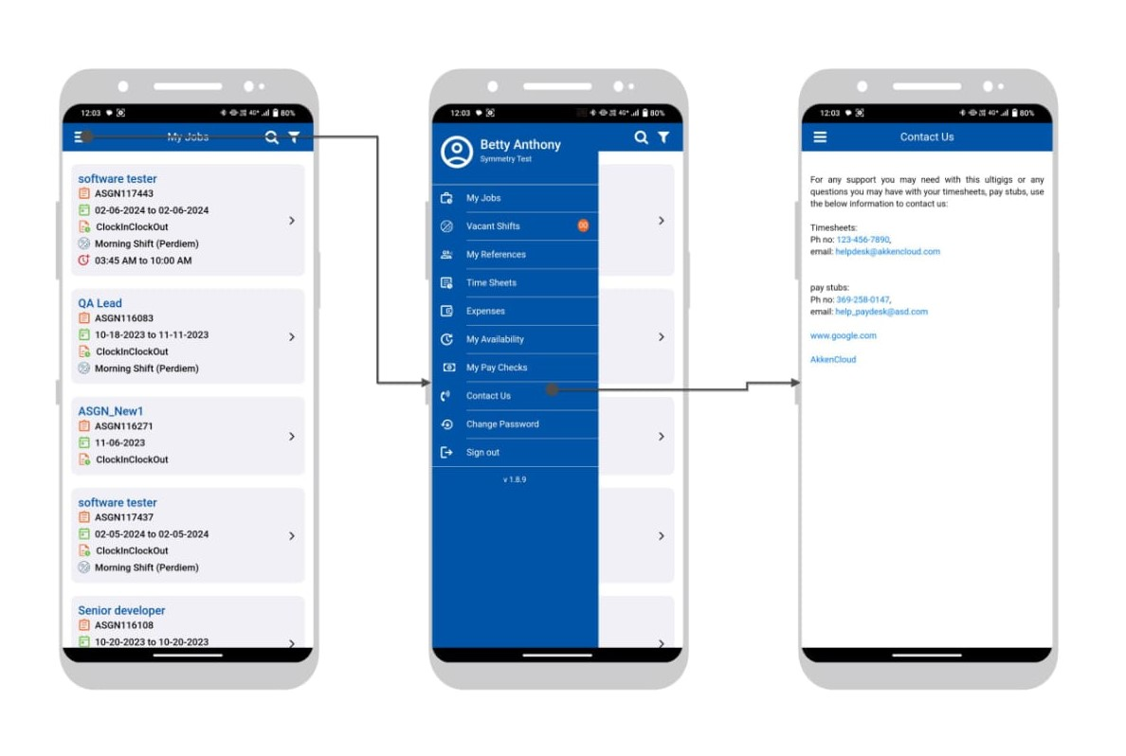
Contact Us Module
Contact Us Module -Call Number
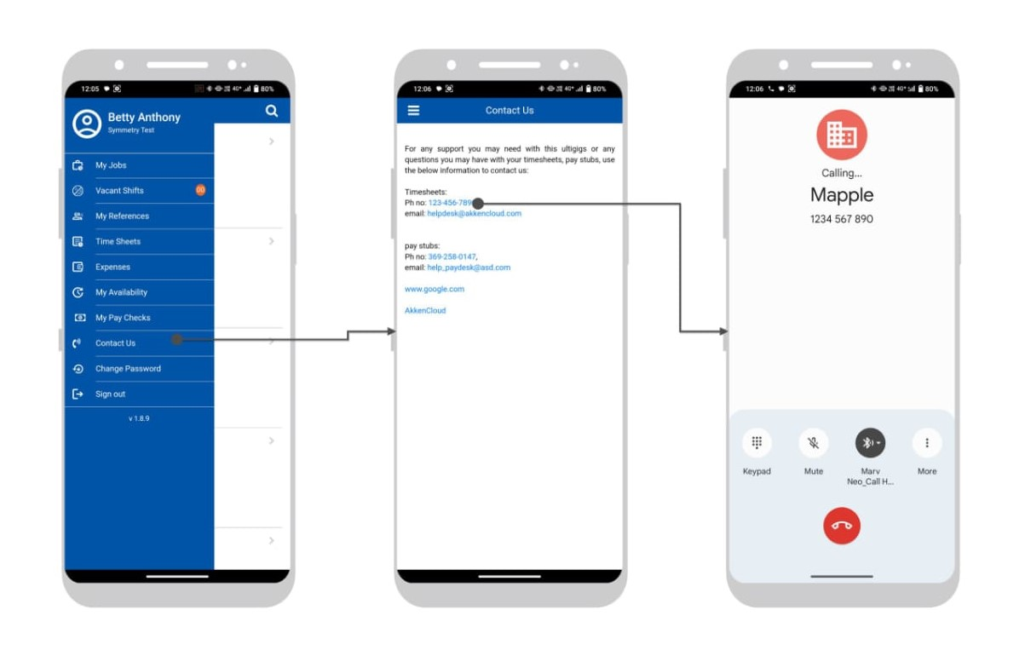
Contact Us Module -Email
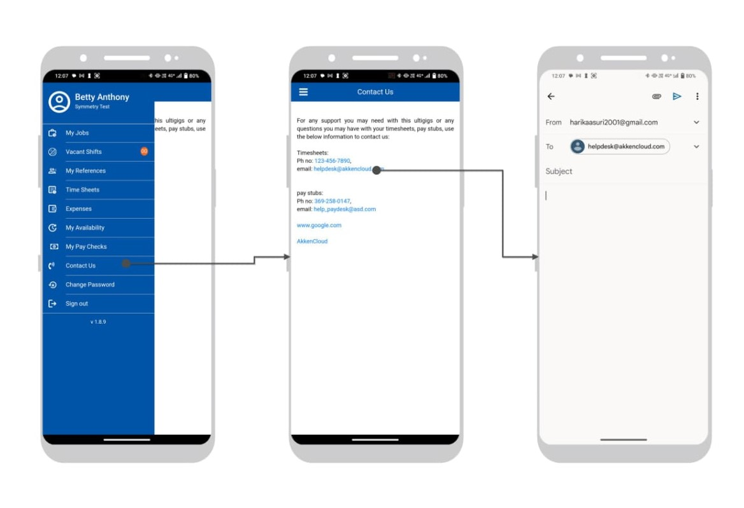

Contact Us Module -Web Site

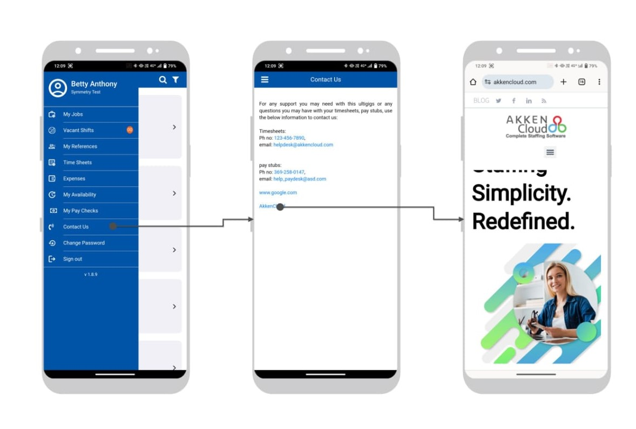

  - Time Clock Mode Sign In
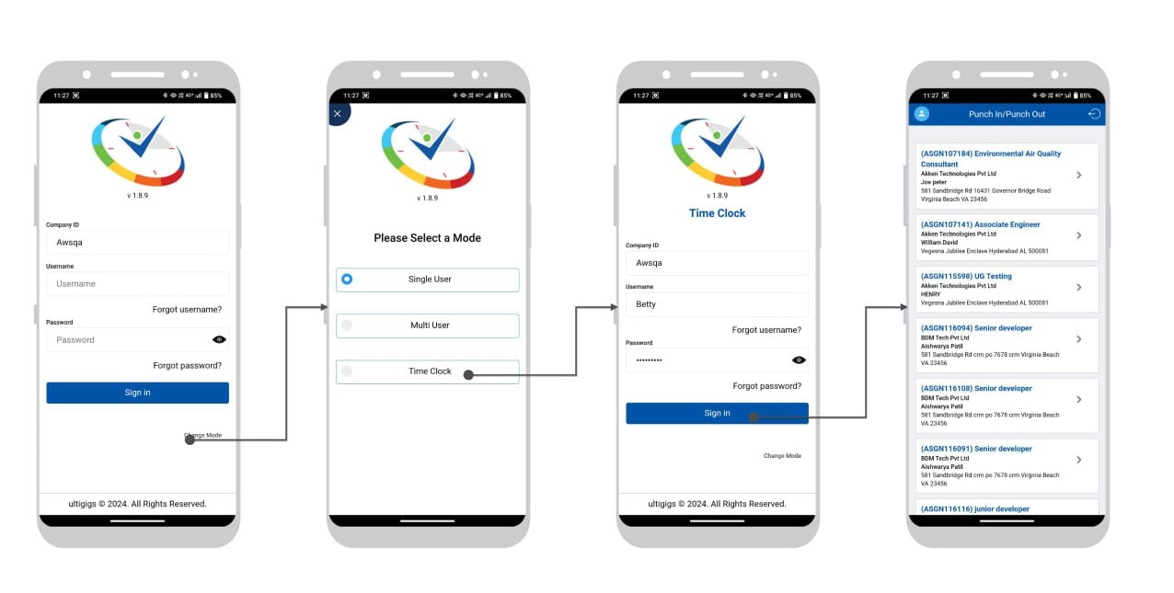
Forgot username
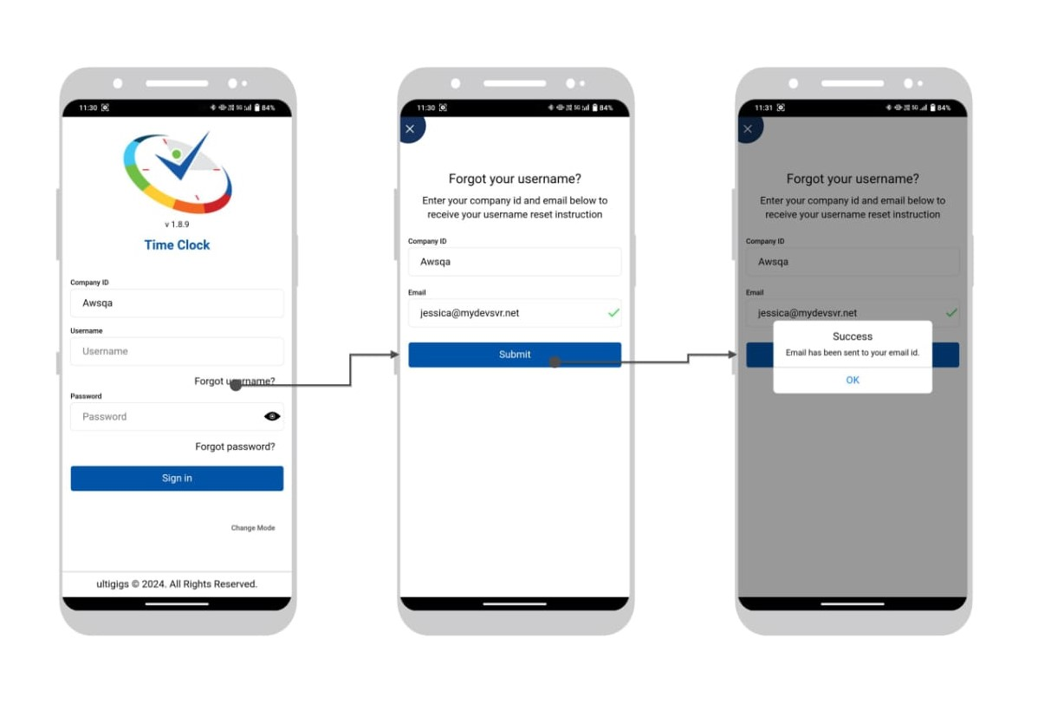

Forgot password
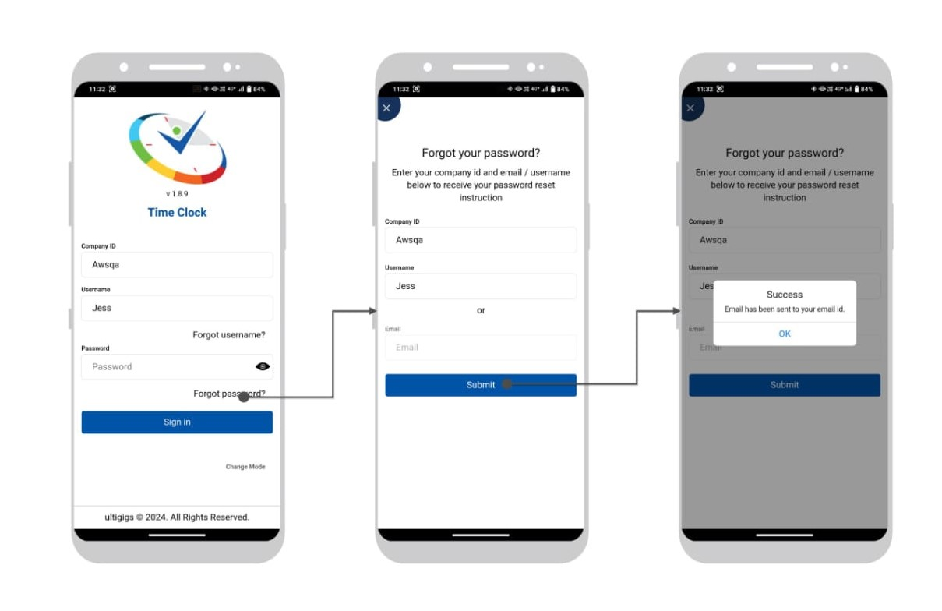

Punch In & Out Time Clock Mode
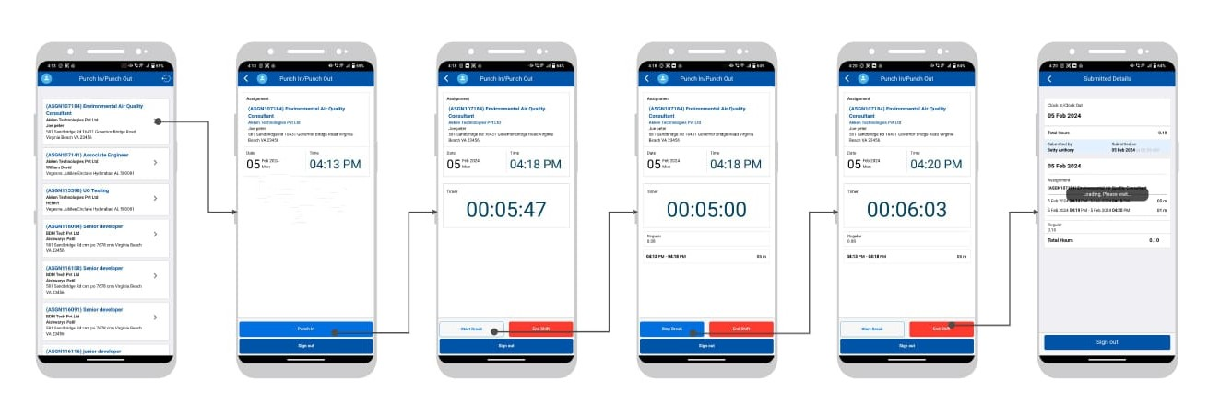

Multi-mode Sign in
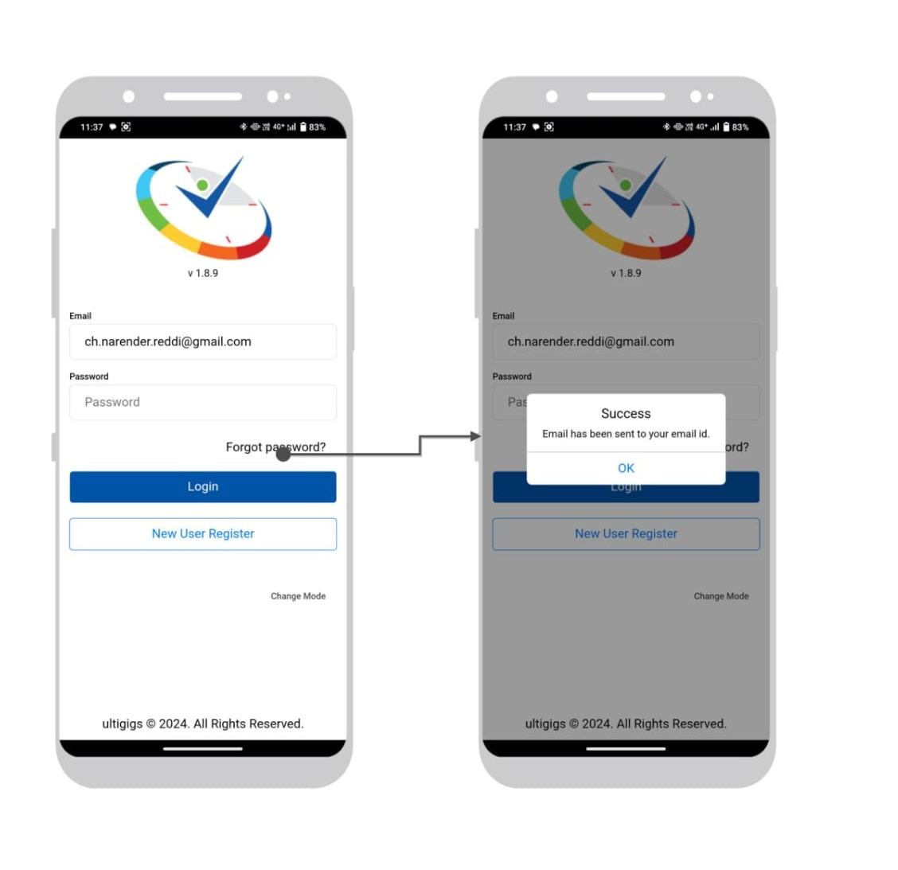

Multi-mode forgot Password
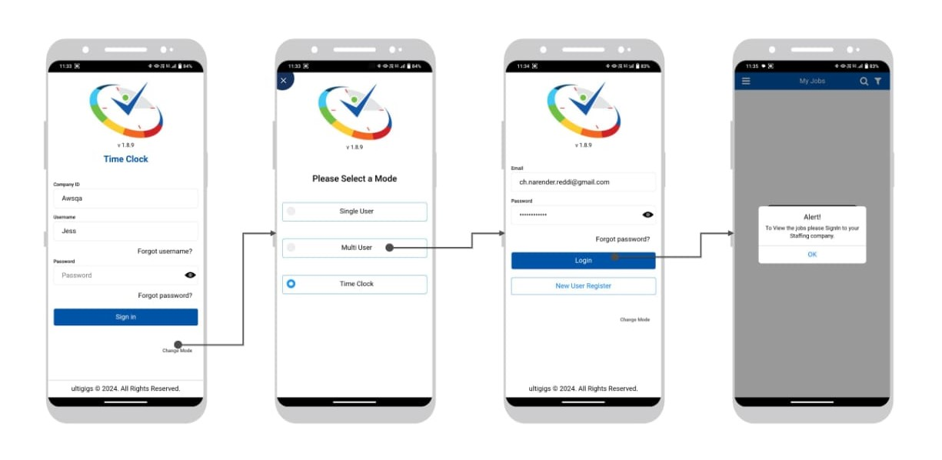

Clicking on Hamburger icon - Multi-user Login menu and sign in to Company – The logged in user’s Company will be displayed. (Email id should match)
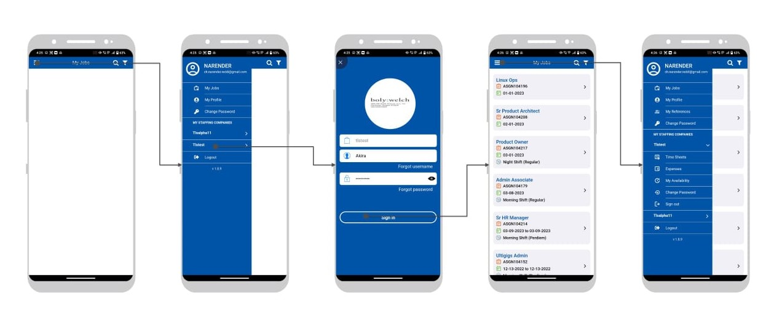

Multi-user mode new registration and activation Procedure

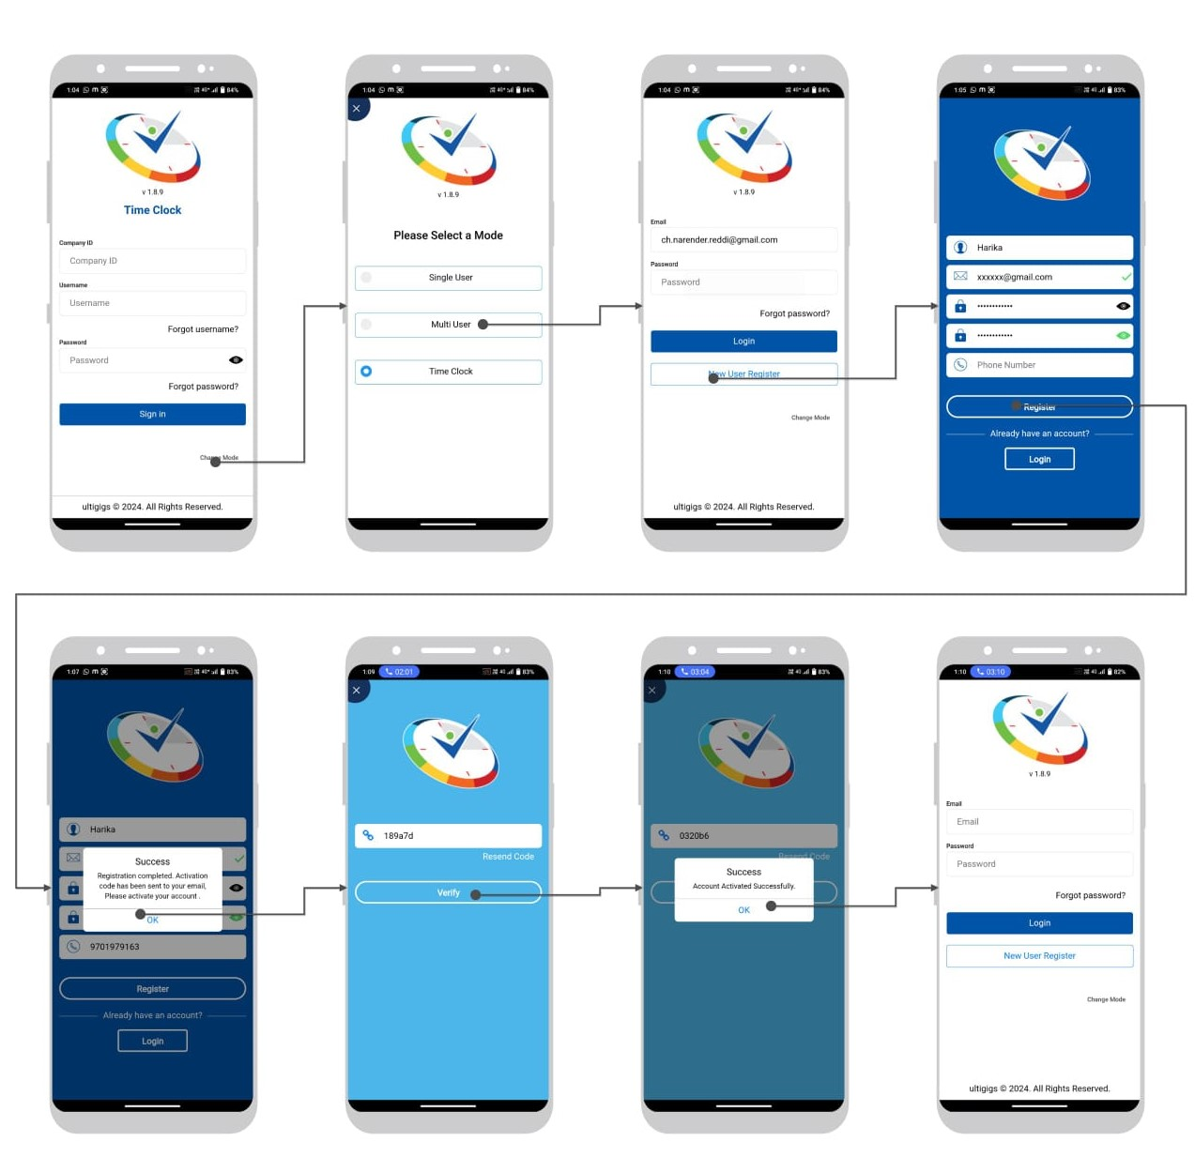

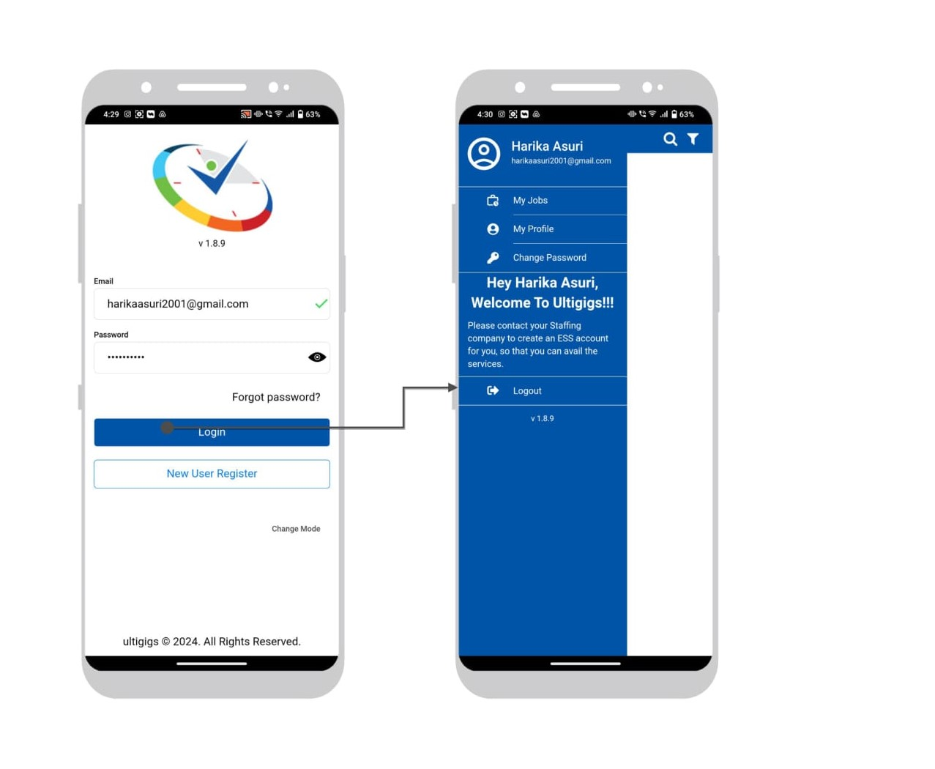
Multi-mode new user login – If email id doesn’t match below screen would be displayed.

Points to Remember

6.1 Single user Mode (Clock In Clock Out) -
- User should be available in the Geo fence (red circle in cico) then click on clock in.
- will work with Geo fence (Radius and auto clock out time is set Admin Payroll setup)
- If user closes the application or mobile is switched off or User Clocks In and internet connection or WiFi is lost -
  - Will wait for auto clock out time if not received any co-ordinates will do auto clock out.
- Will go into break if user moves out from the Geo location however it will wait for auto clock out time before going to break.
- Will go into break if Day is changed –
- User have to clock in again to keep the timer running.
- User will be Auto clocked out and timesheet will be in Saved Mode for below scenarios.
  - If user out of the geofence.
  - If user has no network or GPS turns off
- Once User clock In will update the Clock In time in server and Applicant user can track in Web application (Time sheets => Clock In/Out Dashboard)

Time Clock Mode (Punch In Punch Out)
- Geo fence not used in Time Clock mode
- User must Sign in and will navigates to Assignment page
- User can sign out once clocked in – Timer will run in background.
- User can sign in again and take break and sign-out– The time would be captured and timesheet will be in Saved status.
- User can sign in again and clock out – The clocked-out time would be captured, and timesheet will be submitted.
- Once User clock In will update the Clock In time in server and Applicant user can track in Web application (Time sheets => Clock In/Out Dashboard)

*************************

