Invoices:
AccountingCustomers:
The first section that you will see looks like a chart of accounts. The system will keep track of all outstanding invoices, how many days overdue they are and what their current balance is. This will only remain current if they 'Receive Payments' in Akken. Explain this chart.
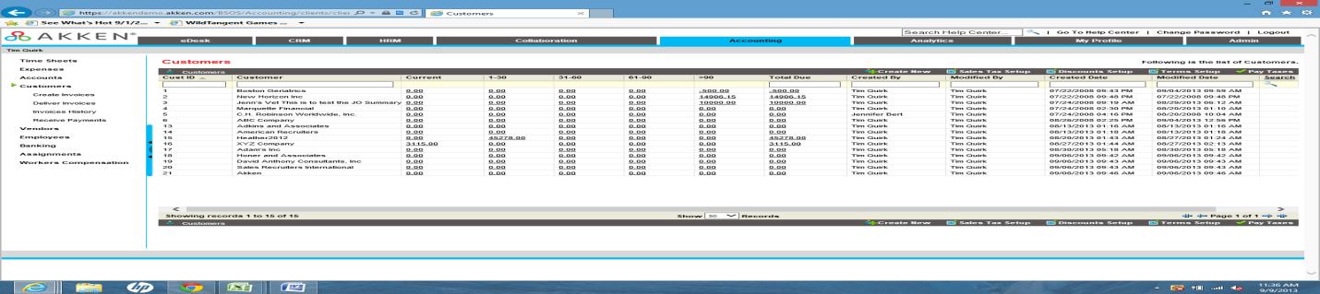
CUSTOMER RECORDS: (Double click on a customer in the chart of accounts to pull up and display a customer 'accounting' record) Scroll down to 'Billing Information"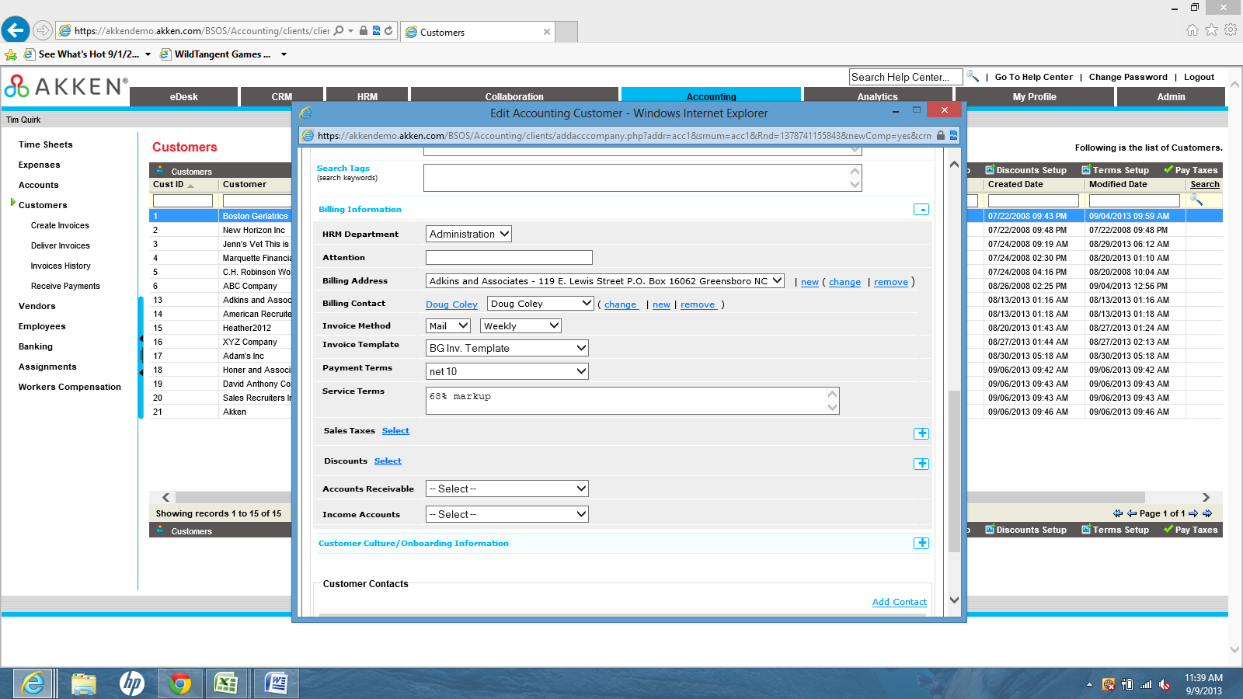
It is very important that the billing information section is filled out for each accounting customer. Our invoicing module pulls info from this customer record. It is imperative that the customer billing address and billing contact are filled in and if the customer has sales tax or discount structures associated with them, those need to be selected and populated on the record. Once everything has been filled in, be sure to click 'update' so the information is saved.
CREATE INVOICES:
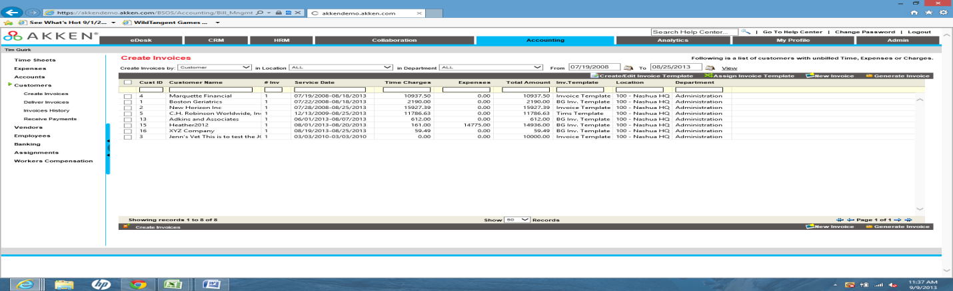
This screen displays the invoices that have not yet but generated but have been created by the system based on approved time sheets. As you can see from the chart, the system will push approved time and expense charges against the appropriate customer listed on the assignment record.
Prior to generating invoices in Akken, you should create and invoice template. Some customers will create these templates per client but others will create a default template that can be used for every generated invoice. (Click 'Create/Edit Invoice Template and then click 'New')
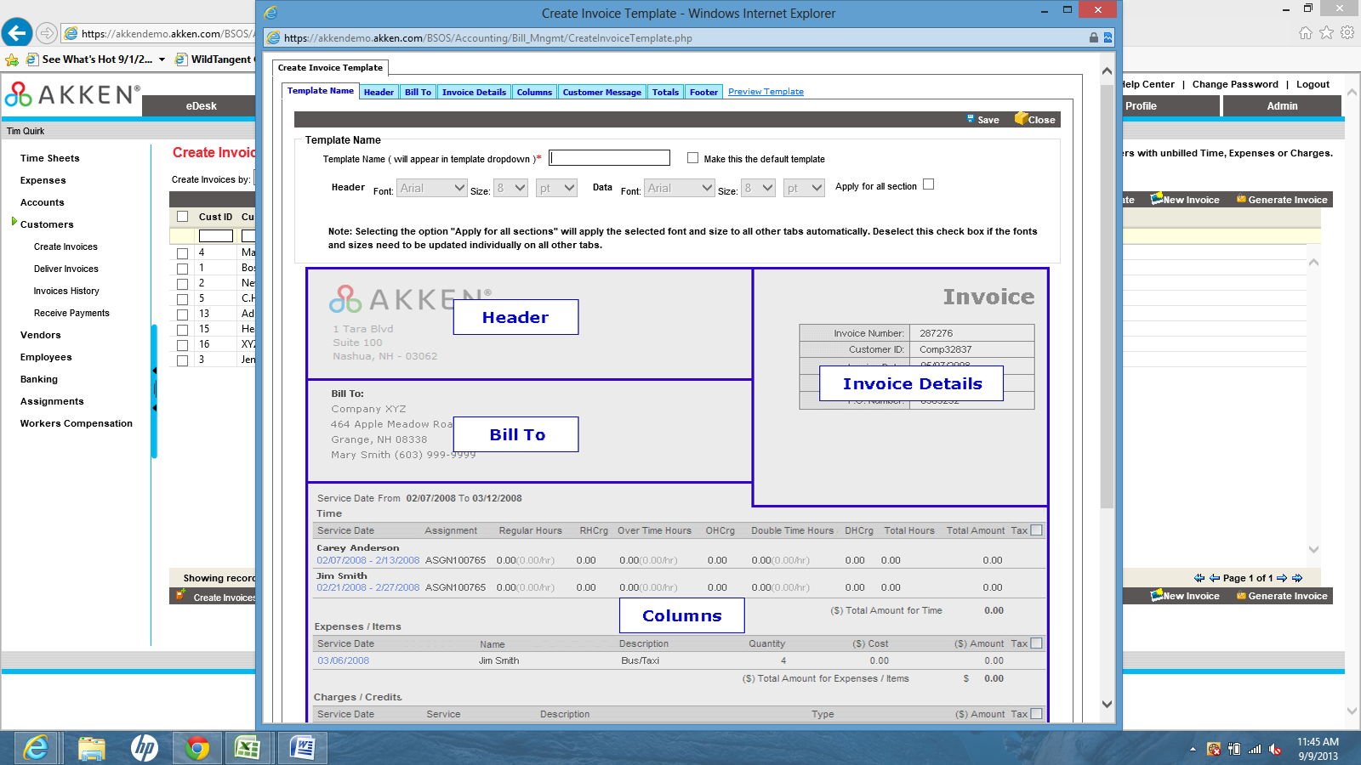
The layout of the info that you are seeing here cannot be changed. However, the info contained within each section can be configured. (Give the template a name and start moving through the tabs)
Header: These have to be created but the logo that you upload in the Admin tab will populate here automatically.
Bill To: The info selected in this section will pull from the Accounting/Customer record.
Invoice Details: This info will pull from the assignment record and customer record. You also have the option to add custom fields to this section which will appear on the template as open text fields.
Columns: In this section you will choose what info you are billing the customer for; time, expense, charges and credits. If you do not reimburse for expense than you can leave this box unchecked so that the info does not appear on the template. You also have the option to add custom fields at this level as well.
Customer Message: Some clients will use this section to note a remit to address or to notify the customer of discounts for early payments or payment terms.
Totals: The system will calculate the total of the invoice based on your selections here. If you are charging sales tax, the system will automatically factor that into the total.
Once you save that invoice template it can be used prior to generating the invoice for your client.
Sort: You can change the sorting of the invoice details such as sorting by Last Name first.
(Go back into Create Invoices, Select and invoice by checking the box next to the customer name in the grid, Select Assign Invoice Template, and Select the Template you created from the list. After this is done, double click to open up the invoice to show the customer the contents. Then click generate.)
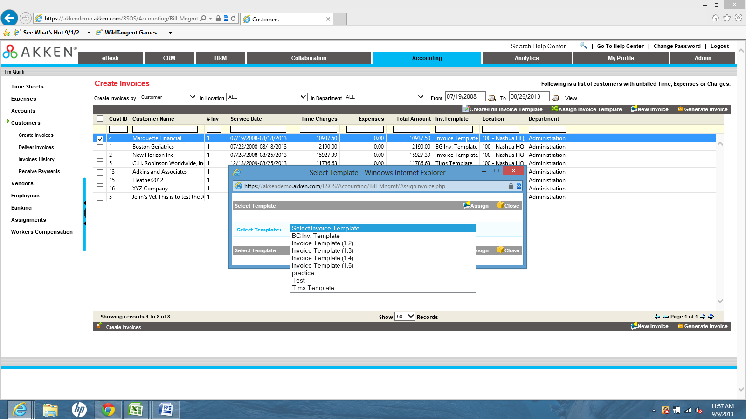
(Assign Invoice Template Screen shot)
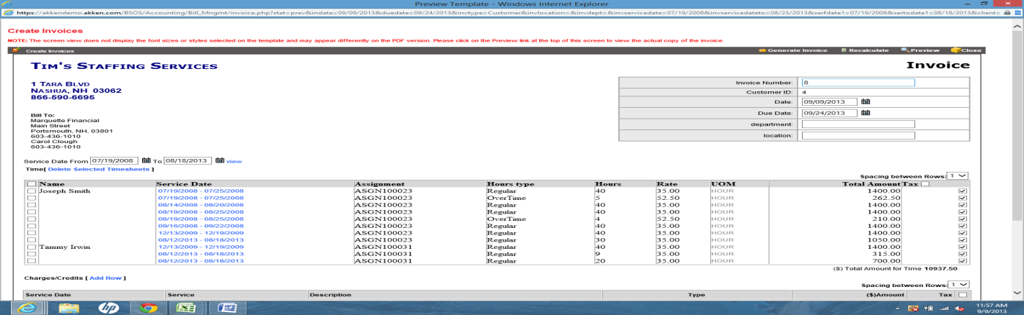
(Invoice prior to generation. Click Generate to push to Delivery Invoices.)
Once you click generate the invoice will fall into 'Deliver Invoices'. From here you will either export to a pdf or print or select the invoice to push into Invoices History. Invoices History is the section of Akken where you can email your invoices.
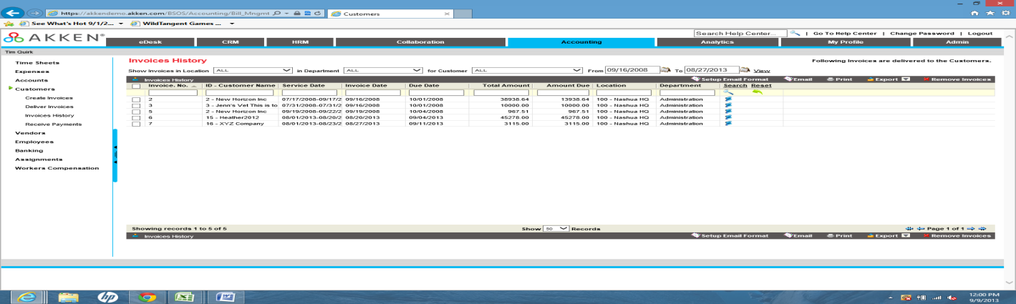
(Invoices History Screen shot)
(Select an Invoice and click 'Email')
The first option that you will need to determine is who you are going to be sending the invoice to. You have three options: You can send to yourself, to yourself and the customer, or just to the customer.
The second screen will ask what you wish to send. Keep in mind, invoices and time sheet attachments will go over as pdf attachments.
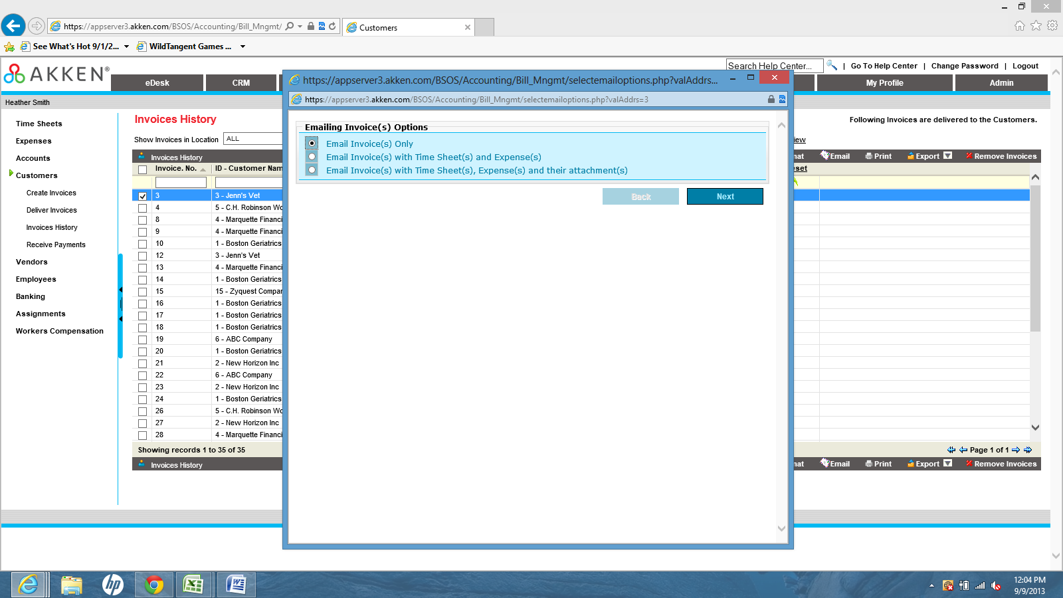
After you have made your selections, the system will pull up the email template that you created during setup.
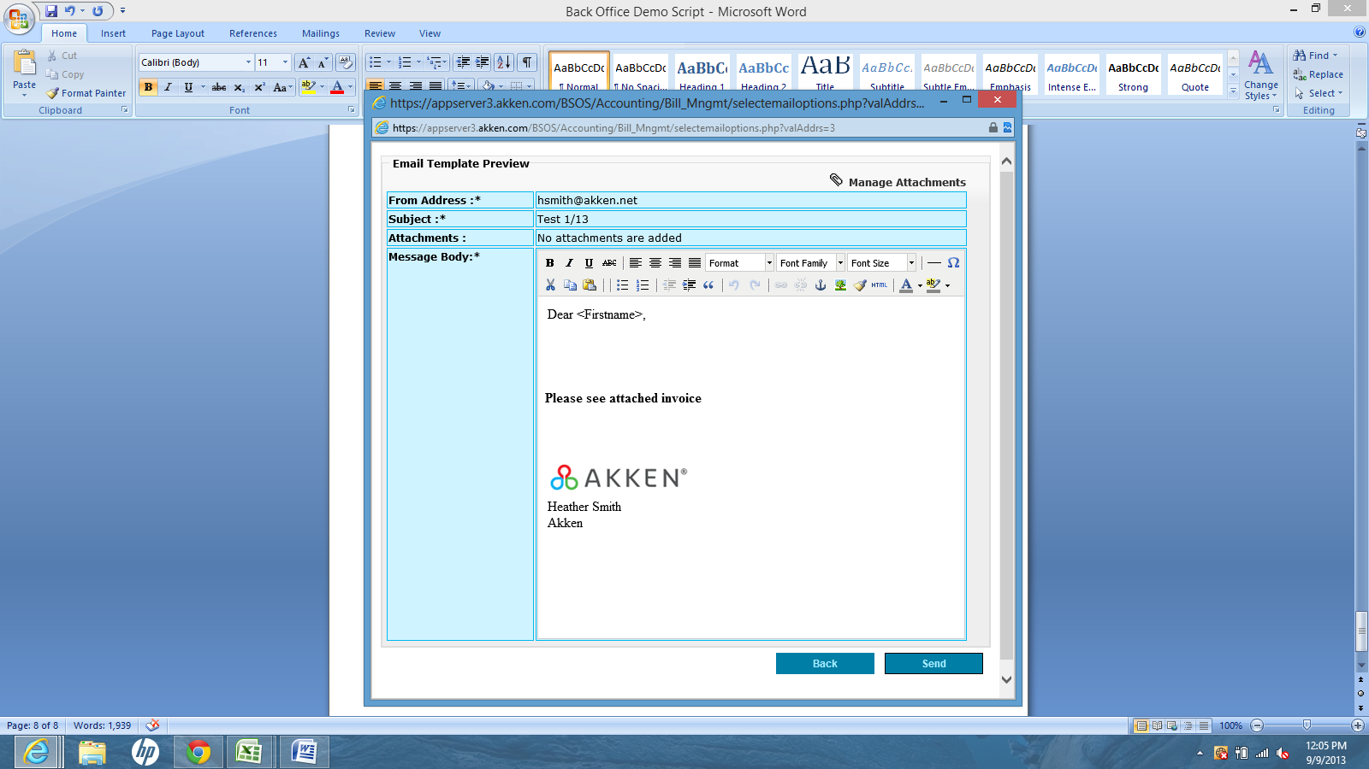
Once you click send the invoice will start processing and an email will be sent.

History of all transactions; emails, prints, and exports, will be kept in a log in Invoices History. The transactions will be date and time stamped with the users name that completed the activity.
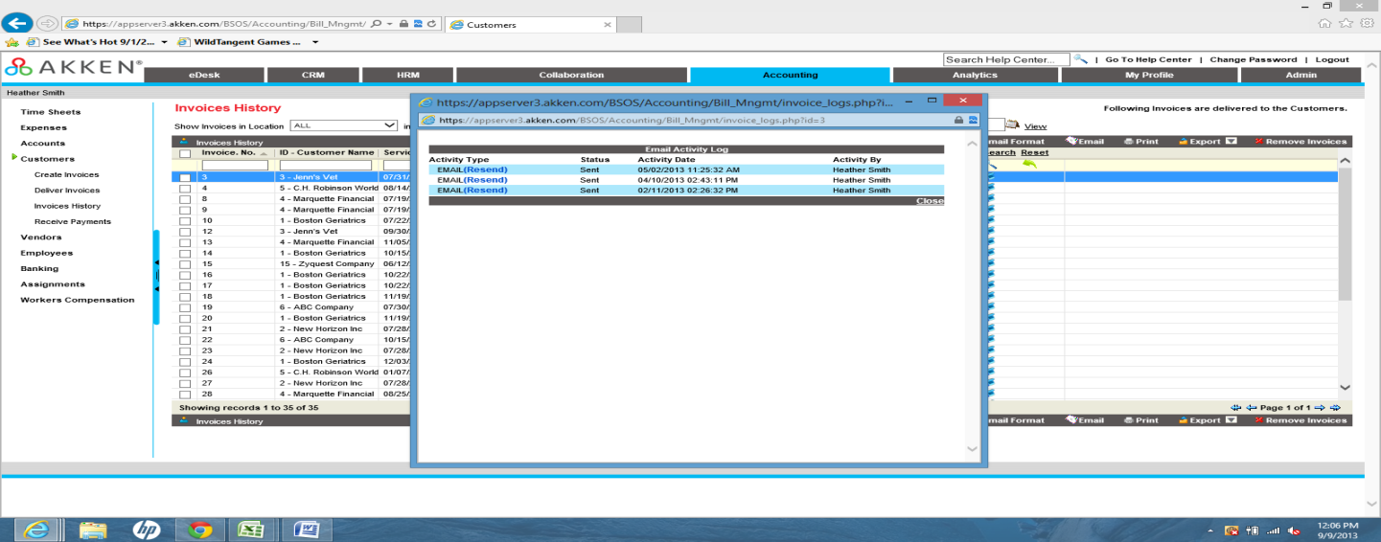
RECEIVE PAYMENTS:
You can receive payments in Akken although this is a manual process. You can select a customer, select the baking info, and all unpaid invoices will display.
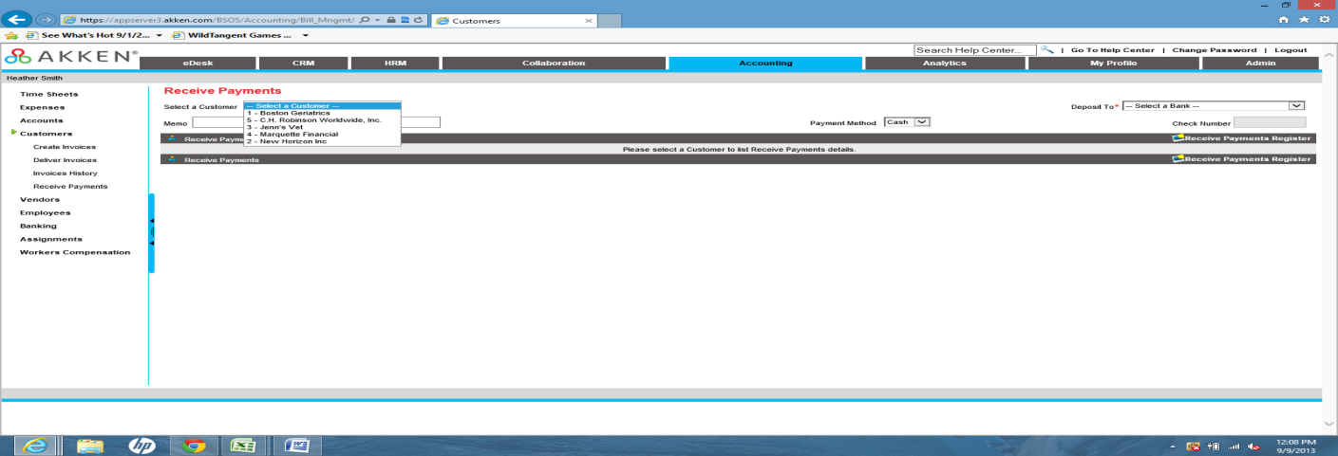
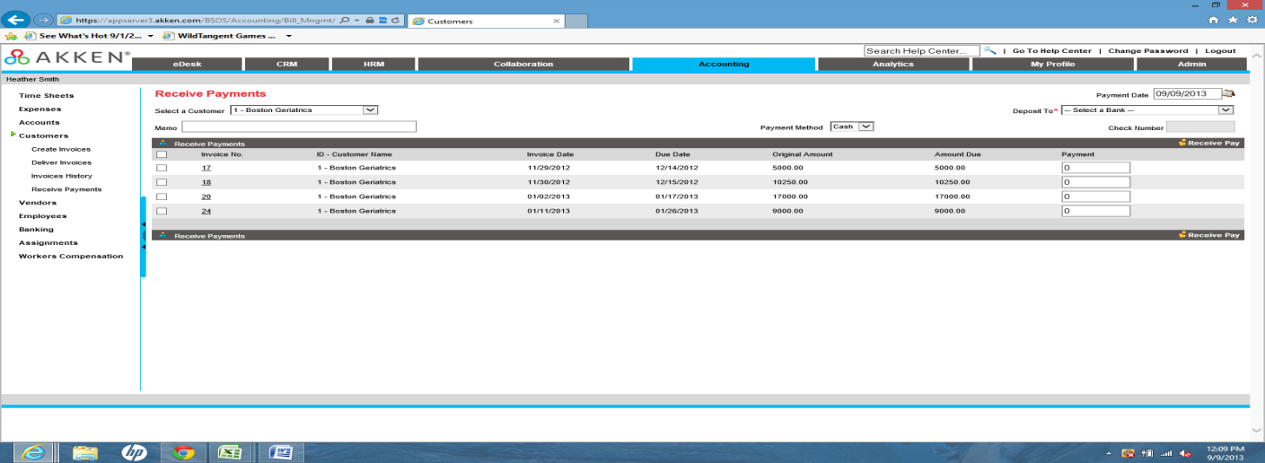
Invoices can be marked as paid in full or you can put a partial payment on an invoice. These transactions will keep your chart of accounts in Accounting/Customers current.

