Setting up email within Akken
- Under AdminUser Management, check user preferences and see if the user is currently setup for Akken email:
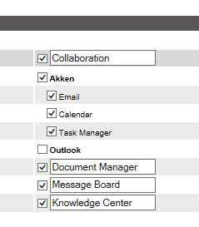
- The next step is to go to CollaborationEmail and click on ‘Setup’ on the left-hand side of the email screen:
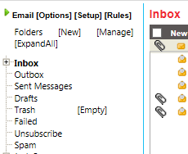

- Next, you would click on ‘Add New Account’ and it brings you to the following screen:
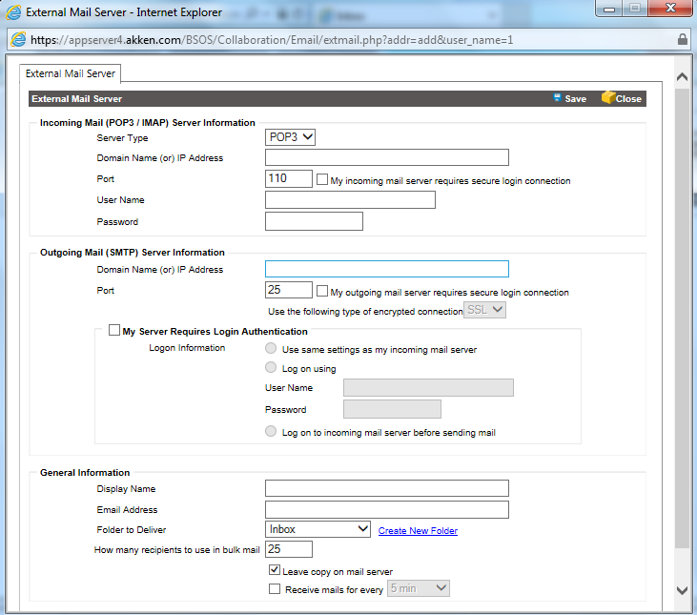
You can enter your incoming/outgoing email server setup here. Your email provider/IT team should have all of the information that is necessary in the above. The Akken email client has the ability to handle POP3 as well as IMAP email configurations.
- Once everything is entered you can click Save. It generally takes a few seconds to authenticate and save your settings.
Note: If you enter invalid credentials or invalid server information it will prompt you saying that it could not establish a connection. You will then need to verify that you have the correct information from your email provider/IT team.

