Customer Self Service Account
This guide reviews the basic features for a Specialized Staffing Customer Self Service Account. Actual usage may vary depending on the chosen features for your account.
Login information:
You can log into your Customer Self Service account two different ways.
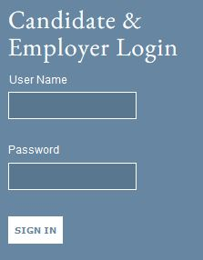
Click on the link within your notification email and use the credentials provided to you to login

or
Go to the company website and use the login information provided to you.
After you have logged in you should have a home page view listing all features you have access to view and manage. It will also list the number of active items in each section.
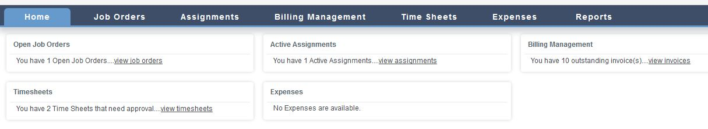

Timesheets:
Create new time sheet: Time Sheets – New - Select the Candidate you wish to create the time sheet for – Select the correct date range – Choose the correct type of Hours (Regular/Overtime) – Type in the number of hours worked in Hours text box – Submit.
In order to approve Timesheets, the candidate must either submit a time sheet through Akken, or you will have to manually enter the data in your self service account.

In the date range box on the top, you can type in the total amount of hours per that week or you can type in individual hours per each day depending upon how hours need to be tracked. To choose Over Time or other hours, click on the drop down list labeled Regular Hours to choose other associated hours. If the Candidate is currently working on more than one assignment you can select the assignment from the drop down list. Once you have correctly filled in the information on the time sheet, hit Submit.
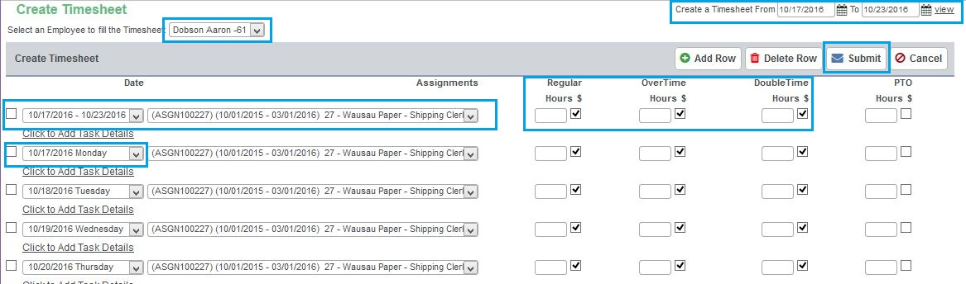
Timesheet Approval:
Time Sheets tab – Click check box on appropriate timesheet – Update Status – Approve select employee(s) timesheet(s) – Update Status
Once the time sheet has been submitted, it will be sent to the Time Sheets home screen to await approval. To approve or reject a time sheet you must select the time sheet by clicking the check box, then click on the Update Status icon.
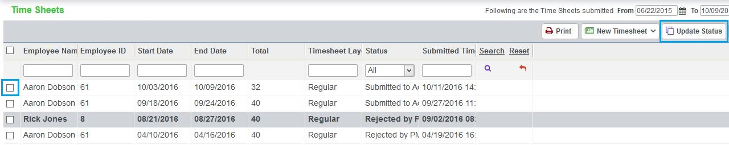
The Update Status screen appears and gives you the option to either Approve or Reject a time sheet. If you reject the time sheet you will have to provide notes stating why you have rejected the time sheet.
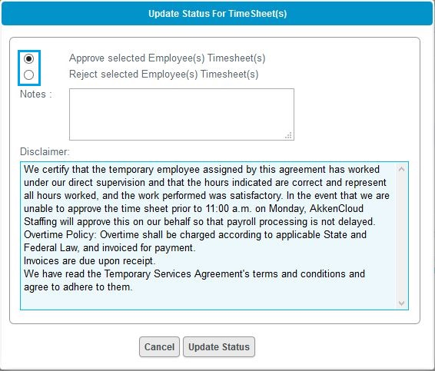

After the time sheet has been approved it will be listed as an approved time sheet in the approved timesheet screen. If you wish to know who approved the timesheet as well as the details of the time sheet you can double click on the time sheet to open it and view the details.
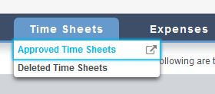
Delete a Timesheet:
Timesheets - click check box for appropriate timesheet – Delete
or
Timesheets – Approved Timesheets – click check box for appropriate timesheet – Delete
To delete a time sheet that may have been incorrectly submitted and approved, select the appropriate time sheet, click the check box and click the Delete icon.

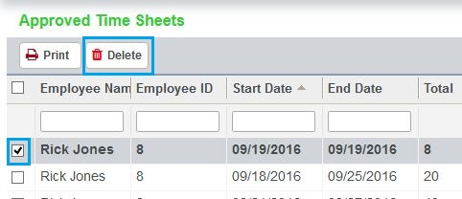

This time sheet will now be sent to the Delete Time Sheets tab and will not be added to your invoice by your billing company.

Assignments: (view only)
You can view current and past assignments (placements) within the CSS portal. After a candidate has been approved for placement an assignment will be created and listed under Active Assignments. Any past assignments will be visible under Closed Assignment.

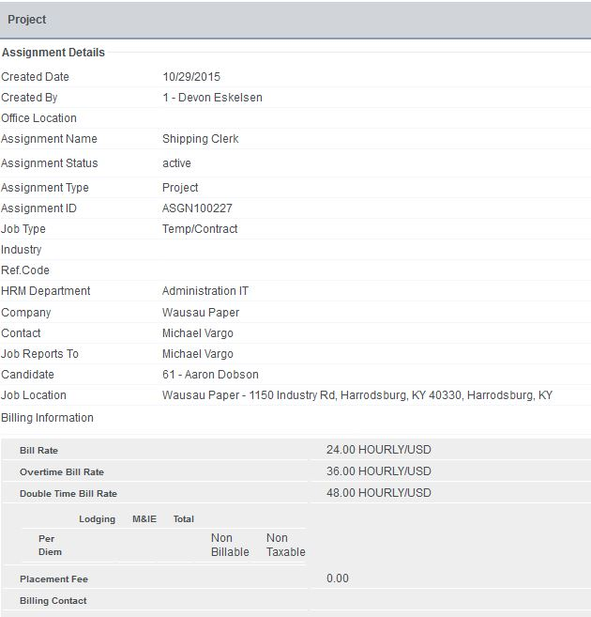
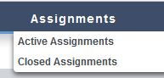

Billing Management:
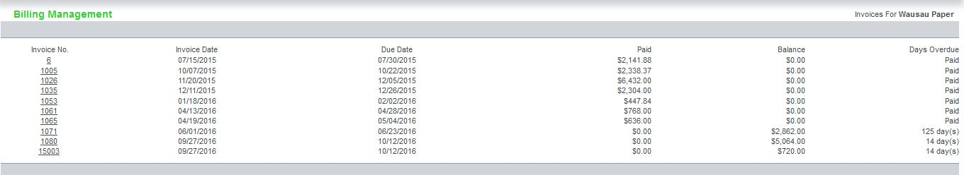
You may receive invoices in your Customer Self Service account if the company you are working with uses the Billing Management feature. This section allows you to review, download, and print your invoices online. You not only get all the detail of the invoice, you also get links to view every timesheet being billed, every expense being billed, and every placement fee or other charges being billed. This gives you a complete audit trail of all services rendered and billed to you including total due, paid, balance, timesheet detail for each individual, etc.

