New AkkenCloud Features - October 10th, 2016

Rates on Company records
We’ve introduced the ability to maintain rates on CRM Company records for your Temp/Contract jobs. Users will now be able to save their contracted rates on the CRM Company.
To add Default Rates to a CRM Company record, click the ‘Edit’ tab, expand the ‘Billing’ section, and ‘select rates’. From the pop-up you will be able to select any rates you currently have setup (under Admin > Manage Rates). Fill in the Regular Pay and Bill Rates, and ‘Update’ the Company record.
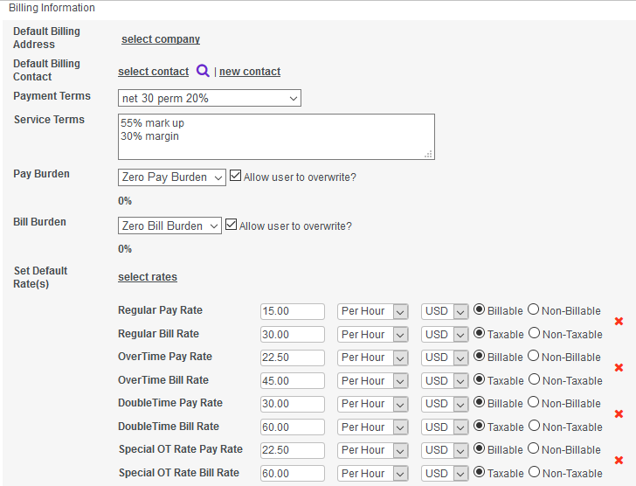
Once this is complete, creating a Job Order for a Company with default rates setup will auto-populate the rates section of the Job Order, eliminating redundant data entry or erroneous data.

Rates populated on a Job Order:
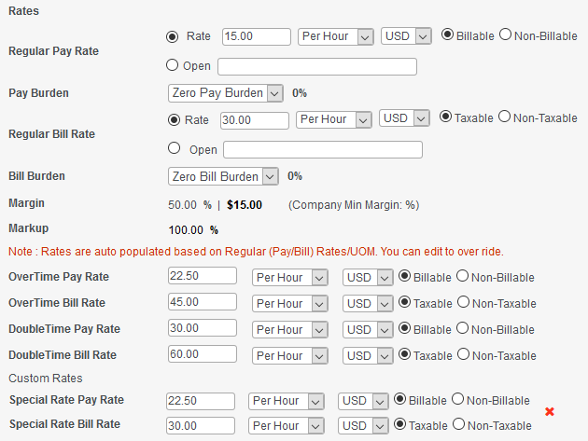

Units of Measure
We’ve introduced 3 new Units of Measure (Per day*, Per Mile* and Per Unit*) for Pay and Bill Rates on Job Orders and Assignments. This will help to avoid any conversion/translation of numbers when invoicing.
Rates on Job Titles
We’ve introduced the ability to maintain Rates on Job Titles in Admin > Manage Job Titles. Users can now define rates when creating job titles. Enforcing the Job Titles as a drop-down instead of a free form text field along with these pre-defined rates will eliminate the need to key in rates on every Job Order. This ability is also available when creating Custom Rates. Users can now attach specific Job Titles to specific Rates.
To add Rates to Job Titles, go to Admin > Manage Job Titles, add or edit a new title, click ‘Select Rates’ in the Assign Rate(s) section, select the rates to apply, fill in the Regular Pay and Bill Rates, and ‘Save’/’Update’.
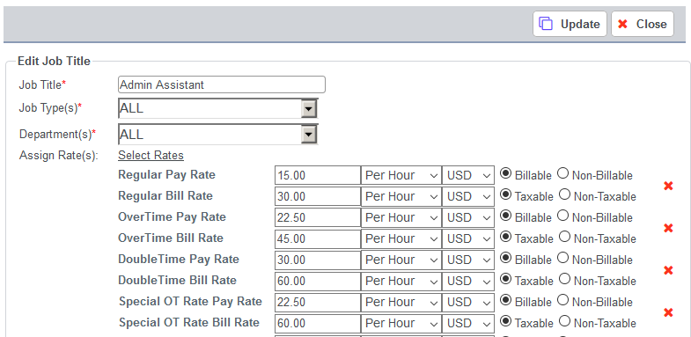
Users can also add Job Titles to Rates from Admin > Manage Rates. Add or Edit a Rate, click ‘Select Job Titles’ in the Assign Job Titles section, add the Job Title, click ‘Save’, and ‘Update’/‘Add’ the Rate.
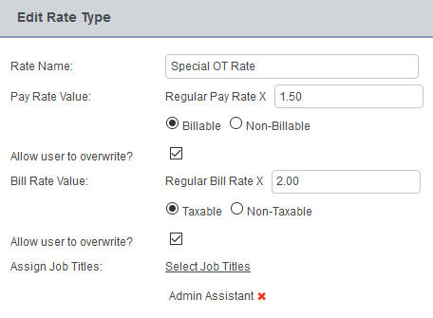
Once either of the above is complete, selecting a Job Title on a Job Order will auto-populate the rates section of the Job Order, eliminating redundant data entry or erroneous data.
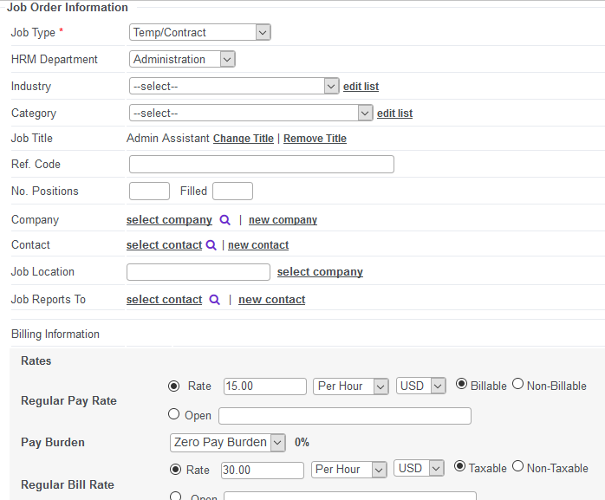
**Please note that if a Job Title with Rates has been selected on a Job Order and a Company with Rates on the Company record has been selected on the same Job Order that the Rates on the Company record will override the Job Title Rates.

Timesheet Rules
We’ve introduced the ability to apply Timesheet Rules to regular timesheets. This new feature will help users save time managing their approved hours for on-time payroll processing.
From Accounting > Time Sheets, click Setup Rules.
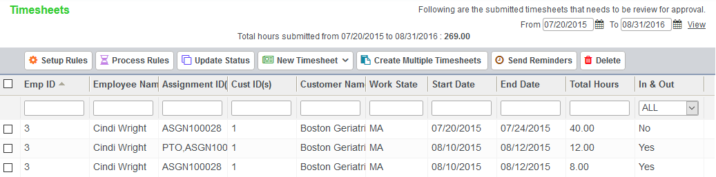
Setup the appropriate Default Timesheet Rules (maximum regular and overtime hours per day and/or week), enable the 7th Day Rule (if applicable), then click ‘Save’.
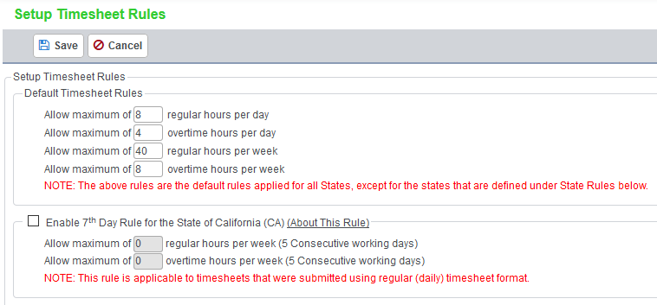
State Rules can also be added to override the Default Timesheet Rules. These will be based on the work location state. Click ‘Add’ under State Rules.
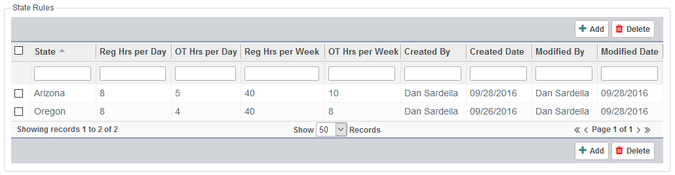
Setup the appropriate State Rules by selecting the state, maximum regular and overtime hours per day and/or week, then click ‘Save’.
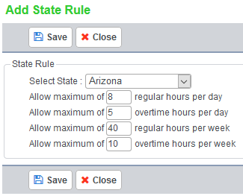
2 new submenus have been added to the Accounting > Time Sheets menu. These are Process Timesheets and Processed Timesheets.
After rules have been setup, from Accounting > Time Sheets, select timesheet(s), and click Process Rules.
This will move the selected timesheet(s) to the Process Timesheets submenu. From there, select timesheet(s), and click Apply Timesheet Rules. The Remove from Process Timesheets button will move selected timesheet(s) back to Accounting > Time Sheets.
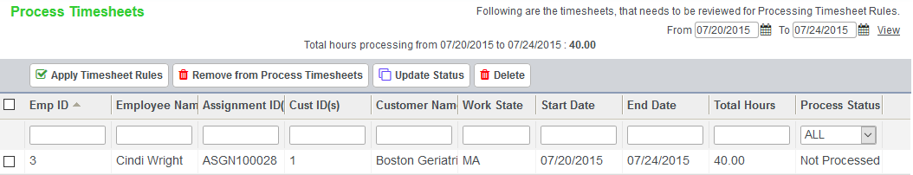
From the pop-up, select the Week Start Date and click Apply Rules.
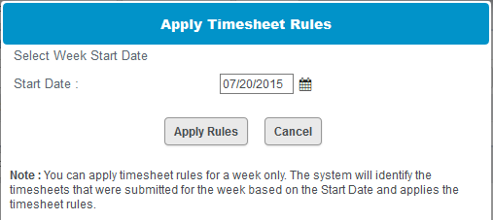
This will move the selected timesheet(s) to the Processed Timesheets submenu. From there, select timesheet(s), and click Update Status.
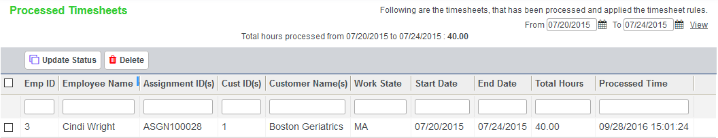
From the pop-up, Approve or Reject the selected timesheet(s), and click Update Status.
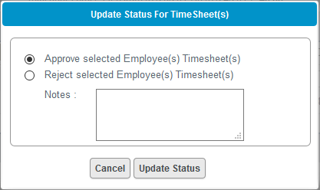
Approved timesheet(s) will now be located in Accounting > Time Sheets > Approved Timesheets with any applicable rules applied.
