New AkkenCloud Features - December 5th, 2016

Preview AOB Forms/Static Link
For our partners using Paperless Onboarding, we’ve introduced the ability to preview Applicant Onboarding forms and to capture a static URL for AOB Form Groups, which can be embedded on your website and offers flexibility for your applicant onboarding workflow.
To preview AOB forms and/or capture a static URL, go to Admin > Web Site Management > Applicant On-Boarding.
From here you can Preview AOB forms and/or Capture Static URL.
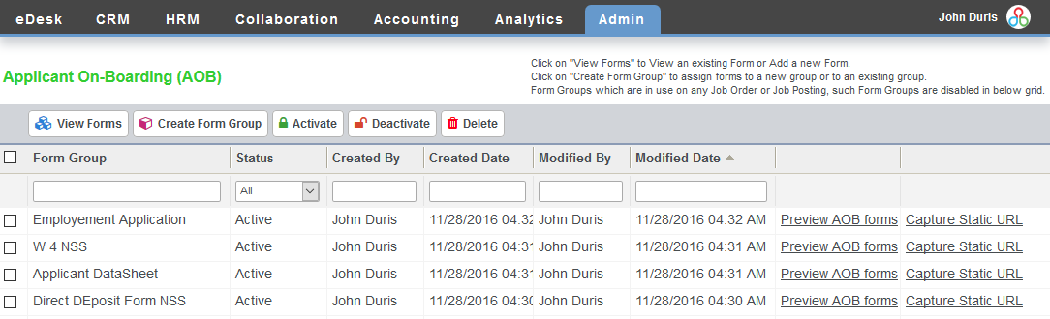
Example of Static URL, which can be copied by pressing Ctrl + C:
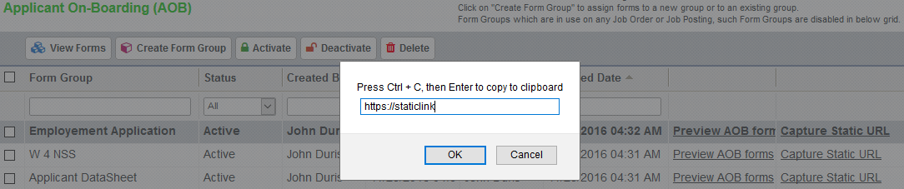
Manage Submissions Options
We’ve introduced two new buttons in the Manage Submissions screen – Place on Another Job and Update Status, which can both be used for multiple candidates.
From the CRM > Job Orders grid, click on a number in either the Submissions or Candidates column and navigate to the Manage Submissions screen (you can also get there by opening a Job Order and clicking Manage Submissions from the Submitted Candidates section on the bottom right-hand side).
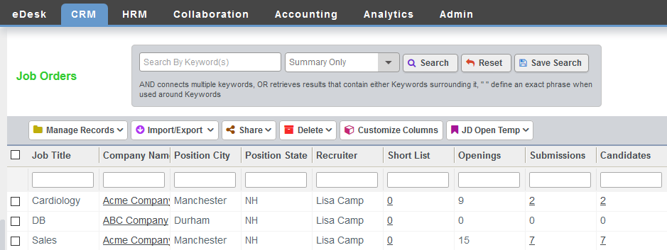
From the Manage Submissions screen, you will see the buttons for Place on Another Job and Update Status.
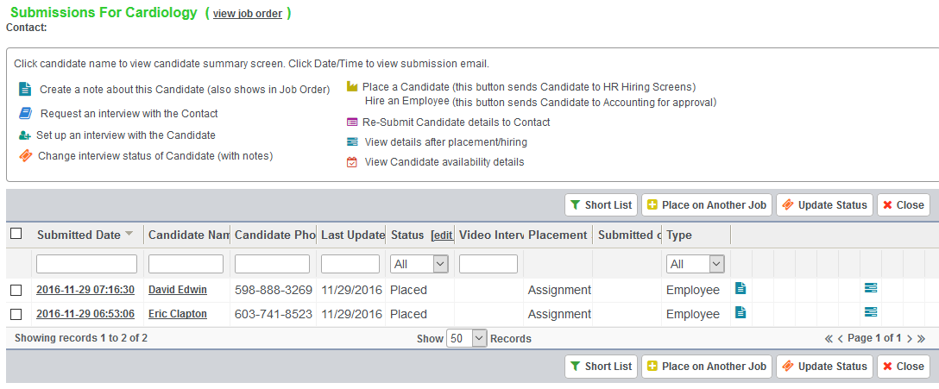
Select one or more submitted Candidates and click Place on Another Job.

From the next screen, click on a Job Order by letter of the alphabet, search for a Job Order, or Create a New Job Order. Click on the name of the Job Order once you’ve located it.
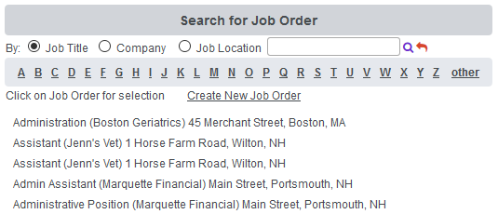
Click OK in the pop-up dialogue to place the Candidate(s) on another Job Order.
You’ll receive a pop-up that the Candidate(s) were successfully placed on the selected Job Order. Click OK.
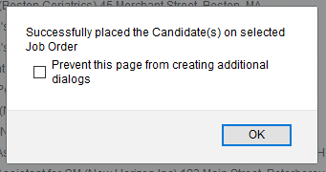
If you navigate to the Manage Submissions screen for the Job Order where you made the placement, you will be able to view the submission and the Placement Details.
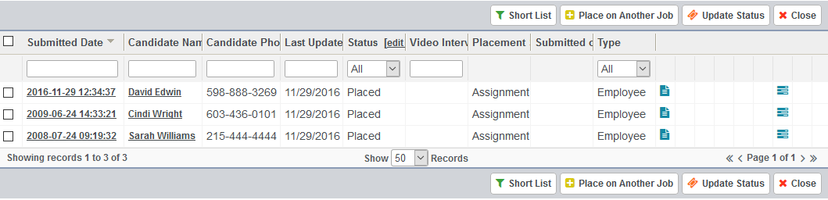
You can also view the Placement Details from the Placed section of the Candidate record.
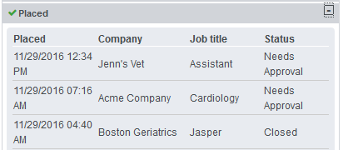
From a Manage Submissions screen, select one or more Candidates that have not been placed and click Update Status.
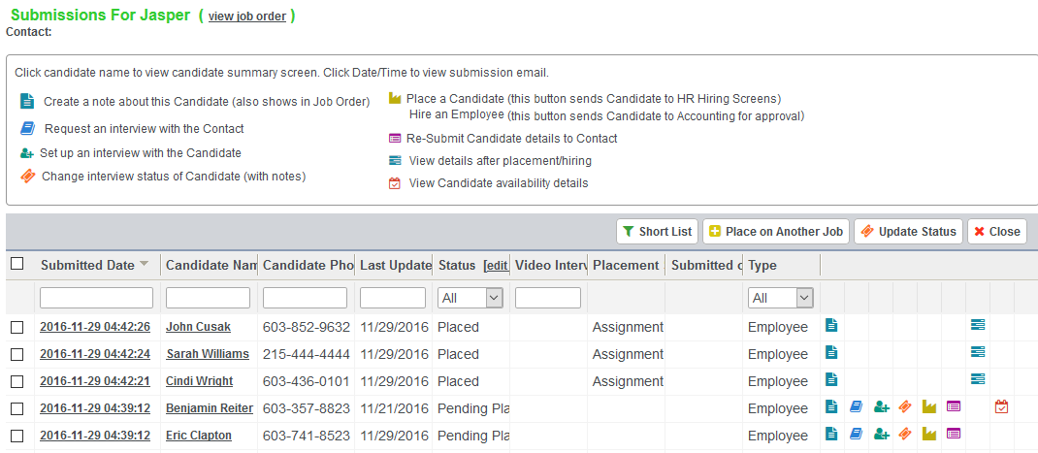
From the next screen, you can select a Status from the drop-down and add Notes. Then click Update. This will save you time by giving you ability to update statuses/add notes of more than one Submitted Candidate at a time.
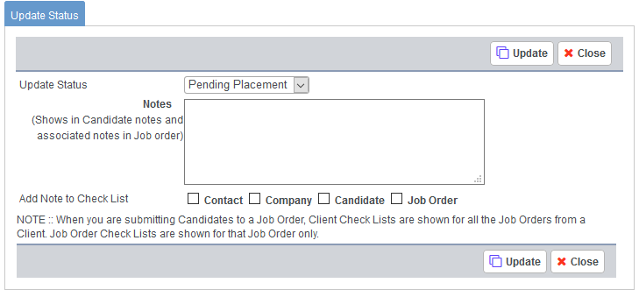
Copy Assignment
We’ve added the ability to copy Assignments from the Accounting > Assignments screen. This is similar to the ‘Copy’ option in CRM > Job Orders, in this case allowing you to create duplicate Assignments.
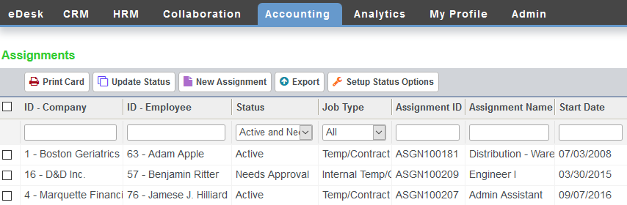
From Accounting > Assignments open an Assignment currently in one of these statuses: Active, Closed, Cancelled. Click Copy.
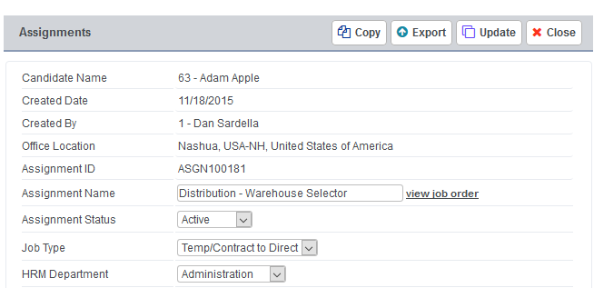
All of the information from the original Assignment will copy to a new Assignment. Click Save.
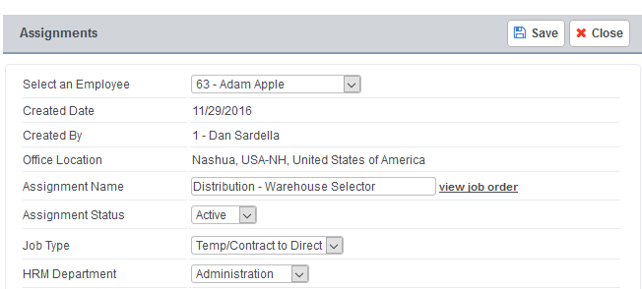
You’ll receive a confirmation that the Assignment was successfully copied. Click OK.
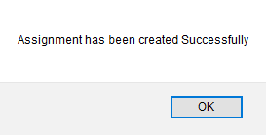
The copied Assignment will appear in the Accounting > Assignment grid. The system will assign the next available ASGN ID to the copied Assignment.
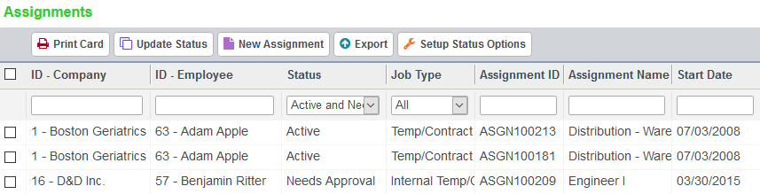

HRM Department View
For easier filtering and sorting, we’ve added a column for HRM Department to the HRM > Employee Management and Accounting > Customers grids. We’ve also added columns for HRM Department and Job Category in the Admin > Web Site Management > Job Postings screen.
Navigate to HRM > Employee Management. Department column can be sorted by clicking the header and can be filtered by typing in search text and hitting Enter.
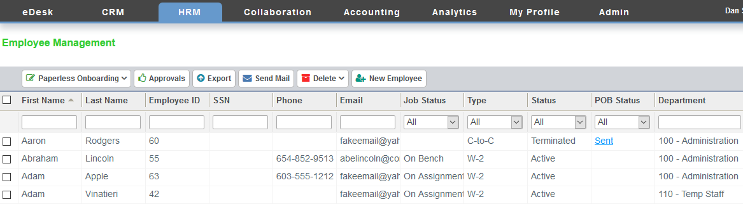

Navigate to Accounting > Customers. Department column can be sorted by clicking the header and can be filtered by typing in search text and hitting Enter.
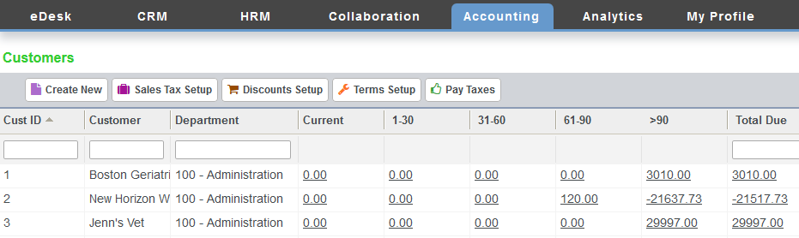
Navigate to Admin > Web Site Management > Job Postings. Department and Category columns can be sorted by clicking the header and can be filtered by typing in search text and hitting Enter.
