New AkkenCloud Features - January 9th, 2017
To take advantage of any of these features, user must have Inbound Talent Marketing.

Set Form Groups
We’ve introduced the ability to select available application forms (Long/Quick) per individual Job Order posted to your Agency Job Board, a feature previously only available to those subscribing to Paperless Onboarding. This feature gives you additional control over how your applicants apply to each job on your jobs page. If particular jobs require that the Long or Quick Form be filled out during application, now you have to ability to set the form per job.
To set Form Groups, go to Admin > Web Site Management > Job Posting.
From here, select one or more jobs and click the Set Form Group(s) button.
In the pop-up screen that appears, select a Form Group (Long Form or Short Form). Click OK.
Form Group selected will now be used for Job Orders that were selected for Applicants applying to those jobs.

Override Job Posting Preferences
We’ve added the ability to enforce Form Groups per domain. For example, if you have more than one subdomain set up for jobs pages, you can now associate the Long or Quick Form (or custom forms if you are subscribed to Paperless Onboarding) per domain. This setting will override the Job Posting Preferences setup in your Web Site Management and the Form Groups you have setup per Job Order (see above).
To Override Job Posting Preferences, go to Admin > Web Site Management > Manage Websites.
Select a subdomain.

Select a Form Group (Long Form or Quick Form) from the drop-down and select the checkbox for Override Job Posting Preferences. Click Update.
Form Group selected will now be used for that domain for Applicants applying to jobs listed on that domain.

Applicant Tracking Enhancement
For our partners using Paperless Onboarding (POB), we’ve introduced a feature to avoid duplicate records in Applicant Tracking. For example, let’s say an applicant applies via the Long or Quick Form and an HRM > Applicant Tracking record is created.
Then suppose you send custom forms to applicants, after they have applied, via the Static URL feature that AkkenCloud offers via Admin > Web Site Management > Applicant Onboarding. **To learn more about Static URLs, please visit December’s Announcement page.**
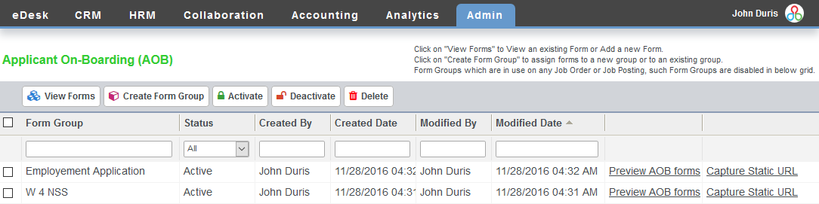
Example of Static URL, which can be copied by pressing Ctrl + C:
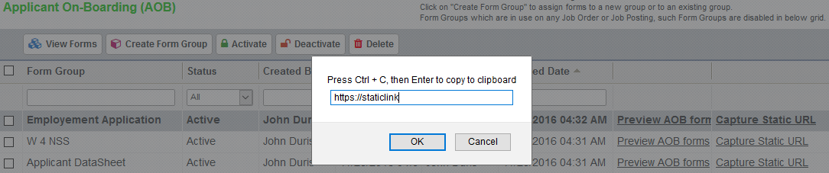
Now when the applicant fills out the custom forms via the Static URL, the system will use Email ID as an identifier, and those forms will be attached to the Activities of the existing Applicant Tracking record, rather than creating a new record.

