Helpful Tips/Hints

Candidates – Position Category
Under the Candidates section in an open Candidate record there is a field called Position Category found in the Candidate Information tab. This allows you to categorize the type of position the individual worked/s in.
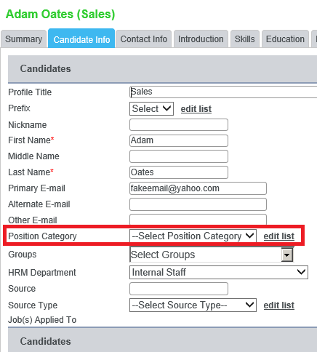
As a team agree upon what terms should be entered into the list (see example below) and do not edit list as this will not ensure accurate data. Use the position category as a means to group individuals in a specified area.
The profile title will automatically be parsed from the resume. This is a free text box which allows deviations due to mistypes and therefore will not be as accurate when trying to search for applicable talent for the job posting.
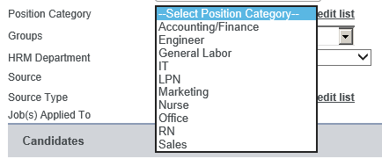
Create a list of positions that are applicable to your area (s) of focus. This will enable you to track all

Administration Department:
In order for administrators to view records within employee management of employees of your company you must be give permissions within the Administration Department in HRM to view the list. Chris Allison is the only user with permissions to view the Administration Department and all the employee records that are associated with the Administration Department. Currently there are 15 employees associated with the Administration Department. 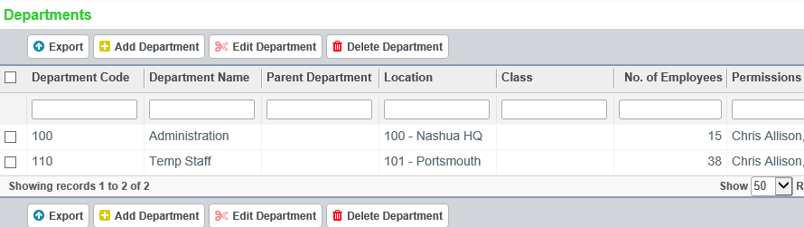
If there is going to be more than one administrator that will require access to the Administration Department, you can add permissions to other users through Edit Department. Check the box next to the department you wish to Edit, then Edit Department.
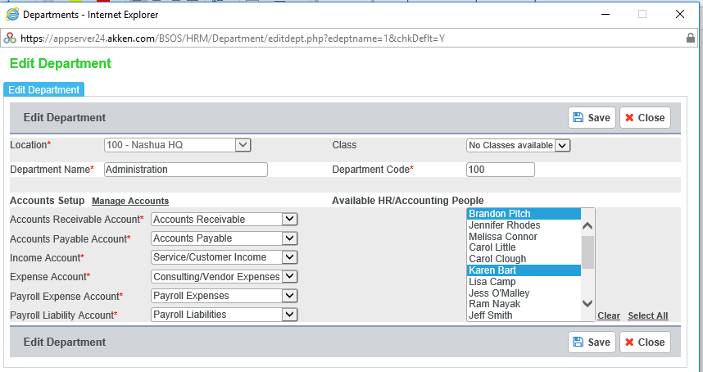
In order to add multiple users you must hold down the control key (CTRL) and select the users you wish to add, then click on Save. These users now have permission to view the records in those folders.
Analytics – Reports:
When customizing a report, it is important to save two copies of the report. One copy should be public, which enables all users to utilize that report as well as edit the report. By creating a separate privatized report, you can continuously utilize the report without other users customizing or doctoring the report. In the private report use “-“ Private to denote the private report on the Analytics screen.
