Before importing information into Akken, look at your CSV file and follow these bullet points:
- Start with a clean CSV file. If you’re on a Mac, the file will need to be saved as a Windows CSV specifically.
- In your CSV file, avoid special characters, including forward slashes.
- In your CSV file, make sure there are no empty cells for fields that you are checking against existing records.
- In your CSV file, make sure there are no empty rows (check below the last row of data).
- In your CSV file, make sure there are no empty columns (check to the right of the last column of data).
- In your CSV file, we recommend naming the columns with the same or similar names as the fields within Akken that you'd like to map to.
- In your CSV file, we suggest using a tag column. For example, the initials of the user doing the import. It's a good way to track imports.
- During an import, when mapping on the 2nd screen (the one to check for existing records), do NOT select the fields that you are updating (only select the fields you are not updating). This only applies if you select 'Update the existing record(s) with the imported data'.
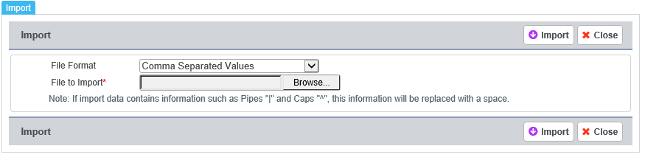
On the CRM > Contacts/Candidates/Companies screen, click Import/Export and browse for your CSV file. Click 'Import'.
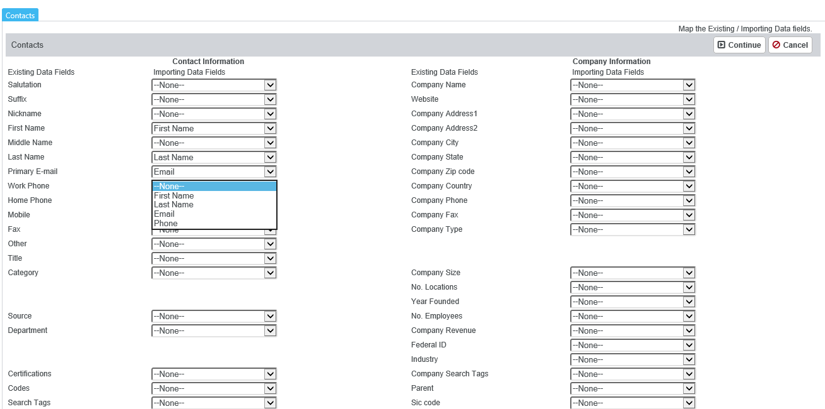
Map out the items on the spreadsheet with the column titles on the left. The dropdown list items are the columns from the spreadsheet. The columns on the left hand side in blue, are the corresponding Akken fields.

Once each field is mapped you will see that the left hand side matches the right hand side (First name and First Name, Last Name and Last Name etc). All titles may not be EXACTLY the same but you can map them anyway as long as the fields correspond with one another. For example: Primary email (on the left) can be mapped to “Email” in the drop down list. It just depends on what you have named the column titles on the spreadsheet.
After you have finished mapping the entire list of drop down items to left hand column titles (Blue titles), click on Continue.
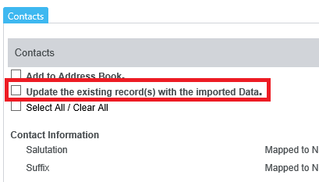
This brings you to the second Import screen. To check for duplicates you will want to uncheck 'Update the existing record(s) with the imported Data'.
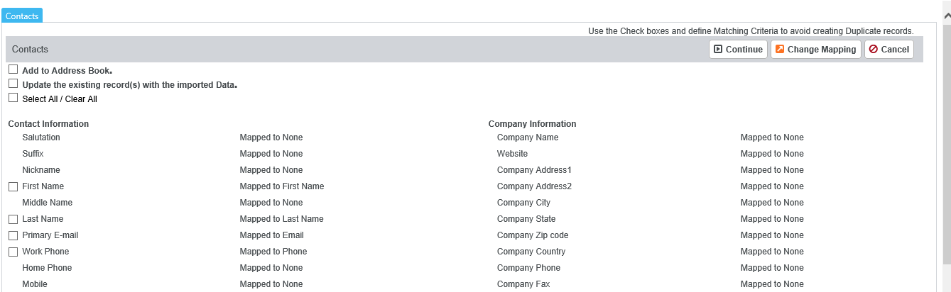
If ADDING new information into Akken via import, then select ONLY First name, Last name, and Primary Email – DO NOT SELECT ALL.
If UPDATING existing information in Akken via import, then do NOT select the fields that you are updating (only select the ones you are not updating).
Click on ‘Continue’. This will start the importing process.
**Once a Company record exists, when the same company name is used in an import, whether or not the "Update existing records" checkbox and Company Name checkbox is selected, no new record will be created.

